THROWING PROGRESSION AND TECHNIQUE
https://www.youtube.com/watch?v=gcN3azy8GDY
Grip
- 3, or 4 fingers (whichever is most comfortable depending on the size of the player’s hand)
- Hold the ball in the fingers, not in the palm
- The fingers should cross the seams of the ball where the knuckles closest to the fingertips are
- Hold the ball firmly but not so hard that the wrist and arm become stiff
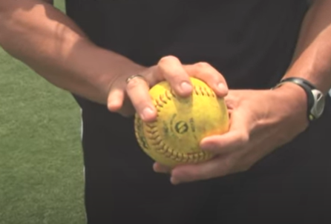

- Glove hand under elbow and elbow at same height as shoulder.
- They then snap their wrist to throw the ball. The ball should spin.
- After snap fingers are always pointed forward and down. Not sideways or up.
- Now working on throwing the ball. Reach behind and is in a L position.
- Hips and shoulders open. Glove hand pointing to target.
- Throw the ball with good wrist snap and closing of hips and shoulders finishing with her arm in front of her body across her knee and down at the ground.
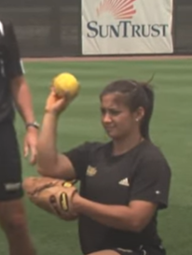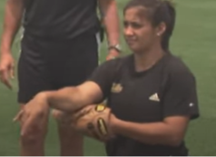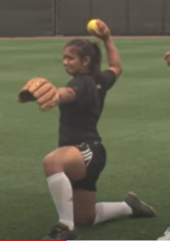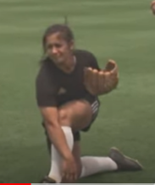
- Stand the players up and have them throw with NO STEP. Just practicing exactly what was above.

- Now with the added steps. We step with the foot that is ball hand with a small 40-degree angle.
- Then step with the glove hand foot towards the target and release the ball at the same time using all the techniques above. The ball hand leg will automatically come forward as the hips and shoulder close.
- The ball hand leg will automatically come forward as the hips and shoulder close. Your throwing hand will then follow thru to across your body like in the steps above.
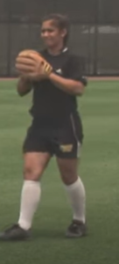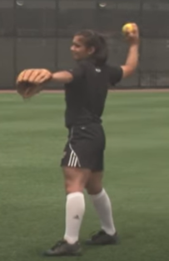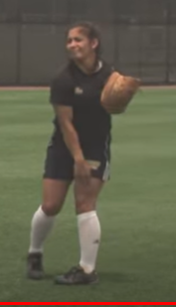

Throwing Mechanics
- Pre-Stride
◼ Back (pivot) foot perpendicular to target
◼ Weight on the back (pivot) foot

- Stride
◼ Step with foot opposite throwing hand (stride foot)
◼ Step straight towards target

- Body Rotation
◼ Rotate trunk approximately 90 degrees away from target
◼ Strong push off the back foot
◼ Unwind in sequence: hips, shoulders, arm, wrist, fingers

- Arm Position/Action
◼ Arm high with elbow at least parallel with shoulder
◼ Concentrate on keeping arm high and having players come over the top (elbow leads and forearm and hand follow in sequence)
◼ Pull non-throwing arm forcefully backward towards body and downward

- Wrist Action
◼ Wrist under the ball at release
◼ Hand snaps forward as ball is released

- Follow Through
◼ Shoulder and arm continue forward rotation
◼ Point throwing arm shoulder at target to complete motion
◼ Allow pivot foot leg to swing forward naturally
Basic Throwing Rules
- Throw to a specific target
- Try to achieve reverse rotation on ball (6 o’clock – 12 o’clock rotation)
Underhand Toss
- Ensure the ball is visible to the receiver
- Create a floating toss (no spin on ball) by locking the wrist
- Step with the same foot, same arm
Backhand Toss
- Stay low
- Bring elbow up to shoulder height
- Extend elbow
- Create a floating toss (no spin on ball) by locking the wrist
- Thumb should be pointing down on release

