LTP Schedule- Westminster School (402-18 St. N.) Mondays & Wednesdays
Date | D1-N.W. | D2 |  | D3-N.E. | D4-S.E. | D5-SW | Practice/Game
Apr 29 | Team 1 | Team 2 | Team 3 |  | Team 4 | Team 5 | Practice
May 1 | Team 2 | Team 3 | Team 4 |  | Team 5 | Team 1 | Practice
May 6 | Team 3 | Team 4 | Team 5 |  | Team 1 | Team 2 | Practice
May 8 | Team 4 | Team 5 | Team 1 |  | Team 2 | Team 3 | Practice
May 13 | Team 5 | Team 1 | Team 2 |  | Team 3 | Team 4 | Practice
May 15 | Team 1 | Team 2 | Team 3 |  | Team 4 | Team 5 | Practice
May 20 | 1 vs 2 |  | 3 Practice |  | 4 vs 5 |  | 2 Games & 1 Practice
May 22 | 2 vs 1 |  | 5 Practice |  | 3 vs 4 |  | 2 Games & 1 Practice
May 27 | 3 vs 1 |  | 2 Practice |  | 5 vs 4 |  | 2 Games & 1 Practice
May 29 | 2 Practice |  | 1 Practice |  | 4 vs 3 |  | 1 Games & 2 Practice
Jun 3 | 1 vs 5 |  | 4 Practice |  | 3 vs 2 |  | 2 Games & 1 Practice
Jun 5 | 1 vs 2 |  | 3 Practice |  | 4 vs 5 |  | 2 Games & 1 Practice
Jun 10 | 2 vs 1 |  | 5 Practice |  | 3 vs 4 |  | 2 Games & 1 Practice
Jun 12 | 3 vs 1 |  | 2 Practice |  | 5 vs 4 |  | 2 Games & 1 Practice
Jun 17 | 2 Practice |  | 1 Practice |  | 4 vs 3 |  | 2 Games & 1 Practice
Jun 19 | Wrap up Night

Team 1 – Coach Jay
Team 2 – Coach Bonnie
Team 3 – Coach Jen
Team 4 – Coach Heather
Team 5 – Coach Alicia

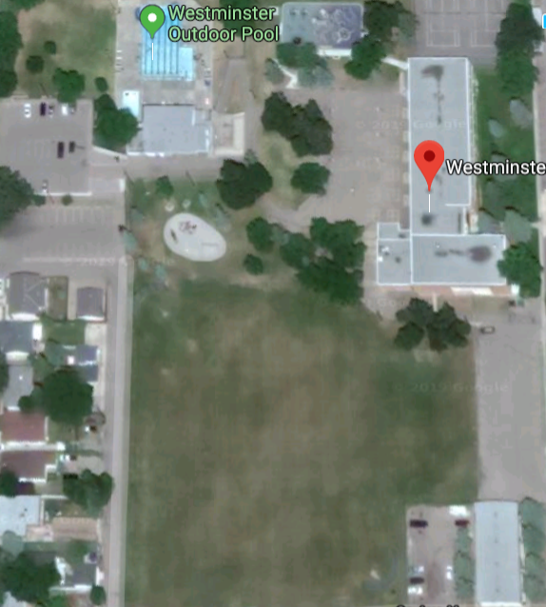
D3 - N.E.
Parking

D5 -S.W.
D4 - S.E.
D2
D1 - N.W.
Parking

