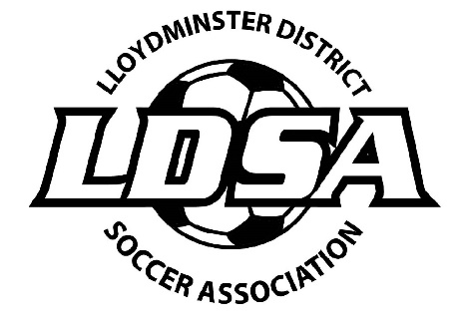
Lloydminster and District Adult Soccer
2020/21 Annual General Meeting
Monday, June 7, 2021 @ 7:00pm
Agenda - Zoom Meeting

- Call to Order:

- Introductions:

- Minutes of the 2019/20 AGM:

- Additions to the Agenda:

- President’s Report:

- Financial Report:

- Reports of Directors:

- Discipline: NA
- Referee: NA

- Old Business

- 2020 Outdoor Season - COVID – 19 – all play is suspended by SSA and we will comply with their regulations – we will meet again when SSA says go and the fields open up – we will hope for a late summer/fall season – a few games maybe
- 2020 Map Grant – Jordyn attended a zoom meeting so we are eligible to apply for funds – we need goals and nets and ref jerseys
- New website – RAMP- hoping to be up and running by end of April
- Men’s and Coed League moving forward – see how the summer/virus goes – then decide if we can run anything
- Board Members – Lack of participation in 3 consecutive meetings in one fiscal year. Kevin Govender, Mike Welygan – Mike is off and Kevin is rejoining for a 2 year term.

Consideration of Amendments:

- Election of Officers

- President: 2yr Term
- Discipline Director – Vacant
- Referee Director – Vacant
- Member at Large 1yr Term – Khiraj Chotee
- Member at Large 1yr Term – Kevin Govender
- Member at Large 1yr Term – Neomi Bexson
- Member at Large 2yr Term – Vacant
- Member at Large 2yr Term – Vacant
- Member at Large 2yr Term – Vacant

- New Business:

- 2021 Outdoor Season
- Fields
- Start Date
- Duration of Season
- Game Size (6 vs 6, 8 vs 8, 11 vs 11)
- Days of the week

- 2021 Map Grant (SSA AGM)
- GIC / Mutual Funds

- Adjournment:

