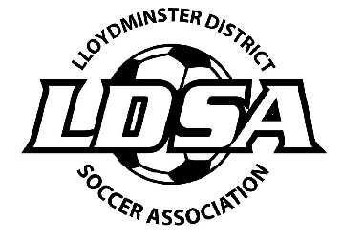
Lloydminster and District Adult Soccer
2021/22 Annual General Meeting
Monday, June 6, 2022 @ 7:00pm
Agenda - Zoom Meeting

- Call to Order:

- Introductions:

- Minutes of the 2021/22 AGM:

- Additions to the Agenda:

- President’s Report:

- Financial Report: Attached:

- Reports of Directors:

- Discipline:
- Referee:

- Old Business

- 2021 Outdoor Season
- Fields – KP Park for both Mens and Ladies League – Amanda made the motion and Dana seconded the motion
- Start Date – July 5, 2021 for Men’s league and July 6, 2021 for Ladies League – Alyssa made the motion and Jordyn seconded the motion
- Duration of Season – Depending on the number of teams, the season will run until the end of August. Alyssa made the motion and Amanda seconded the motion
- Game Size (6 vs 6, 8 vs 8, 11 vs 11) 8 vs 8 for both Men’s and Ladies League – Dana made the motion and Wendy seconded the motion
- Days of the week – Monday / Wednesday for Men’s League and Tuesday and Thursday for Ladies League – Dana made the motion and Amanda seconded the motion

- 2021 Map Grant (SSA AGM) – Map grant was $940.31 – Will purchase what we applied for in the grant.
- GIC / Mutual Funds – Jordyn made the motion to put $55,000 into a GIC, a 2 year non-redeemable term. Amanda seconded the motion.

- Consideration of Amendments:

- Election of Officers

- President – 2 Year Term – Vacant
- Vice President – Alyssa Ogilvy– 1 Year Term
- Discipline Director – Vacant
- Referee Director – Vacant
- Member at Large 2yr Term – Dana Johnston - Up
- Member at Large 2yr Term – Vacant
- Member at Large 2yr Term – Neomi Bexson - Up
- Member at Large 1yr Term – Sarah Davis
- Member at Large 1yr Term – Vacant
- Member at Large 1yr Term – Angel Dillon

- New Business:

- Indoor Season
- Outdoor Season
- 24-hour rule for Player Insurance
- Team Bonds - Forfeits
- Referees

- Adjournment:

