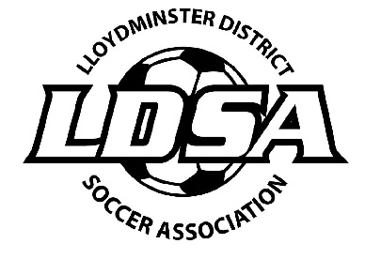

Lloydminster District Soccer Association
Executive Meeting
March 11, 2020 - 7:30pm
Second Cup

- Call to Order: 7:45pm Present: Neomi, Dana, Amanda, Jordyn, Alyssa, Liz

- Additions to the Agenda: none

- Minutes of Last Executive Meeting: see attached

- President Report: nothing to report

- Referee Report: nothing to report

- Discipline Report: nothing to report

- LDSA Financials: Emailed

- Old Business:

    - Mens Drop In League – done end of February
    - SSA AGM – March 21 – Saskatoon – no one able to go

- New Business:

  - Ladies League Tournament Feedback – well done
  - New Website – RAMP – ready to switch over when ladies league is done
  - Steve Grice Email -guy who wants to coach – Amanda will email back and tell him she has passed this on to the teams
  - LDSA AGM: April 20 2020 - 7pm at Cheers for pizza and bevies
  - Spring League -Amanda will check into booking
  - Outdoor Season
    - In Person Team Registration Night – online only
    - Season Start Date – After May Long
    - Field Lining – Mark Cryderman
    - Programming: Days of the week
      - Coed - Sundays
      - Mens - Mondays / Thursdays
      - Ladies – Tuesdays / Wednesdays
    - Ladies League Format 11v11
    - Coed League no league – try to get men’s league back going
    - Advertising -social media only
    - Fields Bookings: Budmiller & Armstrong-check about VLA
      - Men’s
      - Ladies
      - Coed
    - Team Fees:
      - $1300 – Men’s 2019
      - $1100 – Coed & Ladies 2019
      - Jordyn and Alyssa moved that we buy refs jerseys so they all have the same. Amanda will find out who all needs them. Carried.

- Adjournment: 8:45pm
- Next Meeting: April 20 AGM

