Lloydminster Midget Division Tryouts
REGISTRATION FORM

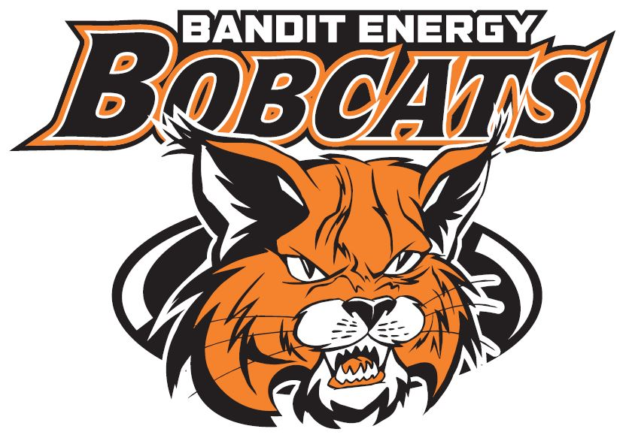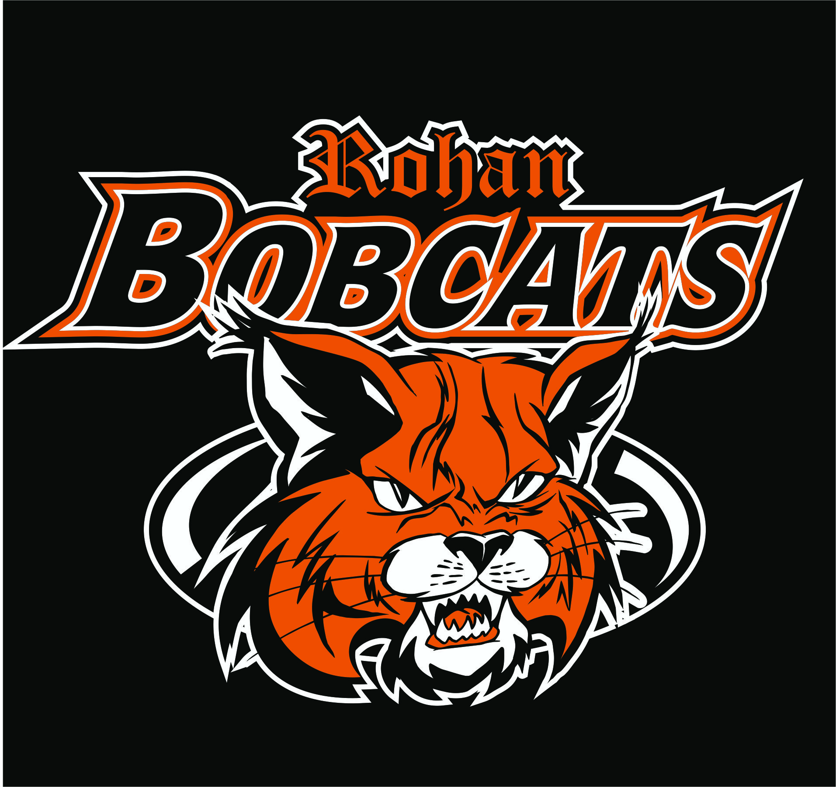

Teams that you are Trying Out For: Please check the Teams that you wish to Try out for. Please Note that if you are not from the Lloydminster Minor Hockey AA Draw Zone you will not be considered for that team. Midget AA Associations are Lloydminster, Paradise Valley, Kitscoty, Marwayne, Dewberry and Onion Lake.

Please Check the Appropriate Box(es) below:

Bandit Energy AAA Bobcats:

Rohan MMAAA Bobcats:
Sobeys Midget AA Blazers:

Players Name:

Birth Date(mm/dd/yyyy): __________________________________
Position: Shot:
Height: Weight:
Address:
City/Town:
Postal Code:
Health Care # (AB/SK/OTHER):
Phone Numbers: Home:
Players Cell:
Parent’s Names:
Mother’s Cell: _______________________
Father’s Cell: ________________________
Email:
Any medical conditions to be aware of

Last Team Played For: ____________
Will you be attending a Junior Camp in August?
No: _______
Yes: _______ Where: ________________________________
Camp Dates: ____________________________

Registration Fee: $300.00 All Registrations must be received BEFORE
August 22, 2018. Late registrations may not be accepted.
(Due to the ice turn back policy we must have a good estimation on how many registrants we will have.)
Please make cheques payable to: (please bring cheques/cash to registration)
Lloydminster Minor Hockey Association
Payment Total: CASH / CHEQUE
Please Circle One

Please email Registration to: ice@lloydminsterminorhockey.com
If you are not from Lloydminster, please make sure to fill in the Proper Notification to tryout form and have your Home Association sign off on it and return it by email it with your registration. NO PLAYER will be allowed on the ice for tryouts without the correct completed NTO form.
Male Elite Notification to tryout form: https://www.hockeyalberta.ca/uploads/source/Forms/2019-2020_Elite_Male_Notification_of_Try_Out_with_Form_Fields%5B1%5D.pdf
AA Midget Notification to Tryout form: https://www.hockeyalberta.ca/uploads/source/Forms/19-20_AA_Notification_of_Try_Out_with_Form_Fields.pdf
Any questions please Contact Maryann ice@lloydminsterminorhockey.com or Taylor Holt factorysports.taylor@sasktel.net or Mike Applegate rohanaaabobcats@gmail.com

Thank you!

