Lorne Park Clarkson Hockey Association
Learn to Play Registration Form
Please make cheque payable to: | Lorne Park Clarkson Hockey Association
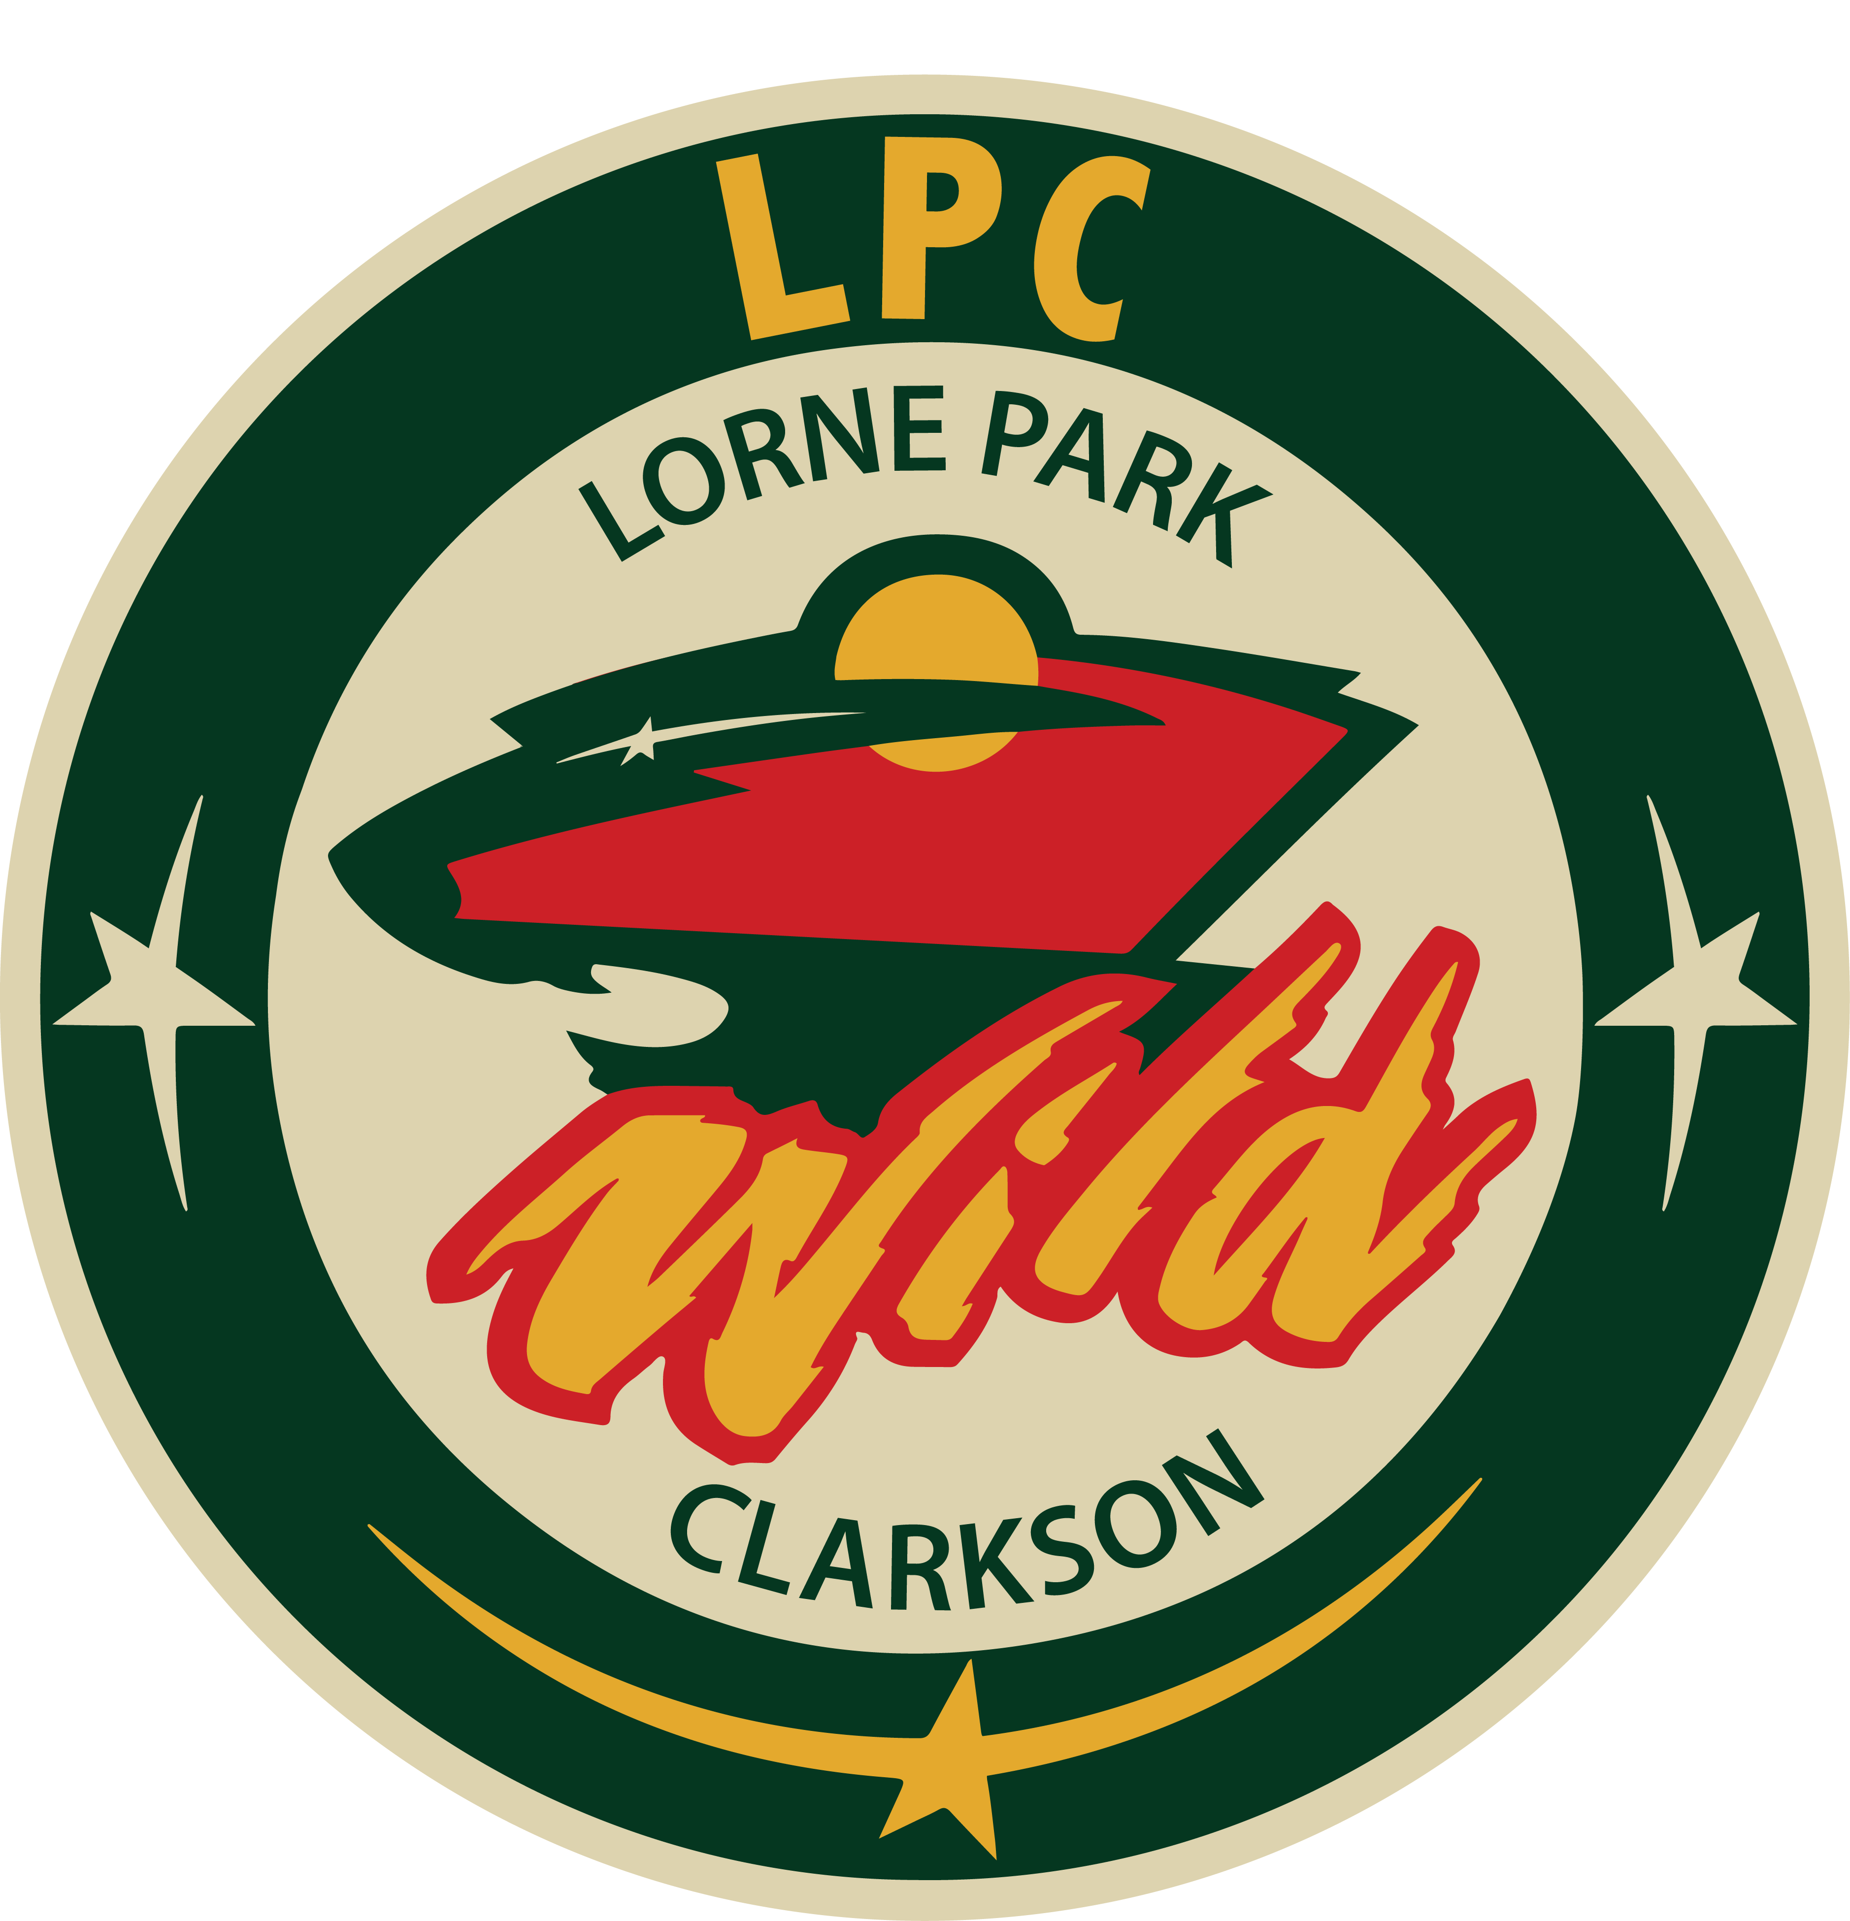  Mail to: | Learn to Play Program  1191 Flagship Drive  Mississauga, L4Y 2K3

Childs First Name:_______________________________________________________________
Childs Last Name: _______________________________________________________________
Date Of Birth (yyyy-mm-dd):_______________________________________________________
Signup Date: ___________________________________________________________________
Phone: ________________________________________________________________________
Email: _______________________________________________________________________
Address: ______________________________________________________________________
Paid: _________________________________________________________________________
Payment Form: ________________________________________________________________

