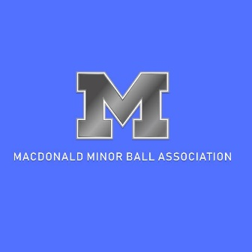

MMBA A& AA TEAM FORMATION POLICY

The Macdonald Minor Baseball Association (MMBA) hosts teams in both “A” Leagues and “AA” Leagues. This optimizes player safety and affords each player the greatest opportunity for fun, further skill development and success at practices and during games.
“A” Leagues: The primary focus of the “A” Leagues is fun, skill development and participation. “A” league teams often have one practice and two games per week.
“AA” Leagues: The primary focus of the “AA” Leagues is skill development for stronger players in a more competitive environment, although fair play rules still apply. “AA” league teams usually have one or two practices and two league games per week. They may also participate in several weekend tournaments during the season.
“AAA” Leagues: Players of Peewee age or older may try out for elite regional “AAA” teams hosted by Winnipeg South Minor Baseball Association (WSMBA). This is the highest level of league competition available in Manitoba. Any MMBA resident player trying out for an “AAA” team must first register with Macdonald Baseball and must provide proof of that registration to be able to participate in “AAA” tryouts. If a player registered with MMBA does not make the WSMBA “AAA” team, they will play for their age appropriate MMBA team, unless granted a transfer in accordance with the MMBA Transfer Policy, or the WSMBA “AAA” Transfer Policy.
Eligibility for “AA” Teams:
To be considered for “AA” teams, a player must:
- Register before the beginning of preseason evaluations.
- Attend all preseason evaluation sessions.
- If a player does not attend the preseason evaluation sessions, they will be placed on an “A” team.
- Commit to attending all weekly practices and all games throughout the entire baseball season, which may continue through the third weekend in July.
- Be in the correct age group (Baseball Manitoba rules state that underaged players are NOT eligible to play in the “AA” Leagues).
- Compete on par with other “AA” players in critical areas of hitting, running, throwing and catching.
Preseason Evaluation:
To form teams at both “A” and “AA” levels, MMBA hosts preseason evaluations to determine each player’s ability level. Volunteer Age Division Convenors organize and oversee the preseason assessment sessions. The actual skill assessing of the players is done by volunteers who have significant baseball experience and do not have children playing in that age group. Teams will be assembled by the Convenor for each age group, in consultation with the MMBA President.
Team Formation:
The MMBA Board reserves the right to limit team size to provide the best experience for all players. MMBA also reserves the right to determine whether the team will be registered in the “A” or “AA” Leagues, after considering the overall caliber of the team. For example, if there is only one team in an age group, the Convenor and MMBA board will determine whether that team will play as an “A” team or a “AA” team.

Policy approved by MMBA Board, March 6, 2014

