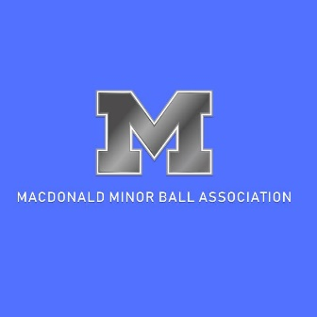

CODE of CONDUCT (PARENTS/GUARDIAN)

It is the intention of this code of conduct to promote fair play and respect for all participants within the MMBA. Parents are to review this guideline and sign the document if in agreement. Parents who decide not to sign this document are required to address their concerns with their Divisional Convenor.
The intent of the Parents’ Code of Conduct is to educate parents and positively influence parent behaviour and to identify what the MMBA has determined to be expected and acceptable behaviour.

PARENTS CODE of CONDUCT:
1. I will not force my child to participate in baseball.
2. I will remember that my child plays baseball for his or her enjoyment, not mine.
3. I will encourage my child to play by the rules and to resolve conflict without resorting to hostility or violence.
4. I will teach my child that doing one's best is as important as winning so that my child will never feel defeated by the outcome of the game.
5. I will make my child feel like a winner every time by offering praise for competing fairly and hard.
6. I will never ridicule or yell (derogatory) at my or any child, a game official, a team official, or another parent.
7. I will remember that children learn by example. I will applaud good plays and performances by both my child's team and their opponents.
8. I will never question the game official's judgment or honesty in public.
9. I will support all efforts to remove verbal and physical abuse from children's baseball games.
10. I will respect and show appreciation for the volunteers who give their time to baseball for my child.
11. I will abide by the team’s communication rules between coaches and parents (established through coach-parent meeting at beginning of season)
12. I will abide by the MMBA “24-hour rule”*.
13. I will be responsible for my guests at my child’s baseball games, encouraging them to respect and abide by the Parents’ Code of Conduct.
I agree to abide by the principles of the Parents’ Code of Conduct as set by the Macdonald Minor Baseball Association. I also agree to abide by the rules, regulations and decisions as set for the WMBA and MBA. I agree to receive any educational resources or learning opportunities as deemed appropriate by the MMBA.

PLAYER’S NAME____________________________________________
TEAM______________________________ PARENT(S)
NAME_____________________________________________DATE_____________________________
SIGNATURES: PARENT___________________________________________PARENT__________________________
*MMBA “24-Hour Rule” – If any person(s) determine that any concerns, events, methodologies, or conduct requires to be brought forward for attention, then that person(s) is to wait 24 hours after the event prior to initiating the contact. This “24-Hour Rule” allows for emotions to be set aside, placing the event in perspective, and enabling the opportunity for an objective evaluation and approach. The recipient of the information is then allowed 24 hours to respond, for the same purposes.

