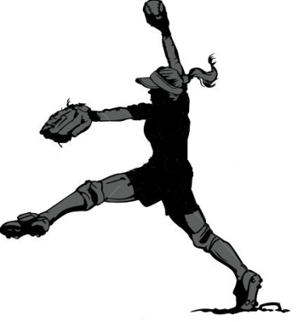 | 2019  PONYTAIL  SOFTBALL  LEAGUE

- The Ponytail Softball League (PSL), now in it’s 5th season, is a "developmental" softball league sanctioned by Softball Manitoba that runs from July, after B Provincials are over, through to late August. The PSL provides an opportunity for players to continue playing softball through the summer months in a non-competitive environment.
- The mandate of the PSL is to expose players to additional development and skill training in a relaxed, fun, full participation setting.
- The PSL is organized around the fact that players have other things to do during the summer, and it is understood they may not be able to attend all games and practices. For that reason, coaches are encouraged to carry larger than normal rosters.
- The PSL hosts 4 – one day (Saturday only) tournaments, tentatively scheduled for Winnipeg (July 20), Brandon (July 27), Portage La Prairie (Aug 10), and La Salle (Aug 24). Teams are expected to practice at least once a week and are encouraged to schedule additional games at their own convenience. NEW FOR 2019: If the number of teams formed increases this season, we will split the league into an east and west division and play the first three tournaments locally (to reduce travel) and bring all teams to Winnipeg for the final tournament (Aug 24)
- The PSL is open to all “A”,”B”,and ”C” players, regardless of skill level, born in the years 2006 through 2011. Exceptions for younger players will be considered to fill team rosters. “A” players may be asked to move to a higher age category.
- All players must have previously registered with Softball Manitoba and participated in a community/association league during April to July of 2019. Exceptions will be considered on a case-by-case basis (e.g. player moving to province in July).
- Teams will be formed in the age categories: U9 (born 2011 & 2010), U11 (born 2009 & 2008) U13 (born 2007 & 2006) based on age (and league play) during the 2019 softball season.
- Teams will be formed in consultation with the leagues in the region/geographical area where they reside. Winnipeg, Eastman, Central, Interlake, or Westman. If there are enough registrants in a region to form more than one team, then two (or more) teams may be formed to accommodate player commutes within the region. For example Wpg North, Wpg South, Wpg West, La Salle, Virden, Brandon, Portage, Morden etc. If no team is formed in an area, players may join a team from another area or region. NEW FOR 2019: The PSL has reached out to local ball organizations and leagues to identify coaches who may wish to canvas players locally and form their own teams for play in the league. The PSL reserves the right place additional players on these made up teams to accommodate individual players within the region. Emphasis will be placed on selection of qualified and committed coaches who can teach individual and team skills.
- The $65.00 registration fee includes entry to the four tournaments and a keeper T-shirt. NEW FOR 2019: The registration fee will increase to $80.00 on June 01, and T Shirts may not be available for players registering after July 01.
If you require further information please contact:
Bobbi-Jo Guffei ponytailsoftball@hotmail.com
Or
Steve Hayward haywards2231@gmail.com

