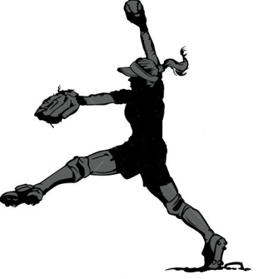 | 2019  PONYTAIL  SOFTBALL  LEAGUE
- Play softball during the summer! Mid-July to late August
- Develop your softball skills in a relaxed, fun, full participation setting.
- Open to all female softball players born 2006 to 2011.
- All players must be registered with Softball Manitoba in 2019
- Teams categories are: U9 (8-9 year old), U11 (10-11 year olds) U13 (12-13 year old)
- Teams will be formed in consultation with the leagues in the region/geographical area where they reside. If no team is formed in an area, players may join a team from another area or region or receive a full refund.

Fee: $65.00
($80.00 after May 31)

For registration form and more info contact
SOFTBALL MANITOBA:
softball@softball.mb.ca

look for Ponytail Softball League under Leagues\Minor Division

