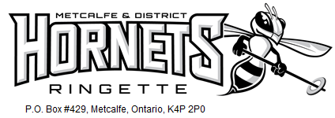

TEAM NAME

Dear NAME,

The Metcalfe & District Ringette Association (MDRA) is a community-based organization located in the southern rural area of Ottawa with players between the ages of 4 and 18, from Greely, Osgoode, Metcalfe and the surrounding communities. Last year MDRA had 12 teams plus a strong Bunnies program and a total of 180 players on the ice. Our organization is continuing to grow and we are looking forward to having even more youth playing ringette in 2017-2018.

The Ringette philosophy is to provide participation in team sport which encourages the physical, mental, social and moral development of individuals within the highest standards of safety, sportsmanship, personal excellence, and enjoyment.

Our TEAM NAME team is an advanced-skill level team that will play in the National Capital Region Ringette League and will participate in local and away tournaments across Ontario. This year’s Provincials will be held in CITY, Ontario on DATE.

With the additional ice time and tournament fees required to compete at this level, it costs approximately $500 per player (this is in addition to player’s annual fees, team fees and regular team fundraising activities). We are hoping that you can help us to bridge that gap through either a business sponsorship or individual donation:

Business Sponsorship: A minimum $250 donation earns your business name on one player’s jerseys (both home and away jersey) as well as we will display your company’s logo on our team website and at our Metcalfe Tournament in November. All corporate sponsors receive a team thank you plaque to proudly display their community support and valued contribution to youth sport.

Individual Donation: No set minimums, as every donation helps to assist with the team budget. You will receive a receipt for any donation over $20.00 upon request.

We certainly hope you will consider becoming a valuable member of our team and the Ringette community through your generous sponsorship. Please feel free to contact us with any questions you may have.

Thank you for your consideration!

PLAYER NAME
C/O ParentA and ParentB Last name
613-XXX-XXXX
TEAM NAME
Metcalfe and District Ringette Association info@mdra.ca www.mdra.ca

