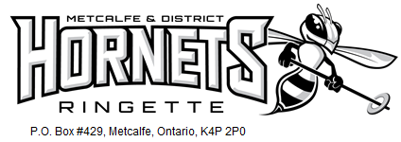

TEAM NAME

Dear NAME,

The Metcalfe & District Ringette Association (MDRA) is a community-based organization located in the southern rural area of Ottawa with players between the ages of 4 and 18, from Greely, Osgoode, Metcalfe and the surrounding communities. Last year MDRA had 12 teams plus a strong Bunnies program and a total of 180 players on the ice. Our organization is continuing to grow and we are looking forward to having even more youth playing ringette in 2017-2018.

The Ringette philosophy is to provide participation in team sport which encourages the physical, mental, social and moral development of individuals within the highest standards of safety, sportsmanship, personal excellence, and enjoyment.

Our TEAM NAME team plays in the National Capital Region Ringette League and will participate in local and away tournaments across Ontario, along with a Championship Tournament at the end of the season. With the high cost of ice time, tournament registration fees and association dues, ringette can become a very costly endeavor. We are hoping that you can help us to bridge that gap through either a business sponsorship or individual donation:

Business Sponsorship: A minimum $250 donation earns your business name on one player’s jerseys (both home and away jersey) as well as we will display your company’s logo on our team website and at our Metcalfe Tournament in November. Corporate sponsors also receive a team thank you plaque to proudly display their community support and valued contribution to youth sport. (remove if your team does not plan to do this!)

Individual Donation: No set minimums, as every donation helps to assist with the team budget. You will receive a receipt for any donation over $20.00 upon request.

We certainly hope you will consider becoming a valuable member of our team and the Ringette community through your generous sponsorship. Please feel free to contact us with any questions you may have.

Thank you for your consideration!

PLAYER NAME
C/O ParentA and ParentB Last name
613-XXX-XXXX
TEAM NAME
Metcalfe and District Ringette Association info@mdra.ca www.mdra.ca

