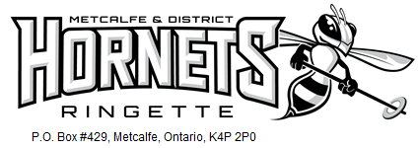

Dear [SPONSOR NAME],

I hope this message finds you well! On behalf of the Metcalfe and District Ringette Association (MDRA), I want to extend our thanks for your past support. Your sponsorship has made a meaningful impact, helping our athletes grow, develop, and thrive both on and off the ice.

As we prepare for the upcoming season, I am reaching out to valued sponsors like you to once again consider supporting our [TEAM NAME] team. Your continued generosity would go a long way in helping us cover essential expenses such as additional training sessions, tournament fees, travel costs, and team-building activities that contribute to a positive and enriching experience for our players.

Our team is dedicated to fostering a positive and encouraging environment for young athletes to develop skills, teamwork, and a love for ringette as well as important life skills such as leadership and resilience. We believe that the lessons learned on the rink extend far beyond the game, shaping our athletes into well-rounded individuals.

If you are interested in sponsoring the team, we offer the following in recognition of your generosity and to showcase your commitment to supporting the team.

Business Sponsorship:
Donations of $250 or more earn your business's name on one player’s jerseys as well as we will display your company’s logo on our team website and at our Metcalfe Tournament in November. Corporate sponsors also receive a team thank you plaque to proudly display their community support and valued contribution to youth sport. [Remove if your team does not plan to provide a plaque]

Individual Donation:
We appreciate all contributions. A receipt for any donation over $20 is available upon request.

With your continued support, we look forward to another successful season and the opportunity to give youth athletes in our community a chance to discover and grow through ringette. If you have any questions or would like more information, please don’t hesitate to reach out.

Thank you for your time and consideration!

[PLAYER NAME
C/O ParentA and ParentB Last name
613-XXX-XXXX
TEAM NAME]
Metcalfe and District Ringette Association info@mdra.ca www.mdra.ca

