TEAM MANAGER’S MANUAL

TEAM MANAGER’S MANUAL

The Team Manager is a central figure in creating the flow of communication – not only within the team (players, parents and coaches), but between the team and all support systems such as the Minor Hockey Association (MHA), Commissioners, other teams, referees, officials, etc. Simplistically, a team is like a small business with the coach being the CEO and the manager being the CAO. Ultimately, the manager is responsible for ensuring all the off-ice tasks are completed. This does not mean that the manager has to do it all; he or she needs to make sure that it gets done via delegation. Also, it should be noted that some coaches will take on some of the activities that the manager is normally responsible for overseeing. By taking on the operational aspects of the team, the manager enables the coach to focus on player development and on-ice instruction to provide the players with rewarding hockey experiences. This manual provides information to aid Team Managers in the smooth operation of the team by discussing the need to delegate and by identifying key topics that the Team Manager will need to address. Numerous appendices including samples, templates and a glossary of terms are included to assist the Team Manager in pre-planning and organization.

Required certification as per SHA for the manager is Respect in Sport – Activity Leader. This certification can be obtained by visiting www.sha.respectgroupinc.com.

Table of Contents
I. TEAM MEETINGS.............................................................................................................................................1
II. VOLUNTEERS / DELEGATION....................................................................................................................2
III. TEAM RULES / SAFETY...............................................................................................................................3
1. CODE OF CONDUCT................................................................................................................................................3
2. DISPUTES...............................................................................................................................................................3
3. EQUIPMENT / APPAREL .........................................................................................................................................3
IV. RECORD KEEPING / DISTRIBUTION......................................................................................................5
1. TEAM REGISTRATION / ROSTERS ..........................................................................................................................5
2. CONTACT LISTS ....................................................................................................................................................5
3.MEDICAL INFORMATION.........................................................................................................................................5
4. PRACTICE / GAME SCHEDULES .............................................................................................................................6
5. GAME REPORT.......................................................................................................................................................6
V. ORGANIZING GAMES...................................................................................................................................7
1. PRE-GAME .............................................................................................................................................................7
2. DURING THE GAME................................................................................................................................................7
3. POST GAME ...........................................................................................................................................................7
VI. APPLYING FOR TOURNAMENTS..............................................................................................................8
VII. ORGANIZING TRAVEL ..............................................................................................................................9
1. TRAVEL PERMITS....................................................................................................................................................9
2. EQUIPMENT ............................................................................................................................................................9
3. ACCOMMODATION /MEALS....................................................................................................................................9
4. COSTS.....................................................................................................................................................................9
5. ARENA MAPS..........................................................................................................................................................9
VIII. TEAM FINANCES.......................................................................................................................................10
1. BUDGETING ..........................................................................................................................................................10
2. TEAM ACCOUNT ...................................................................................................................................................10
IX. TEAM ACTIVITIES.......................................................................................................................................12
1. FUNDRAISERS .......................................................................................................................................................12
2. PHOTOS.................................................................................................................................................................12
3. CELEBRATIONS .....................................................................................................................................................12
X. COACHES’ RESOURCES ..............................................................................................................................13
1. HOCKEY CANADA SKILLS DEVELOPMENT COACHING APP………..........................................................................13
2. COACH MENTORSHIP PROGRAM …………….......................................................................................................13
XI. SUMMARY......................................................................................................................................................14
Appendices…………………………………………………………………………………………………….15-44

Appendix List
APPENDIX 1: FAIR PLAY CODES
APPENDIX 2: FIRST PARENT MEETING OUTLINE
APPENDIX 3: PARENTS’ CONTACT & RESPONSIBILITY LIST
APPENDIX 4: PLAYER CODE OF CONDUCT
APPENDIX 5: PARENT CODE OF CONDUCT
APPENDIX 6: ABBREVIATIONS & ACRONYMS
APPENDIX 7: ROSTER
APPENDIX 8: TEAMS, CLUBS AND AFFILIATIONS
APPENDIX 9: TEAM CONTACT LIST
APPENDIX 10: ASSOCIATION CONTACT LIST
APPENDIX 11: PLAYER MEDICAL FORM
APPENDIX 15: INJURY LOG
APPENDIX 16: INJURY REPORT
APPENDIX 17: BLANK CALENDAR
APPENDIX 18: GAME REPORT
APPENDIX 19: GAME CHECK LIST
APPENDIX 20: STATS SHEET
APPENDIX 21: TRAVEL PERMIT
APPENDIX 22: BUDGET

I. Team Meetings

Team meetings are essential in the development of formal communication amongst a team and they encourage participation from all members. An initial meeting should be set up shortly following the formation of the team – for many this will be the first time they meet other players, parents and coaching staff. Ideally, the manager should be in place before the initial team meeting, which should also discuss the seasonal plans and preliminary budget. This helps to ensure that all parents understand the commitment, both time and financial (including tournaments), up-front and before the season commences. Also, the importance of a qualified Treasurer should be noted and team rules and safety should be introduced for discussion. There is much information to discuss at the beginning of the season, so it is up to the Team Manager to lead this meeting ensuring that the group stays on topic and does not exceed any time restrictions. Be sure that minutes from the initial meeting are taken and distributed to parents. These minutes may be useful when dealing with disputes or concerns later in the season. As well, have extra copies of any handouts or forms that need to be circulated to parents and players (such as Fair Play Codes – Appendix 1: Fair Play Codes). Having information in handout form for parents to take away will assist with the retaining of dates and details.

Once the First Parent Meeting has taken place, team meetings can be set based on the team’s need and desire for more meetings. Many sub-committees will form following the first meeting as well. Every Team Manager must delegate, it would be virtually impossible to perform all tasks alone. However, the Team Manager should be aware of or involved in the operations of these sub-committees and should pass along updates to the rest of the team. Should a volunteer not carry through with their tasks, this supervision and monitoring will ensure the problem is caught early on and dealt with based on team policy. Many of the duties covered in this manual will actually be carried out by the parent volunteers and not directly by the Team Manager.

A basic outline for the ‘First Parent Meeting’ is included in appendix two. Many of the topics listed in the outline will be discussed in more detail throughout the following sections of the manual. Appendix 2: First Parent Meeting Outline.

The team manager or parent designate may want to use social media as a form of communication. The ramp website or apps such as Team Snap are helpful tools that allow communication of game/practice schedules as well as other messages that need to be communicated throughout the season. Meadow Lake Minor Hockey, SHA, the NEAHL and the STEP leagues have very strict social media policies that will be enforced if the use of social media is abused. The MLMH social networking policy #23 can be found in the MLMH website.

II. Volunteers / Delegation

The most important thing the Team Manager can do is delegate – it is almost impossible for a Team Manager to do everything without help. Not only will the Team Manager’s stress levels decrease, but having parents take a hands-on approach with their child’s team will increase communication among the parents. A strong parent base will make for a strong team.
Most parents will be prepared to volunteer in some capacity; a good rule of thumb is that each family should take on at least one role.

Additionally, the manager will want to ensure that the volunteers (and players) are in a safe environment when performing their tasks. Meadow Lake Minor Hockey has a policy in place for criminal record checks. The Team Manager will need to collect any required criminal record checks.

Once committees and areas of responsibility have been determined, the Team Manager should circulate a schedule and a parents’ contact / responsibility list to all parents. This could help resolve disputes later in the season, and helps direct information and ideas to the proper party. Appendix 3: Parents’ Contact & Responsibility List.

If possible, it is a good idea to put someone new to a position with a veteran when creating the volunteer schedule. Further, for game volunteers or shift-work roles, a course of action should be discussed or distributed regarding whom the parent is to contact should they no longer be able to work one of their shifts – e.g. the parent may be responsible for swapping shifts or finding their own replacement. The Team Manager should be prepared on occasion to fill in when someone must cancel. If people are consistently not fulfilling their roles, the Manager will need to ‘step in’.

Parent Volunteer positions may include:
• Treasurer
• Jersey Care
• Games Volunteers (time keepers, stats sheets, 50/50 ticket sellers)
• Team Safety Person
• Post-Ice Snacks
• Phone/Communication/Email list
• Tournament Committee / Tournament Finder
• Fundraising Coordinators
• Social / Events Committee (celebrations, photos, etc.)

III. Team Rules / Safety

The Team Manager and the coaching staff should discuss team rules and safety procedures at the beginning of the year with both the players and the parents (at the first parents’ meeting). A copy of the rules should be signed by the coaches and circulated back to the team. The most important thing to remember when dealing with team rules is to be fair, progressive and consistent! Further, the Manger and team needs to keep in mind that when dealing with minor hockey most players have other activities/priorities along with hockey, so conflicts and absences are to be expected. The level of commitment will vary with age, level of the team, etc. When implementing rules, explain the significance of the rule to the team and the consequence for not abiding by it. When enforcing rules, everyone on the team must be treated equally or team unity will break down.

1. Code of Conduct
Having a set code of conduct will ensure consistency when dealing with any team issues that may arise. The Code of Conduct should be discussed as part of the expectations for parents and players during the first parent meeting, and a finalized copy should be distributed among all team members. It is a good practice to have parents and players sign a copy, showing that they are committed and will take responsibility for their actions should a dispute arise during the season. A Code of Conduct is for both the parent and player have been included as Appendix 4 and 5.

2. Disputes
There may come a time where a Team Manager will have to act as a liaison between the team parents and coaches to resolve disputes. The parent should be comfortable knowing they can bring concerns to the Team Manager for any reason - equal playing time, coaching tactics, harassment, etc. The Team Manager should work with the coach and parents to first try to resolve disputes at the team level. Open communication, consistency, and mediation by the Team Manager are key. If a dispute cannot be resolved at the team level, the Team Manager should contact their Association for the appropriate next step. No person may question the decision of a coach or team officials or confront a coach or team officials before, during or after a game or practice if the intent of the conversation may lead to a volatile or confrontational situation. The persons involved must wait a minimum of 24 hours after the game or practice to address the situation. If the situation requires immediate attention, the Executive Committee shall be contacted to intervene.

3. Equipment / Apparel
Game Jerseys. The Team Manager will be responsible for the care of the team jerseys. They will want to ensure that both home and away jerseys are present at all games. A volunteer position can be created to delegate this responsibility to a parent who will organize jerseys, collect them after games and wash them between games.

Water Bottles. Discuss what the water bottle policy will be at the beginning of the season. It is
recommended that each player has his or her own water bottle that they bring to practices and games.

Other Equipment (pucks, first aid kits, etc.). The team will be assigned equipment from the Association the Team Manager will need to discuss with the Association what the responsibilities of the team will be for caring for that equipment; then the Team Manager may be able to delegate some of these responsibilities to parents.

Dress Code. If applicable, the Team Manager should discuss the dress code with players and parents at the beginning of the year. Player’s should be dressed in a respectful manner for games, but as a team you will want to consider issues such as cost, sponsors and relevance for your team. For example, if the team does a warm-up prior to games, the dress code may be tracksuits. The need for a dress code may vary based on age, competitive level, etc.

IV. Record Keeping / Distribution

The Team Manager is the keeper of the Team’s personal information. Because one never knows when a specific piece of information is needed, it is a good idea for the Team Manager to create a binder of forms and handouts that can be taken to meetings, games, etc. to keep data easily accessible. Documentation will have to be completed following all games as well, and it is a good idea to have extra forms on hand. The team manager will want to become familiar with hockey terminology and acronyms to aid in reading and filling out forms properly. Appendix 6: Abbreviations & Acronyms.

Documents to include in a binder:
• Roster
• Contact lists
• Player medical forms (in a confidential folder within the binder)
• Forms (game reports, injury reports)
• Schedules (practices, games and parent volunteers)
• Notices
• Arena information
• Committee updates
• Current financial information

1. Team Registration / Rosters
A roster should be given to the Coach from the Registrar once registration has been completed. While the coach should have a copy for each game, it is a good idea to have a spare in the Team Manager’s records. Referees have the right to review the roster if any player disputes arise. Tournaments may also require this information. Appendix 7: Roster.

Any questions regarding registration should be directed to the Registrar or the President.

2. Contact Lists
Parents’ Contact / Responsibility List. Having the parents’ contact / responsibility list available can aid the Team Manager during disputes by acting as an outline for where responsibilities lie. Distribution of the list at the beginning of the season allows it to be used by other team members to contact the proper party with questions or ideas, without first having to direct everything through the Team Manager. Prior to distribution, the Manager will want to ensure that a team email protocol or process has been developed that is agreed to by everyone; this will help prevent negative comments and gossip. Appendix 3: Parents’ Contact & Responsibility List

Team Contact List. The Team Contact list should be distributed at the beginning of the season to encourage open communication within the team. It is a good idea to have extras on hand for parents who have lost their copy or to be able to easily look up a player should they need to be contacted on short notice, for example: to track down why a player is late for a game.
If the Team Manager is approached by a scout or other individual requesting a team list, it is important that the Team Manager respect any privacy regulations. This is true when dealing with any form of personal information. When dealing with an information request, the Team Manager could reverse the situation. Have the scout provide their contact information which can then be passed along to the player that is being inquired about. The player and his or her family can then decide if they wish to contact the scout. Appendix 9: Team Contact List.
Association List. If an Association Contact List is not provided to the team at the beginning of the season it is a good idea as Team Manager to create one. Having this information readily available will make it easier to get any questions through to the appropriate person. Appendix 10: Association Contact List.

4. Medical Information
Each player / parent should fill out a medical information sheet. While it is important for coaches and staff to review this information, and be aware of any medical concerns, it is not likely they will remember every detail about every player. Having the medical sheets close can provide important information in the case of an emergency, as well as provide contact information for family physicians and emergency contacts when the parents are unavailable. Coaches also need to fill out the medical form. Appendix 11: Player Medical Form.

At the very least, the medical information form should include:
• Player’s Health Care Number
• Doctor’s name and contact information
• Emergency contact information
• Important medical conditions / allergies

The use of a team injury log provides the Team Manager or Safety Person with medical updates based on injuries that take place throughout the season, after medical forms have already been filled out. The log ensures that the most current information is available should the needs arise, as well, the log may detail how to manage current team injuries (for example, does an injury require taping prior to a game?) and act as a quick reference to injury reports that have been filed throughout the season. Appendix 12: Injury Log.

6. Practice / Game Schedules
The Team Manager, in coordination with the coach and the Association, should create and provide parents with a practice and game schedule at the beginning of the season; followed by monthly updates highlighting any alterations. If a change is made with short notice it is best to phone parents (use the parent volunteer phone tree if one is set up) rather than email to ensure the message has been received. Appendix 17: Blank Calendar.

7. Game Report
Following each game, the home team is required to submit the game sheet to the via email within 24 hours to the league representative. Before submitting a game report, it must first be signed by the referees and by both teams. Note that some Associations may only use a scorer's game sheet. Appendix 18: Game Report.

Game reports have multiple purposes:
• Evaluation for the seeding round
• Determine positions for playoffs
• Identify suspensions in the case of a major penalty
• Used for posting official standings (website)
• Report to media

V. Organizing Games

For a game to run smoothly and follow all regulations, the Team Manager must not only monitor what is happening during the game, (such as off-ice conduct), but they must put in time prior to each game to ensure all positions are staffed. Tasks can be divided in to pre-game, during game, and post game. Appendix 19: Game Check List. Please note that for all exhibition games the manager must submit an exhibition game application form to SHA in advance of the game. This application can be completed and filed through the SHA website. Any financial transactions have likely been delegated to the team’s treasurer.

1. Pre-Game

Prior to the game the Team Manager has many duties:
• Check dressing rooms and secure;
• Organize volunteers and train if necessary.
- This could include stats sheets, game clocks, selling 50/50 tickets, etc. Appendix 20: Stats Sheet.
- Volunteers need to be alerted to the schedule well in advance and there should be a policy in
place that volunteers can use to fill their position if they have to cancel, for example: swapping shifts, contacting the Team Manager within a certain time frame, etc.

2. During the Game
During the game, the Team Manager’s main role is supervision. This may include:
• Fill in for a volunteer parent if they need a break;
• Monitor off-ice conduct of players and parents;
• Frequently check that the dressing rooms have remained secure.

3. Post Game
The Team Manager’s post game duties include:
• Ensure rink has been left in good condition (dressing rooms);
• Submit the game report to the League;

VI. Applying for Tournaments
At the beginning of the season the division as a whole may decide to host a home tournament. A committee consisting of parents from all teams taking part in the tournament should be formed to handle the organization of the home tournament. Discussions with the division commissioner should also take place to schedule ice.

Before deciding to attend a tournament, the team should consider the following issues:
Time Restrictions
-What dates work for the team?
-Will the tournament fit into the team’s regular schedule?
-When do fees need to be paid?

Costs
-What funds would have to be raised?
-Travel (transportation, permits)
-Entrance fee

Competition
-Will the tournament present the team with the right level of challenge?

Format
-What will the set-up be: how many games, round robin, play-offs, overtime, etc.?
-How many games is the team guaranteed?
-What is the set-up? Any unique rules?
-Is same day travel an option or is accommodation required?

Other
-Is there adequate accommodation nearby?
-What other activities are available to teams during down time?
-What prizes/extras does the team receive?
-Does a team roster need to be sent or any other documents?

VII. Organizing Travel

Whether for games, tournaments, or events, the Team Manager will have to be aware of issues
surrounding team travel. The parent’s are responsible for ensuring their child is on time, and team rules will likely be in place for those that arrive late for games and practices. However, there are many situations that can require more attention to travel plans, for example: traveling as a group on a bus, traveling to a tournament outside of the team’s area, overnight travel, etc.
Travel should be included in the discussion of extra games / tournaments that takes place during the first parent meeting. The team will need to come to an agreement on what means the team will use to travel and how extra costs, such as hotels, gas and meals will be paid for – whether by parents or through fundraising. Prior to team travel the Team Manager should determine if any of the following issues are applicable to their team.

1. Travel Permits
Permits will be required for a team to play in games or tournaments outside of the province. If required, permits can usually be obtained in advance from SHA. Appendix 21: Travel Permit Sample.

2. Equipment
Due to space, players and parents traveling with the team may need to be given luggage restrictions. The Team Manager will need to ensure that the method of travel has adequate storage for the players’ hockey equipment. Also, the Manager should inquire/confirm with the hotel regarding equipment storage, including size, cost, etc.

4. Accommodation / Meals
If the team is traveling to a destination that will require an overnight stay, or meals, the Team Manager will need to book space in advance so that hotels and restaurants will be prepared to accommodate a large group. The Team Manager will also want to familiarize him or herself with any players’ allergies and notify the kitchen if a team meal is prepared.

5. Costs
How is the travel being funded? This should be decided prior to committing to any travel arrangements.

6. Arena Maps
If the destination is not familiar to the team, it is a good idea to print off an arena map and contact information prior to heading out.

VIII. Team Finances

The Team Manager is also responsible for the team’s finances; however, it is a good idea to appoint a Team Treasurer so that one individual is able to focus on this important area. The Team Treasurer is responsible for collecting, banking and distribution of all funds. It is important to identify a qualified Treasurer as the need for proper budgeting and accurate and timely reports are essential.

1. Budgeting
Budgeting issues should be discussed with the parents at the beginning of the season to ensure that team expectations are reasonable. Determine what expenses cannot be avoided, what additional activities the team would like to participate in and their additional cost to the team and then, how the necessary funds will be raised and distributed. Various budget spreadsheets are provided in the appendix to aid in number crunching. Appendix 22: Budget.

Expenses. There are numerous expenses that the team should be aware of when budgeting. It is a good idea to provide a small cushion in the funds should something unexpected arise.
• Games / practices
• Events / tournaments
• General operations
• Miscellaneous payments

Income. In most cases, it is up to the team to raise their own funds. Fundraising efforts should be determined on need and parents’ commitment. Fundraising is discussed in more detail in section IX, Team Activities. Team members may also pay team fees; it is the responsibility of the Manager to inform members of these fees, as well as collect them. At the beginning of the season there should be a clear outline of:
• How much the fees are
• What will be covered and will not be covered by the fees
• Payment options
• Deadline for paying the fees and consequences for late payments
• Who the fees must be paid to

2. Team Account
A team account will be provided by the Association at Innovation Credit Union with a starting balance of approximately $40. This amount should also be left in the account at the end of the year.

When working with a team account it is especially important to implement numerous checks and balances to ensure that the funds are managed based on the team’s agreed upon budget, and to ensure that funds are in no way misappropriated.
Checks and balances may include:
• Ensure that the account requires two signatures. Generally, the signature of the Treasurer
and a parent. The two individuals (and any others that have signing authority) should not
have a personal relationship or connection outside of the team. This separation of duties
means that no single person is responsible for a transaction from start to finish.
• The Team Manager and the parents should receive a copy of the account’s monthly
statement and they have the right to ask financial questions at any time as it is their money in
the account.
• Any unforeseen payments that arise should be discussed with the parents before any
transaction takes place.
• Ensure receipts are obtained or a copy provided for all transactions that take place. In
general, receipts should be numbered in order for easy tracking and should contain the
following information:
- date of transaction;
- service rendered / purpose of payment;
- company owing payment;
- company receiving payment;
- signature of individual accepting payment;
- amount;
- form of payment.
• When writing a cheque, the description line should always be filled out; and, if one is
available, write the invoice number on the cheque.
• Δο νοτ ωrite cheques made out to cash

IX. Team Activities

The off-ice activities of the team can have a great impact on how a season unfolds. Some activities may be decided upon from the very start, such as fundraisers and team photos. Others may be more impromptu, such as team celebrations. Regardless of the goal, each activity is a great way to build team spirit. When organizing team activities note that some on-ice and off-ice activities need to receive approval from the Association as a sanctioned event to ensure insurance coverage.

1.Fundraisers
Almost every team will have to raise funds throughout the season. All teams MUST sell the MLMHA discount cards as their first fundraiser, a minimum of one per player. No team will be able to do any other fundraiser without prior board approval, with the exception of male and female ‘AA’ midget, NEAHL and carded teams. As a team, it is important to discuss what set costs and what extra costs the team will face throughout the year. The Team Manager needs to ensure the team’s goals are reasonable and that the team has the ability and dedication to perform the chosen fundraising initiative. The team should decide on a per player basis the number of cards required to be sold and whether minimum participation levels are required/expected, etc.

2. Photos
Often photographers and photo sessions are organized by each team. The Team Manager will need to liaise with the photographer and pass the information on to the team.

3. Celebrations
Team celebrations, planned or impromptu, are a great way to increase team spirit. The Team Manager’s role is to ensure that all team members are included in the event and that the team continues to act in a respectful and sportsman-like manner as long as they are representing the team in public. As well, if team funds have been committed to the event, the Team Manager or Treasurer will need to make any necessary payments. Other off-ice events for team building include Holiday parties, pizza parties, movies, bowling, gym training, swimming, etc.

Year End Wrap-Up Party. A year end wrap-up party is a great way to thank all the parent volunteers and coaching staff for their dedication and assistance throughout the year. The team may want to consider creating or purchasing a thank you card / gift for those volunteers that went above and beyond to help the team. A final financial report should be presented at the year end (should be done even if there is no planned party), along with any rebates to players, and the bank account should be closed. This brings final closure to the season.

X. COACHES’ RESOURCES

- Hockey Canada Skills Development Coaching App

The Hockey Canada Network gives coaches and players the tools to succeed with drills, skills, videos, practice plans and articles on your tablet or phone.
Your subscription will provide you with access to:
• More than 1,500 drills, each including a drill diagram, video demonstration, skill description, key teaching points and a Team Canada game clip highlighting how each skill is used.
• Hundreds of coach skill video demonstrations.
• The entire Hockey Canada Skills of Gold collection.
• Hockey Canada Skills Manuals, including 32 lesson plans for each level.
• TSN World Juniors drills from 2010 to 2019.
Subscription holders will also have the ability to create, customize and share Training Plans and will receive Hockey Canada’s recommended Drills of the Month specific to their program level at the start of each month.
Canadian minor hockey coaches should reach out to their member branch or minor hockey association for additional information prior to purchasing a subscription.
Subscription Info:
• Download the app and try it absolutely free.
• For complete access to every video, article and drill, subscribe to the Hockey Canada Network for $5.49/month or $47.99/year through the app.
• Subscriptions automatically renew unless auto-renew is disabled at least 24 hours before the end of the current period.
• Your account will be charged for renewal within 24 hours prior to the end of the current subscription period, and will identify the cost of the renewal.
• No cancellation of the current subscription is allowed during active subscription period.

• U7 • U13
• U9 • U15
• U11 • U18
• Goaltender • Half-Ice

App cost is approximately $50/year and is available for order at Hockey Canada’s online store, Breakaway (www.hockeycanada.ca), or by calling 1-800-667-2242.

Copies of these manuals can also be found in the Minor Hockey office located in the Meadow Lake Arena.

- Coach Mentorship Program
Contact a Board member if you are interested in this program.

XI. Summary

The Team Manager’s role is crucial to the successful operation of the team’s season. The Manager acts as a central source of communication by implementing a strong communication philosophy between themselves, the coach, parents, players and all participants. Both the ability to work well with a variety of people and the ability to maintain a fair and consistent outlook are strong managerial attributes that will help to maintain communication between all members throughout the season. While the Team Manager’s role is one of in-depth involvement – from safety planning to financial planning to reporter to event organizer – there is no reason to become overwhelmed. The team is there to support and, through delegation, a ‘divide and conquer’ approach can be extremely efficient. Focus on the primary roles of organizing, planning and overseeing, take advantage of all available materials, such as the appendices and websites listed in this manual, and the season can be a successful one.

Appendix 1. Fair Play Codes
Players
* I will play hockey because I want to, not just because others or coaches want me to.
* I will play by the rules of hockey, and in the spirit of the game.
* I will control my temper - fighting and “mouthing off” can spoil the activity for everybody.
* I will respect my opponents.
* I will do my best to be a true team player.
* I will remember that winning isn’t everything - that having fun, improving skills, making friends and doing my best is also important.
* I will acknowledge all good plays/performances - those of my team and of my opponents.
* I will remember that coaches and officials are there to help me. I will accept their decisions and show them respect.

Parents/Guardians
* I will not force my child to participate in hockey.
* I will remember that my child plays hockey for his or her enjoyment, not for mine.
* I will encourage my child to play by the rules and to resolve conflicts without resorting to hostility or violence.
* I will teach my child that doing one’s best is more important than winning so that my child will never feel defeated by the outcome of the game.
* I will make my child feel like a winner every time by offering praise for competing fairly and trying hard.
* I will not ridicule or yell at my child for making a mistake or losing a game.
* I will remember that children learn best by example. I will applaud good plays/performances by both my child’s team and their opponents.
* I will never question the official’s judgment or honesty in public.
* I will support all efforts to remove verbal and physical abuse from children’s hockey games.
* I will keep any negative comments about players, volunteers, coaches, managers, officials, etc. to myself or discuss them in a rational manner with a board member, manager or coach as needed.
* I will respect and show appreciation for the volunteer Coaches who give their time to coach hockey for my child.

Spectators
* I will remember that participants play hockey for their enjoyment. They are not playing to entertain me.
* I will not have unrealistic expectations. I will remember that players are not professionals and cannot be judged by professional’s standards.
* I will respect the officials’ decisions and I will encourage participants to do the same.
* I will never ridicule a player for making a mistake during a game. I will give positive comments that motivate and encourage continued effort.
* I will condemn the use of violence in any form and will express my disapproval in an appropriate manner to coaches and league officials.
* I will show respect to my team’s opponents, because without them there would be no game.
* I will not use bad language, nor will I harass players, coaches, officials or other spectators.

Coaches
* I will be reasonable when scheduling games and practices, remembering that players have other interests and obligations.
* I will teach my players to play fairly and to respect the rules, officials and opponents.
* I will ensure that all players get equal instruction, support and playing time.
* I will not ridicule or yell at my players for making mistakes or for performing poorly. I will remember that players play to have fun and must be encouraged to have confidence in themselves.
* I will make sure that equipment and facilities are safe and match the players’ ages and abilities.
* I will remember that participants need a coach they can respect. I will be generous with praise and set a good example
* I will obtain proper training and continue to upgrade my coaching skills.
* I will work in cooperation with officials for the benefit of the game.

Appendix 2. Sample Agenda for Parent Meeting at beginning of season

Parent Meeting Agenda
Age Group xxx – Team xxx
September xx, 20xx

- Welcome and introductions (5 – 10 minutes)
-Introduce yourself (manager), coach, assistant coaches, trainer, etc.
-Give a brief explanation of the importance and purpose of the meeting.

- Coaching Overview (10 minutes)
-Have the Coach provide information on the goals and objectives for the season and his credentials and philosophy.

- Details of Program/Expectation for Players (10 – 20 minutes)
-With the Coach, present specific information on the operation of your hockey program.
-Discuss expectations of the player (and parents)
-“Fair Play” definitions
- Time commitment
- Respect for themselves, all players (own and opposition), referees, officials, parents, etc.
-Expected conduct – games, practices, locker room, events
- Discipline
-Let parents participate in deciding rules of parent conduct at games, team functions, etc.

- Budget (15 minutes)
- Outline expected costs
- Initiate fundraising discussions – will there be a fundraiser or will each family make a contribution
- Extra activities – social events, photos, extra tournaments, etc.

- Team Apparel (5 minutes)
- Discuss dress code
- Water bottle policy

- Expectations of Parents/Volunteers (10 minutes)
- Determine roles and responsibilities for parents (i.e. 50/50, jersey washing, etc.)
- Determine how conflicts within the team are to be resolved (what is the procedures)
- Determine rules for parents (e.g. no parents in dressing rooms, no coaching from the stands, etc.)

- Questions (5 minutes)

Appendix 3. Parents’ Contact and Responsibility List

Role | Name | Cell Phone | Email

Appendix 4. Player Code of Conduct

Players shall recognize that coaches, managers and other team officials are placed in a position of “loco parentis” (acting as responsible and reasonable parents) by the Association. As such they are charged with controlling and directing player behaviour both on and off the ice, at all hockey or team activities, while representing the Association. Players are, therefore, subject to disciplinary action at the team, league or Association level, should they exhibit behaviour that transgresses these guidelines/expectations.

Players shall:
(a) comply to and obey all reasonable direction of the coaching staff, manager and team officials, providing such direction does not transgress normal moral, ethical or religious standards;
(b) Protest unreasonable direction in a respectful, courteous fashion;
(c) Comply with all Association, League, Saskatchewan Hockey Association, Hockey Alberta (if applicable) and Hockey Canada rules;
(d) Demonstrate a positive attitude to the game, practice and learning in general;
(e) Arrive for games, practice and other team functions at the time specified by the team;
(f) Have all equipment (see policy# 6) maintained in good repair and ready for use prior to games and practice; returning any Association property to appropriate officials in a condition similar to that when issued other than normal wear and tear;
(g) Advise the appropriate team official if unable to attend a game or practice due to illness, injury or other commitment, well in advance of the activity;
(h) Demonstrate respect for coaches, game officials, teammates, opposing players/coaches and officials by refraining from profanity, verbal, physical or any other abuse (including physical gestures) at all times;
(i) Maintain dressing rooms in a clean and orderly fashion. Vandalism of any sort is expressly prohibited and shall be subject to appropriate disciplinary action;
(j) Dress cleanly and smartly for all team activities, recognizing that teams may specify a dress code (normally agreed at a team meeting, which does not place excessive financial burden on the player or parent/guardian);
(k) Refrain from the use of; or associating with those (excluding parent(s) or guardian(s)) who use; alcohol, tobacco, chewing tobacco, vaporized inhalation substances, cannabis products or other banned or illegal substances, while participating in a team activity on or off the ice;
(l) Recognize that they are subject to the authority of the team and the Association for the time spent in the arena before, during and after any game or practice, and for the full extent of any road trip from the time the bus leaves Meadow Lake until its time of return. Further, any road trip is a fully functional team activity and behaviour in hotels, restaurants and other arenas is to be consistent with these guidelines/expectations.

Appendix 5. Parent Code of Conduct

Parent/guardians and spectator responsibilities shall be centered on commitment and support.

1. Registering with MLMHA means not only a commitment to your child, but a commitment to the coaching staff and other players on the team. Parent/guardians must be committed to their team from the beginning of the season until the completion of the team’s hockey season.

2. Parent/guardians shall make every effort to ensure their child attends all practices, games and tournaments for the team and arrives at the time specified by the team. If a player cannot make a practice/game/tournament the manager or coach of the team must be informed with a valid reason. Invalid reasons can result in reprimand as decided by the coaches and manger of the team in consultation with the commissioner.

3. MLMHA will not tolerate inappropriate behaviour by Coaches, Managers, Assistants, Players, Parent/guardians, or fans. Such individuals will be subject to discipline as determined by the Disciplinary Committee.

4. Conduct of Spectators and Team Followers: Parent/guardians or spectators who are abusive to referees, game officials, players, team officials or other spectators will be subject to discipline as determined by the Disciplinary Committee.

5. Complete any courses as required by SHA or appropriate league.

6. One parent/guardian of each player MUST complete the Respect in Sport - parent course. Proof of completion must be presented at the time of registration with the exception of initiation parents/guardians who will have until October 31. Failure to comply with this policy will result in the suspension of the player from ALL ice sessions until proof of completion has been received. The course can be found on either the SHA or Hockey Canada’s website.

7. No person may question the decision of a coach or team officials or confront a coach or team officials before, during or after a game or practice if the intent of the conversation may lead to a volatile or confrontational situation. The persons involved must wait a minimum of 24 hours at the conclusion of the game or practice to address the situation. If the situation requires immediate attention, the Executive Committee shall be contacted to intervene.

8. Any parent/guardian/spectator ejected from a game for abuse or harassment must leave the arena. Failure to do so shall result in the RCMP being called. Any suspended person causing a disturbance at future games, while still under suspension shall be subject to further disciplinary action.

9. Remember hockey is for your child’s enjoyment and any negative comments/complaints about MLMHA, board members, coaches, managers, assistants, players, and parents/guardians shall be kept to yourself (including posts to social media) or brought to the attention of a board member in writing.

10. Transgressions of the Code of Conduct shall be subject to discipline as determined by the Disciplinary Committee.

Appendix 6. Abbreviations & Acronyms

HC Hockey Canada
SHA Saskatchewan Hockey Association
MLMHA Meadow Lake Minor Hockey Association
BCH British Columbia Hockey
HA Hockey Alberta
HM Hockey Manitoba
HN Hockey North
HNB Hockey New Brunswick
HNL Hockey Newfoundland and Labrador
HNO Hockey Northwestern Ontario
HNS Hockey Nova Scotia
HPEI Hockey Prince Edward Island
HQ Hockey Quebec IIHF International Ice Hockey Federation
ODHA Ottawa District Hockey Association
OHF Ontario Hockey Federation
OWHA Ontario Women's Hockey Association
ADC Athlete Development Committee
CAAWS Canadian Association for Advancement of Women in Sport
CAC Coaching Association of Canada
CDM Canadian Development Model
CHL Canadian Hockey League
HCRC Hockey Canada Regional Centre
HCSA Hockey Canada Skills Academy HDC Hockey Development Council
ICC International Coaches' Conference
IP Initiation Program
LTAD Long Term Athlete Development
MHA Minor Hockey Association
NCCP National Coaching Certification Program
NCMP National Coach Mentorship Program
NHL National Hockey League
NSST National Skills Standards and Testing
NWT National Women's Team
RIC Referee in Chief

Score Sheets / Game Abbreviations
A Assists
C Centre
D Defenseman
DvP Points Scored against Teams within Div
EN Empty Net
F Forward
FL Face-offs lost
FW Face-offs Won
FWP Percentage of Face-offs Won
G Goals or Goaltender
GAA Goals Against Average
GP Games Played
GW Game Winning Goal
HmP Points Scored on Home Ice
L Losses
LW Left-wing
NO Player Jersey Number
ODvP Points Scored against Teams outsidethe Division
OT Overtime
P/G Average Points Scored per Game
PIM Penalty Minutes
PK Penalty Kill POS Player Position
PP Power Play Goal
PPP Points Scored while on the Power Play
PTS Points
RdP Points Scored on the Road
RW Right-wing
S% Shooting Percentage
SA Shots Against
SH Short Handed Goal
SHP Points Scored while Short-handed
SO Shutouts
SOGS Shots on Goal
SV Saves
SV% Save Percentage
T Ties
W Wins

Appendix 7. Sample Roster
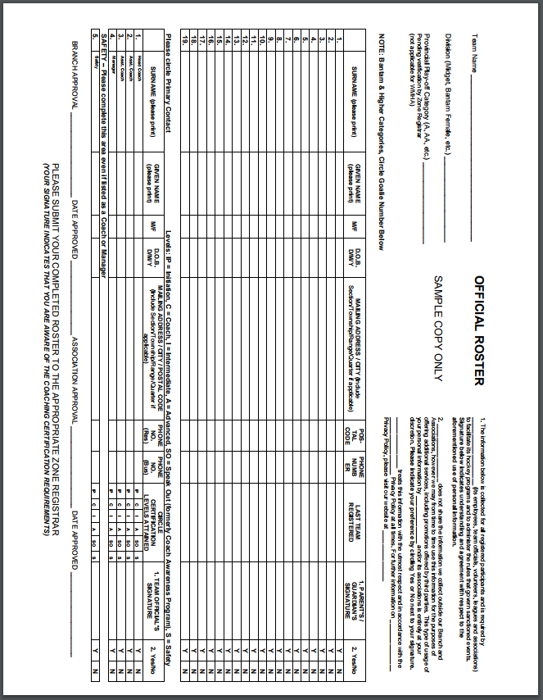
Appendix 8. Affiliations

1. MLMHA shall follow all SHA (see below) and league rules regarding player affiliations.
2. All player affiliations MUST be approved by the division commissioner before filing the form with SHA. Any conflict between the team manager and Commissioner shall be dealt with by the Board.
3. Any affiliated player MUST fulfill his/her responsibilities to his/her team before playing for the affiliated team.

6.06.01
a) For all purposes of affiliation regulations, Female teams may only affiliate players registered on female teams and Male teams may only affiliate players on male teams.
b) For a player to be affiliated they must be registered on a team.
c) A team may have affiliated with it one team or nineteen (19) players from a lower tier or age classification of hockey. At all times, a player may only be affiliated with one team.
d) A team cannot affiliate a team, or players from a team, that are registered in the same age classification within a league that they compete against.
e) For teams categorized as AA, the players must reside in the sponsoring center of the team to be affiliated with, or must be registered in the sponsoring center of the team to be affiliated with.
f) For teams categorized as A, B, C or D, the players must be registered in the sponsoring center of the team to be affiliated with or reside in one of the centers that make up the team and are registered in a lower age classification.
g) For Midget AAA hockey, teams based in Saskatoon, Regina and Notre Dame, may only affiliate players from within their Minor Hockey Association. For other Midget AAA teams, they may affiliate from their Minor Hockey Association and six (6) players whose parents reside within a 160-km radius of their sponsoring center 130 Minor with the exception of any sponsoring center of another AAA team from their respective league.
h) i) For Male Bantam AA hockey, teams based in Saskatoon and Regina may only affiliate players from within their Minor Hockey Association. For other Bantam AA teams, they may affiliate from their Minor Hockey Association and six (6) players whose parents reside nearest to the sponsoring center and also within a 120-km radius of their sponsoring center. If a player wishes to be AP’d to a AA team that is not their nearest AA center, they must obtain a release from all the AA centers that are closer to their residence than the center they wish to AP to.
ii) For Male Midget AA hockey, teams based in Saskatoon and Regina may only affiliate players from within their Minor Hockey Association. For other Midget AA teams, they may affiliate from their Minor Hockey Association and six (6) players whose parents reside nearest to the sponsoring center and also within a 160-km radius of their sponsoring center. If a player wishes to be AP’d to a AA team that is not their nearest AA center, they must obtain a release from all the AA centers that are closer to their residence than the center they wish to AP to.
i) A, B,C and D centers who have two or more Initiation Program teams registered, may affiliate players from one another for tournament and exhibition games only. The affiliate players may only be used if a team is unable to ice a team of eleven players. When affiliate players are used, the total on the team cannot exceed eleven (11) players.
j) In all categories of hockey, players must be notified of the intent to affiliate them. In Minor Hockey, the player’s parents and the player’s coach must be notified of the intent to affiliate them. 6.06.02 The names of affiliated teams and/or players must be filed with the General Manager prior to using an affiliate player(s). Additions and deletions can be made to the affiliation list up to January 10th once the affiliation form is filed.

6.06.03
a) i) Players registered on, of affiliated to, Midget AAA or Male Bantam AA categorized teams, shall be restricted to playing 131 Minor only ten (10) games as an affiliate all season until the team they are registered with has completed their season, upon which time they may play the remainder of the season with their affiliate team (this does not include tournament or exhibition games).
ii) Permanent affiliates are not permitted and are defined as a player who is registered on a team of a lower category or age classification for the sole purpose of being available to the team he is affiliated to on a full-time basis. iii) Goalkeepers are only charged with a game when they actually participate in the game. b) For players not registered on Midget AAA or Bantam AA categorized teams, or affiliated to teams categorized as Midget AAA or Bantam AA, the number of games shall be unlimited.

6.06.04
The official scorer shall request that all affiliated players, or players playing up, who are dressed for the game be designated on the game sheet by the use of the symbol “A.P.” after their name.

Appendix 9. Team Contact List
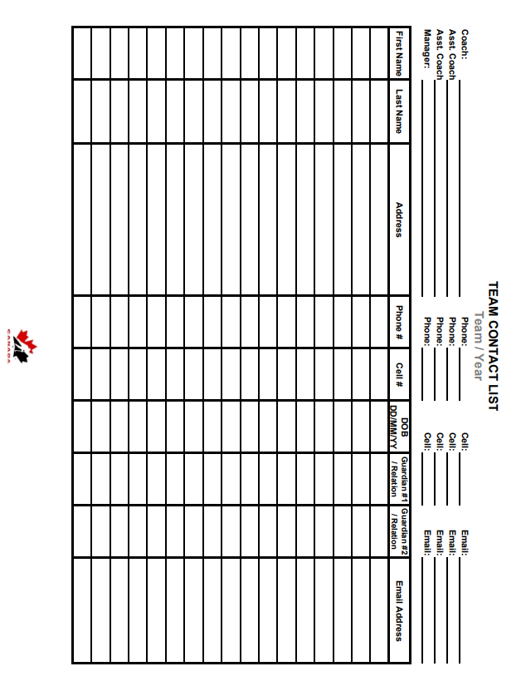

Appendix 10. Association Contact List for the 2019/2020 season

Jace Andersen
President
christie.jace@sasktel.net
306-240-8522

Regan Beck
Vice-President
regan.beck@norsask.ca
306-240-4600

Jeannie Kwasniuk
Secretary
jeanniekwasniuk@hotmail.com
306-304-7422/306-236-2697

Amanda Gutek
Treasurer
amanda.gutek@investorsgroup.com
306-304-1574

Gord Whittle
U7 commissioner
gordon.whittle@gmail.com
306-304-7973

Gwen Osborne
U9 commissioner
gkier@hotmail.com
306-240-8636

Karla Hansen
U11 commissioner
karla.hansen@rbc.com
780-515-0000

Gerry Green
U13 commissioner
greeng@sasktel.net
306-240-9448

Rodney Zuchotzki
U15 commissioner
rodneyz@sasktel.net
306-240-8030

Stacey Nolin
U18 commissioner
stacey.nolin72@gmail.com
306-236-8796

Stacy Groenewegen
Referee Coordinator
groenewegen2@sasktel.net
306-240-5888

Jennilee Spencer
Ice Scheduler
mlmhscheduling@gmail.com

Clay Debray
Director of Hockey Development
claydebray@hotmail.com
306-240-8786

Ryan Twidale
Director of Policy and Procedure
rtwidale@hotmail.com
306-240-7578

Jordan Hansen
Communications Officer
jordan.hansen@nwsd.ca
306-304-7409

Appendix 11. Player Medical Form
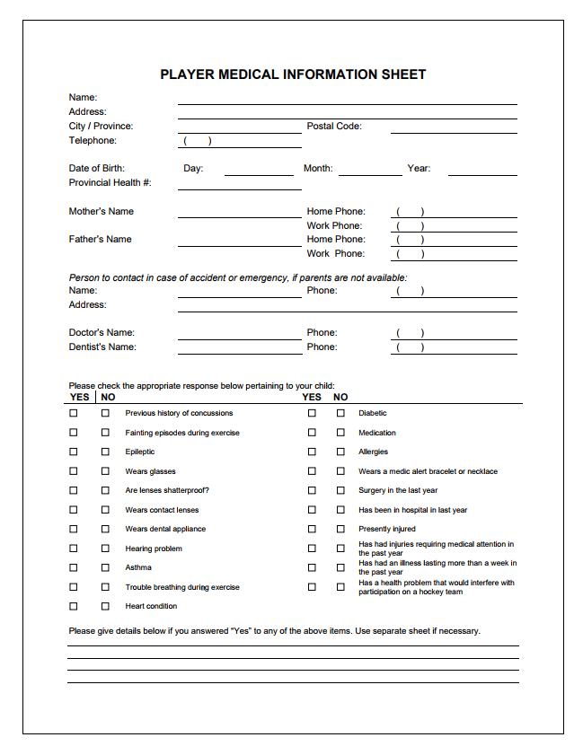

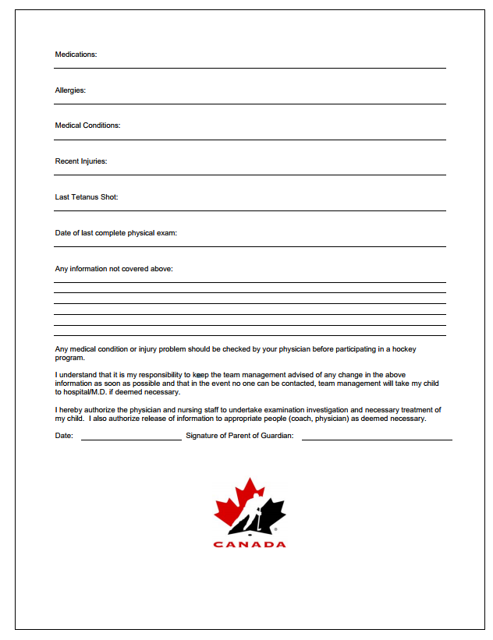

Appendix 15. Injury Log
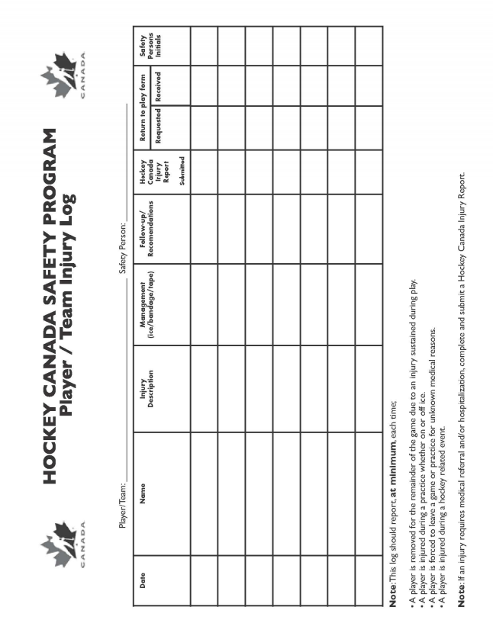

Appendix 16. Injury Report
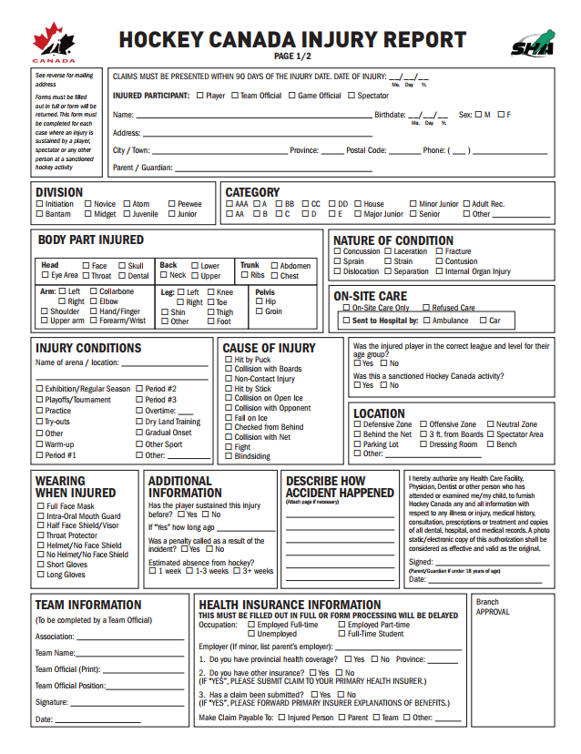

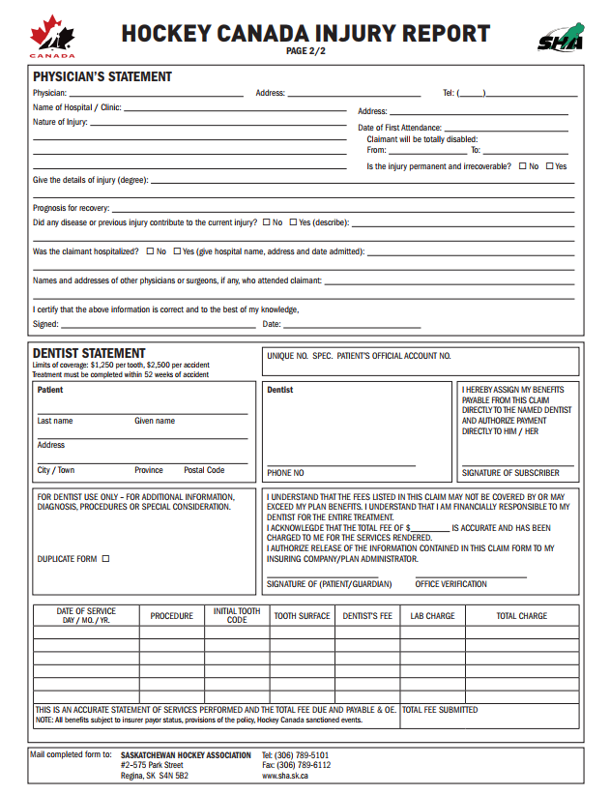
Form available on SHA website.

Appendix 17. Blank Calendar
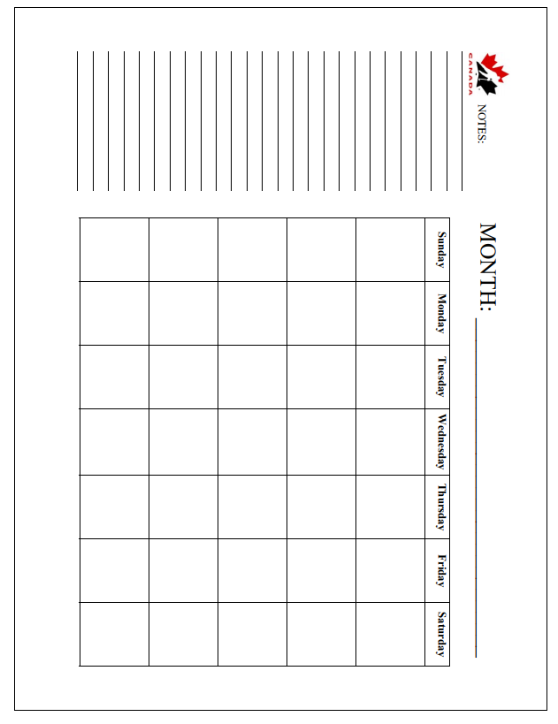

Appendix 18. Game Report
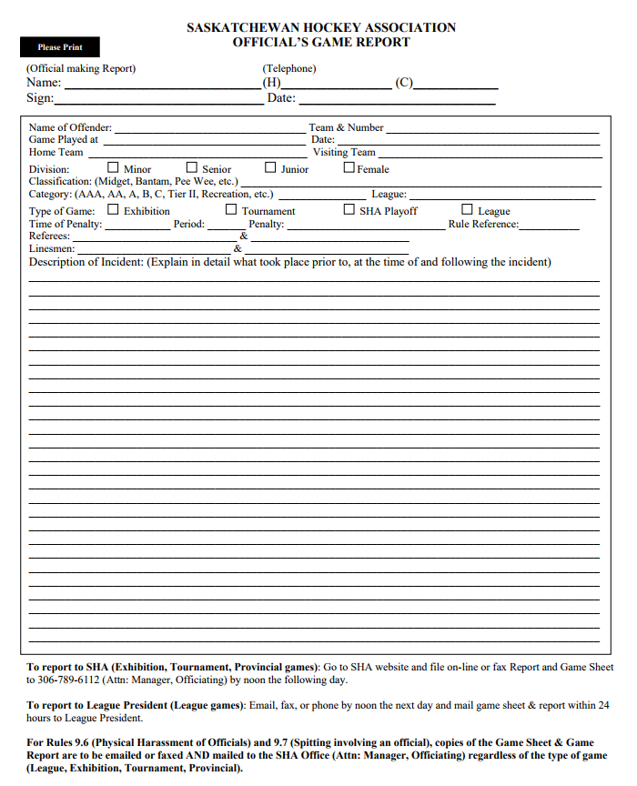

Appendix 19. Game Check List
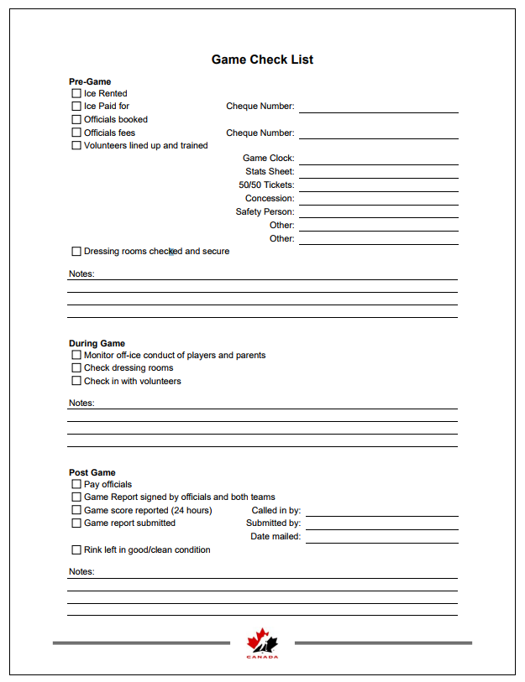
Appendix 20. Stats Sheets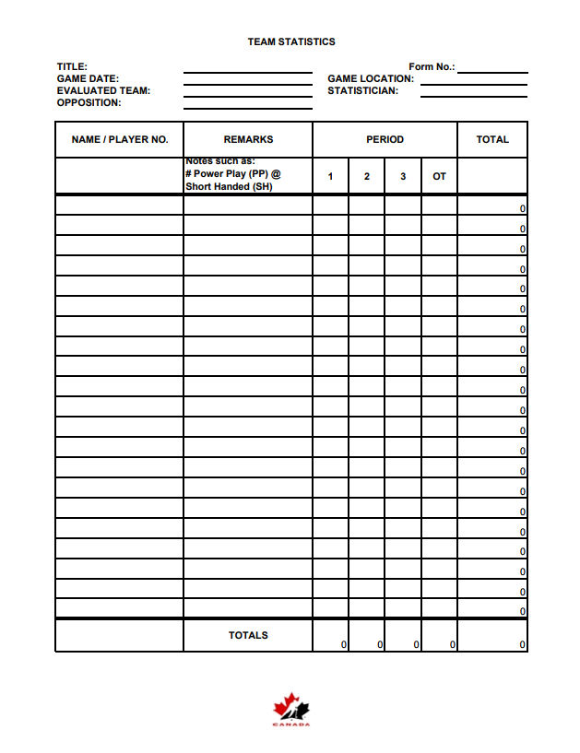

Appendix 21. Travel Permit
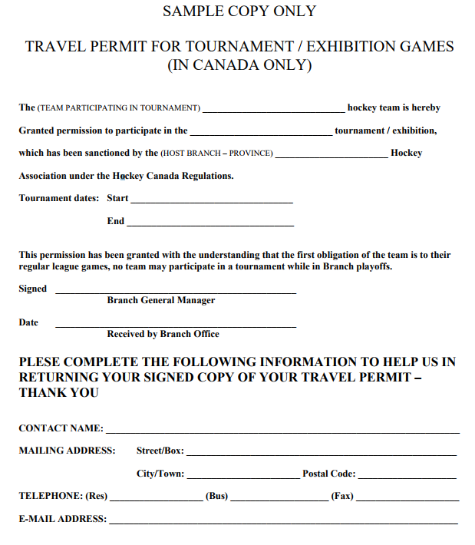

Travel permits can be obtained on-line through the SHA website.

Appendix 22. Budget
