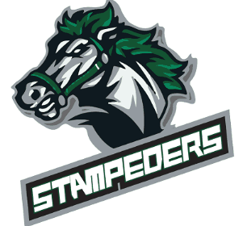
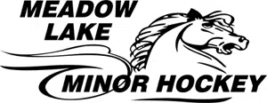

Social Media Policy
Intent
MLMHA endorses the use of local media, social media, email, newsletters, and the Association website for disseminating information to its membership and recognizing significant achievement. Advertising for registration, any tenders, fundraising events, community events, General Meetings or any special meeting shall be completed through the Association Administration. Any material of a sensitive or controversial nature shall be referred to the President or Executive Committee for approval prior to publication.
Procedures
- The Association shall hold the Executive Committee and all of its Members, players, Coaches, and Officials who participate in social media and networking to the same standards as it does for all other forms of media including radio, television, and print.
- Comments or remarks of an inappropriate nature which are detrimental, harmful, or malicious, in the sole opinion of the Executive Committee, to a team, the Association, or an individual Member or player, or another Association, team, or player, regardless of whether such comment or remark was made through Association social media channels or through an individual’s private social media channels will not be tolerated and may be subject to disciplinary action.
- The following are examples of conduct through social media and networking mediums that are considered violations of the MLMHA Social Media and Networking Policy and may be subject to disciplinary action by the team, MLMHA, the league and/or Hockey Saskatchewan:
- Any statement deemed to be publicly critical of Officials or disrespectful of MLMHA, team staff, players, or any Member.
- Divulging confidential information that may include, but is not limited to the following: player injuries, game strategies, or any other matter of a sensitive nature.
- Negative or derogatory comments about any other team, Association, league, and/or MLMHA players, Coaches, volunteers, spectators, staff, or Members.
- Any form of bullying, harassment, or threats against Coaches, players, spectators, or Officials.
- Photographs, video, or comments promoting negative influences or criminal behavior including but not limited to: drug use, alcohol abuse, public intoxication, hazing, sexual exploitation, etc.
- Online activity that contradicts the current policies of MLMHA or any of its member Associations.
- Inappropriate, derogatory, racist, or sexist comments of any kind.
- Online activity that is meant to alarm other individuals or to misrepresent fact or truth.
- All such offences may be dealt with by the Association in accordance with the disciplinary procedure set out in these Policies.

