Millet Minor Hockey Association Executive Meeting
August 3, 2021
Minutes

Attendance: Stephen Mardy, Bryana Mardy, Eric Brown, Ashleigh Barr, Noah White, Amy Dreichel

Absent: Cindy Kroetch, Tasha Brenneman, Hollie Brown, Matt Starky, Lindsay Petite

- Call to Order: Stephen called the meeting to order at 7:12pm
- Approval of Minutes: Bryana motioned to approve minutes as presented. Ashleigh seconded. All in favor – approved.
- Additions/Approval of Agenda:
Under New Business add:
b. Declaration of Teams
c. Tournament Date for Millet to Host
Bryana motioned to accept the agenda with the additional items. Eric seconded. All in favor – approved.

- Reports:
  - President – Stephen Mardy – No Report
  - Vice President – Hollie Brown – No Report
  - Treasurer – Lindsay Petite - No Report
  - Registrar – Bryana Mardy
    - Registration #’s as of Aug 3 meeting
      - U7 – 20 players registered
      - U9 – 21 players registered ( 1 female requested to play on female team)
      - U11 – 17 players registered ( 3 players asked for release, 2 – tier 2 tryouts, 1 female)
      - U13 – 8 players registered (5 players released for tryouts)
      - U15 – 10 players registered(5 players released for tryouts)
      - U18 – 5 players registered (2 players released for tryouts)
    - After having registration open for 1.5 months – it’s suggested to look into only having registration open for 1 month.
    - For U11 – looking to potentially have an over age player.
    - This year has been difficult to remind all players to register in Millet at their home site, a couple of families have moved and we have a few new families starting
    - We are needing Coaches – Ashleigh to make a facebook post.
Noah is going to look into setting up to coach as well.
    - Matt can you look into booking a coaching clinic in Millet

  - Ice Coordinator – Open Position (Stephen & Hollie)
    - Update from Meeting with Town
      - Signed the contract for the Ice Schedule
      - This years schedule:

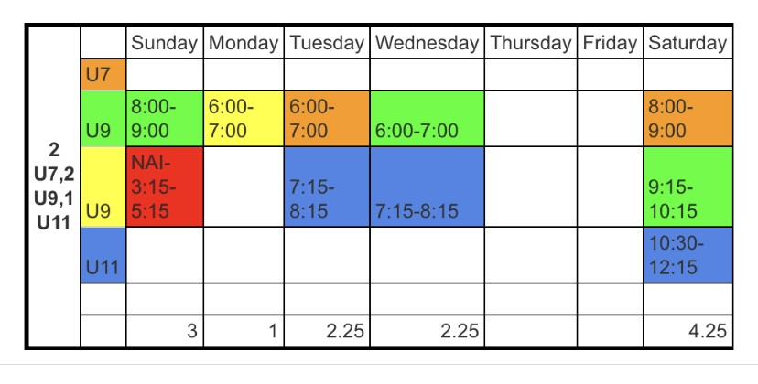

  - Referee in Chief – Noah White
    - Noah would like to have time on a Sunday for A Referee Clinic –will give us a Date
    - Would prefer it to be a Sunday
  - Public Relations – Ashleigh & Hollie
    - Post on Facebook – looking for Coachs, Refs and U11 coordinator
  - Equipment Coordinator – Eric Brown – No Report
  - Bingo/Fundraiser Coordinator – Cindy Kroetch – No Report
  - Coach/Player Development – Matt S – No Report
  - All Level Coordinators
    - U18 (midget) – vacant
    - U15 (Bantam)- vacant
    - U13 (PeeWee) - vacant
    - U11 (Atom) -vacant
    - U9 (Novice) – Tasha Brenneman – No Report
    - U7 (Initiation) – Ashleigh Barr – No Report
- Old Business:
  - Update on Player share with Wetaskiwin
    - Wetaskiwin proposed our U11 players come for a tier 2 tryout as they would like to field a tier 2 team. Then once the team is made any U11 players not on the tier 2 team would come back to millet.
    - U7 and U9 – we would make a house league to play games against but we van also still book games against other teams as well
    - Player movement forms will be filled out for U13, U15, and U18 for this 2021-2022 season only.
    - If wanting a release, they will now have to go through Wetaskiwin
    - Coaches can apply – They will have a coaches selection committee made up of Wetaskiwin: President, Vice President, Level Coordinator and Millet President
    - Millet President to sit in on all tiering of teams
Noah motioned to go into a Player Share/player movement for U13, U15, & U18 for the 2021-2022 season with Wetaskiwin. Ashleigh seconded. All in Favor – approved.
Steve will draft a letter and send to the parents
  - Rules and Regulations Committee update – no update
  - Ball Hockey Tourney Update
    - Looked into insurance – they would need to approve the waiver and would want a first aid tent. For one day is would cost $350
    - After having trouble finding a location and a date – Hollie proposes to table the Ball Hockey Tournament until Spring of 2022 as a kick off to our registration for the 2022-23 season.
    - Discussion to start in January 2022 for a potential June date. Kick off early registration and potential to use the arena.
Eric motioned to table the Ball Hockey Tournament for this year and start discussion in January 2022 to host in the spring of 2022. Ashleigh seconded. All in Favor - approved
  - Team Snap – tabled until Nov 2021

- New Business:
  - Release Requests
    - All Tier 1 AA/AAA releases have been approved
    - Tier 2 requests will be player movement forms to Wetaskiwin.
  - Declaration of Teams
    - In light of the registration numbers to date.
Bryana motioned to declare no teams for U13, U15 and U18 and to enter into a player share with Wetaskiwin. Ashleigh seconded. All in favor. Approved.

Player movement forms will be issued for all registered players for Wetaskiwin.
  - Millet Tournament Dates
    - Dates we have available to choose from:
      - Dec 3, 4 & 5, 2021 –Not using these dates
      - Jan 14, 15&16, 2022 – U11 tournament
      - Jan 28, 29 & 30, 2022 – Holding onto these dates
      - Feb 4, 5 & 6, 2022 – U9 tournament
      - Feb 18, 19 & 20, 2022 – Not using these dates
      - Mar 5&6, 2022 – U7 tournament
We need to let the town know which dates we have picked and if we make a change they need 2 weeks notice.
We choose to keep the extra weekend in January, 2022 for potentially two U9 tournaments, or the possibility of having a joint tournament with Wetaskiwin.

The Upcoming season starts Sept 20th, 2022

- Date of Next Meeting: Sept 13, 2021 @ 7pm Millet Scout Hall
- Adjournment: Stephen adjourned meeting @ 8:28pm

