Millet Minor Hockey Association Executive Meeting
Sept 20, 2025
Meeting Minutes

Attendance: Steve Mardy, Noah White, Jay Porter, Duane Klapstein, Daleen Shaver, Jacinthe LeBlanc, Trent Shaver, Felicia Kovacs, Corinne Urquhart, Natasha Brenneman, Bryana Mardy, Justin Gessner,
Ashleigh Barr

- Call to Order: 7:31
Approval of Minutes:
Moved: Justin Gessner
Second: Tasha Brenneman
Motion Carried

- Additions/Approval of Agenda:
U13 Coordinator would like to discuss financials
Moved Noah White
Second: Tasha Brenneman
Motion Carried

- Reports:
  - President – Stephen Mardy-
- Try outs have started.
- Mandatory 3 skates from Hockey Alberta.
- Acknowledge we have a learning curve.
- Both associations committed to doing their best for kids.

  - Vice President – Noah White
- Coaching applications coming in slow and steady. Evaluations and interviews started.
  - Treasurer – Natasha Brenneman.
    - Ice fees $7846.25. Note we did receive 2000 back for ice returns.
    - Currently locked out to changes and require paper work to be completed.
    - Bank Balances:
      - General Account:
      - Casino Account:
(Numbers as Of XX , 2025)
    - 2023-2024 Review/Audit – Jacinthe to file
    - 2024-2025 Review/Audit

  - Registrar – Jacinthe LeBlanc
- Update that the bad standing member has been paid.
- 79 Registrations received
- 6 In try out at other leagues
  - U7 -8
  - U9-17
  - U11 17
  - U13 17
  - U15 18
  - U18 7
  - For U7 we will send a welcome email soon once the ice slots are confirmed
  - Payments will be updated in the coming weeks.
  - Once Hockey Alberta approves over age we can adjust to that division fee.

  - Ice Coordinator – Darren Challaghan.
- Millet will bill at regular ice cost in credits once we know the mix of local vs non.
- Meeting with Wetaskiwin to plan ice this week.
- Brought questions forward in regard to how evaluations work. Found out the procedure on Wetaskiwin site

  - Referee in Chief – Open Position
    - Fill/Appointment for 1 year term

  - Public Relations – Ashleigh Barr
  - No Updates, except resharing Wetaskiwin information on social media.
  - Photographer Scott Molan was selected due to price and service with larger group. Memory mate and sing photo included for families.

  - Equipment Coordinator – Justin Gessner
    - Shelf is in arena and we need to plan what we need to store.
    - Once teams are finalized see if any kids need any equipment.

  - Bingo/Fundraiser Coordinator – Daleen Shaver
- AGLC Licence for our raffle tickets- 1 days of Christmas.
- Pay out $6000 in total.
- Color paper is half the price. $154.00 instead of $300. Will move forward with yellow.
  - Coach/Player Development – Trent Shaver No Report

  - All Level Coordinators
    - U18 – Jeff Cross No Report
    - U15 – Bryana Mardy No Report
    - U13 – Duane Klapstein
      - First round of evaluations went.
      - Next will be half practice, half scrimmage.
      - Next will be full scrimmage.
      - Groups will be shuffled based on groups
    - U11 –Ashleigh Barr– No Report. Offered help to Wetaskiwin, not needed.
    - U9 – Jason Porter
- Prep skates 16th, Tryouts on the 20th, 4 teams plus queens.
    - U7 – Felicia Kovacs–
      - Start date the 15th. Needs to be set up team snap and will communicate to parents’ tentative plan.

- Old Business:
- Bylaws still at lawyers waiting for signage.
- Player Share Update- nothing new. Try to do a joint meeting every couple months.

- New Business:
  - WhatsApp Motions:
- Ashleigh Motioned to continue the Teddy Bear Toss for the 2025/2026 season
- 12 in favor -1 opposed In Favor
- First come first served for ticket sales.
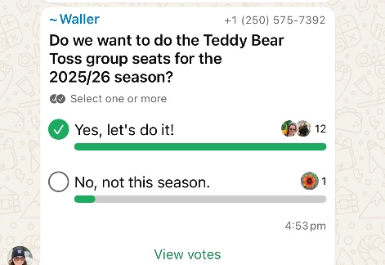

- Additions:
- Based on meet and great, with Wetaskiwin board we learned they do team funds different then Millet. Wetaskiwin pay funds post tournament. Parents pay up front and get reimburse after. This needs to be understood more and flushed out for Millet families.
- Multiple Concerns around development, we want to take ensure our kids get the development we are used to.

- Date of Next Meeting: October 20th 7 :30

- Adjournment:8:53OM

