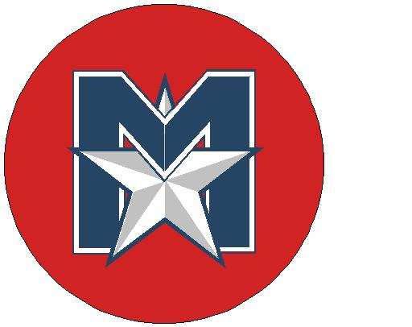
MISSISSAUGA MAJORS BASEBALL ASSOCIATION

ROOKIE BALL SPRING TRAINING CLINIC

Sat. May 11, 2019

9:00 am-12 pm @ LAKEVIEW WEST

Get back into the swing of things for the new season with throwing, catching, hitting and base running activities.

- $30 if registration received by April 29, 2019 or $50 if received afterwards
- Registration fee includes lunch and a Majors Spring Training T-Shirt
- You may register on the day of the clinic.

- 9:00am Registration @ Lakeview West
- 9:30am Players take the field
- 11:30-12 pm Lunch provided for players

------------------------------------------------------------cut along here and hand in with a cheque--------------------------------------------------------

ROOKIE BALL REGISTRATION FORM

PLAYER’S NAME ___________________________________________

YEAR OF BIRTH (circle) 2010 2011

DIVISION ____________________________________________

EMAIL ____________________________________________

HOME PHONE # ____________________________________________

EMERGENCY CONTACT ____________________________________________

PHONE # ____________________________________________

T-SHIRT SIZE YOUTH XS S M L XL ADULT S M L XL

Mail cheques payable to the MISSISSAUGA MAJORS BASEBALL ASSOC. to
Mississauga Majors, 1427 Myron Dr.., Mississauga, Ont. L5E 2N5

www.mississaugamajors.com

