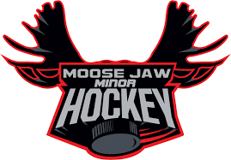

PROOF OF RESIDENCY

I / We, _________________________________________________________ parents or legal
guardian(s) of __________________________________________________________________,
currently reside at __________________________________________________________with the
player named above. (Full residential address, or land location required. No box numbers.)
Signature of parent / legal guardian ______________________________________________________
Signature of parent / legal guardian ______________________________________________________
Contact________________________________ Date_______________________________________

PLEASE SIGN AND RETURN THIS FORM ALONG WITH SCANNED PDF’S, PHOTOCOPIES OR HIGH RESOLUTION PHOTOS OF 2 OF THE FOLLOWING
• a current utility bill in your name (must include service address as well as mailing address)
• proof of school enrollment (U7,U9,U11 & U13 only. Cannot accept for U15, U18)
• current GST statement or income tax assessment
• homeowner/rental insurance statement
• if moving prior to start of season - a signed purchase/rental agreement with possession date
• if moving to a home under construction – a signed builder agreement with possession date
Please note that cell phone bills, and driver’s licenses will NOT be accepted as proof of residency.

This form and the above listed documentation are required to ensure that Moose Jaw Minor Hockey is in accordance with Hockey Saskatchewan regulation 3.01.19 regarding residency.
Return Completed form and supporting documents to:
E-mail to admin@mjhockey.com

