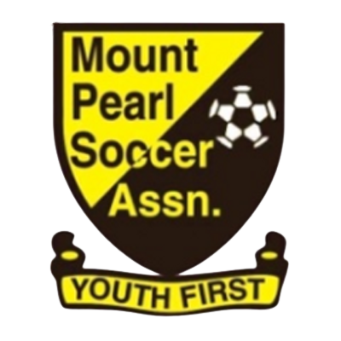
Mount Pearl Soccer Association
44 Arena Road, Mount Pearl, NL A1N 0J6

Coach Discount Policy

Mount Pearl Soccer Association appreciates the time commitment of all of our volunteers. We will provide the coaching staff of our Metro and PYL teams a discount on registration as a token of appreciation each year.
Who is Eligible
- One Head Coach, Assistant Coach, and Manager for each Metro team, to a maximum of three staff
- One Head Coach, Assistant Coach, Goalie Coach or Trainer, and Manager for each PYL team to a maximum of five staff in addition to the Head Coach
Criteria to Receive Discount
- Member must be approved by the Board as part of the coaching staff for the team
- Member must be in good standing
- Member must complete the full season in the position
Discount to be Awarded
- $100 for Head Coach
- $50 for all other Coaching Staff
Other information
- Discounts will be applied in the next calendar year upon registration
- Multiple discounts may be applied if a member is approved to work with more than one team
- No money will be paid directly to coaching staff
- If a member of our coaching staff does not have a child in the club, they will get a credit for the applicable amount for Club Merchandise.
- Junior coaches will receive a training shirt - not a discount
- This policy is to be reviewed and approved annually.

