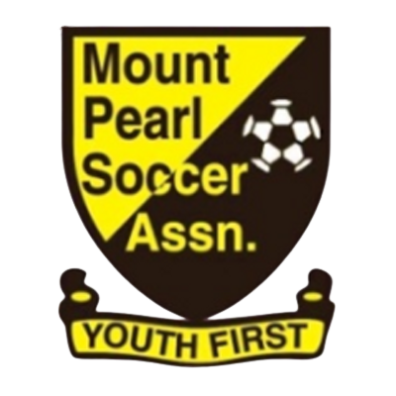
Mount Pearl Soccer Association
44 Arena Road, Mount Pearl, NL A1N 0J6

Concussion Return to Play Protocol

What is a Concussion?
A concussion is a brain injury which causes a temporary disturbance in brain cells that comes from and is the result of an extreme acceleration or deceleration of the brain within the skull and should be regarded as potentially serious. The common misconception is that you must be hit in the head to cause a concussion injury - this is not true. Because a concussion is the result of acceleration or deceleration of the brain, a concussion can happen with a significant blow to anywhere on the body, provided sufficient acceleration/deceleration is transmitted to the brain tissue, head or face, there may be no other visible signs of a brain injury. It can cause changes in the brain that may not be seen in a CT scan or X-Ray. Balance, reaction time and cognitive skills can also be impacted.
What are the Signs and Symptoms of a Concussion?
Symptoms of a concussion range from mild to severe and can last for or appear within hours, days, weeks, or even months. In some cases there may be no symptoms at all. If you suspect a concussion, or notice any of the symptoms listed below, contact your doctor immediately. In severe cases, proceed to an Urgent Care Centre or Emergency Room immediately.
Visible Symptoms
• Loss of consciousness or responsiveness
• Unsteady on feet / balance issues
• Dazed, vacant or blank look
• Disoriented
• Sensitivity to light
• Seizures or convulsions
• Loss of motion / slow to rise
• Grabbing / clutching head
• Vomiting
• Bleeding from nose / ears
• Unequal pupils (eye)
• Deteriorating conscious state

Non-Visible Symptoms
• Confusion / disorientation
• Complaints of dizziness / nausea
• Inability to concentrate
• Nervous / anxious
• Complaints of fuzzy / blurred vision
• Complaints of pain / headache

• Easily upset / angered (emotional)
• Complaints of tingling / burning feeling in arms & legs
• Tired / sleeping more or less than usual
• Trouble falling asleep
• Memory loss - unable to remember events leading up to incident
* Please note that complaints of neck pain should be addressed immediately as a head injury may also result in a neck and/or spinal injury

MOUNT PEARL SOCCER ASSOCIATION
44 Arena Road, Mount Pearl, NL A1N 0J6
Phone: (709) 364-9793, fax: (709) 368-4981
mpsasoccer@bellaliant.com www.mpsa.ca
A player showing any signs/symptoms as listed on the Pocket Concussion Recognition Tool or as listed in this document must be removed from play immediately. All Coaches/Trainers are required to be familiar with the use of this tool and follow the Association’s protocol without question. The player is not to re-enter the game or practice.
• In the event of a loss of consciousness, call 911 for assistance immediately. Do not move the player unless absolutely necessary for safety reasons.
• Ensure that a member of the team staff stays with the player.
• Notify any family members immediately if they are present.
• The player must be evaluated by a physician prior to returning to play. Documentation from the physician is required. Average recovery period is 10 -14 days, but can sometimes be longer.
• Graduated “Return to Soccer Strategy” as outlined in the CSA Concussion guidelines (2018); however, return to education or work must take priority over return to playing soccer.
• Coaches must complete the required injury report and submit to MPSA within 24 hrs of the incident.
MPSA Return to Play Stages Protocol
This is a multi-part process that requires supervision from the player’s health care provider at each stage. • Please see the CSA Return to Soccer Strategy as outlined in the CSA Concussion Guidelines for a more detailed description of each stage

1. Limited activity – physical and cognitive rest
2. Light aerobic exercise – walking, swimming, cycling
3. Sport specific exercise – light running skills, no heading
4. Non-contact training drills – passing/movement
5. Full contact practice – normal training cycle
6. Return to play – normal game play
*A minimum of 24 hrs is required between each stage.
Any recurrence of symptoms requires the player to return to the previous level. MPSA Coaches, Assistant Coaches, Managers and Trainers are not authorized to oversee Return to Play processes.
Caution
The Mount Pearl Soccer Association is committed to providing a safe environment for all players regardless of age and gender. It is, however, ultimately the responsibility of the parent to ensure that appropriate professional care is provided to players under the age of 18 in the event of injury concussion diagnosis, premature return to play can result in serious and sometimes permanent injury, particularly in the event of a second impact. Parents should seek ongoing medical evaluation from their family physician for the benefit of the player’s long-term health and safety.
If you have any questions or concerns regarding MPSA’s Concussion Return to Play Protocol, please contact our Technical Director.

