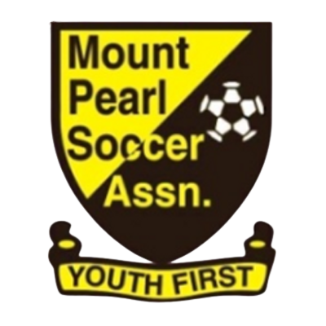
Mount Pearl Soccer Association
44 Arena Road, Mount Pearl, NL A1N 0J6

Playing Up Policy

The Mount Pearl Soccer Association (MPSA) supports and is aligned with the Canadian Soccer Association’s principles of Long Term Player Development (LTPD). This policy has been developed to address individual player and team playing up as it relates to age category circumstances.

Who is Eligible
The selection of a player to play at a higher age category will only be supported by MPSA if the player meets the following guidelines and has been brought forward to the MPSA Board by the head coach and technical director:
- Technical Ability: A player must demonstrate a high degree of individual skill, which must be transferable to competitive match situations. In addition, a player’s individual skill must meet or exceed the technical abilities of other participating players within the older age category the player wishes to participate in.

- Physical Ability: A player must meet or exceed other players within their age category in physical strength, technical skill and speed, and have the ability to blend in with players of the intended age group.

- Mental Ability: A player must meet or exceed other players within their age category in game awareness and general knowledge of the game. To include the mental strength that will be necessary when dealing with older and physically superior opponents.

- Social Ability: A player must be able to interact with players within the older age category on and off the field (games, dressing room, training and social gatherings).

