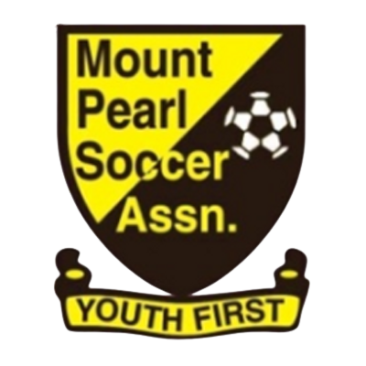
Mount Pearl Soccer Association
44 Arena Road, Mount Pearl, NL A1N 0J6

Youth Travel Policy

The Mount Pearl Soccer Association (MPSA) is committed to creating a positive sports environment in which all individuals are treated with respect, dignity and within the same rules and regulations. It is expected that each coach, player, and parent will conduct themselves professionally at all times and respect the common roles of every participant in the competition, particularly players under the age of majority.
PYL teams may have the opportunity to participate in competitions locally as well as in other areas of our province and country.
MPSA teams who plan to travel within the province for NLSA sanctioned events must adhere to the following guidelines:

Planning for Travel:
- For events outside the regular PYL schedule, Managers must provide at least 30 days notice prior to travel on the island and 60 days notice prior to travel off the island. The Team Manager must submit a Team Travel Plan along with the supporting information to the All Star Director for review and approval by the MPSA Board of Directors.
- All players and coaching staff must be registered with MPSA.
- Players and teams are subject to NLSA travel rules and regulations.
- For all travel, the Team Manager must submit a list of all players and Team Coaching Staff that are travelling to the All Star Director.
- The Team Manager must ensure that all Health forms have been completed for every player and Team Coaching Staff member and have these forms accessible at all times during the trip.
- If travelling to tournaments within the province for exhibition games, the Team Manager must ensure that the clubs they intend to play are properly registered with the NLSA.
- It is the responsibility of the parent(s)/guardian(s) to make suitable travel arrangements for players. The Team Manager must be aware of and document the travel arrangements for each player and member of the Team Coaching Staff.
- Team Coaching Staff are not permitted to rent vehicles to transport players.
- All travel expenses for team coaching staff will be shared equally amongst all travelling players - including accommodations, travel, and meals. Coaching staff must keep receipts.
- All teams travelling outside the province must have the approval of the MPSA Board of Directors and the NLSA.
- Request to travel outside the province forms (available from the NLSA office) must be submitted to the NLSA office accompanied by a $50.00 fee per request.

Accommodations:
- Team Coaching staff may decide if players will stay together as a team, or if the players will remain with their parents. Arrangements must be inclusive and allow for all players to be properly supervised at all times.
- If it is decided that the team will stay together:
  - The Team Manager is responsible for booking and assigning all accommodations for the players and coaching staff. The accommodations must be approved by the All Star Director.
  - If booking group travel, the Team Manager must book a professional driver. At no time is the Team Coaching staff permitted to transport players or rent vehicles for that purpose.
  - Supervision of the players is the responsibility of the Coaching staff.
  - The Team Manager is responsible for ensuring that all players have regular meals.
  - For players requesting one way transportation, a “Release of Child Form” must be signed by the parent/guardian of the player.
  - In hotels, the following criteria shall apply:
- Rooms should be in close proximity to each other if possible
- Rooms should be on the same floor if possible
- Rooms with outside entrances should be avoided
- Parents/guardians must be informed of and agree to the accommodations arrangement.
- When it involves players under the age of majority, anytime a room is visited by anyone other than the occupant(s), the door will be left ajar for viewing by a member of the coaching staff
- Team Coaching Staff should inspect each room for damages before taking possession of the rooms
- Team Coaching Staff should inspect each room for damages before signing out of the hotel.

- If it is decided that the team will not stay together:
  - The Team Manager must be aware of and document the accommodations arrangements for each player and member of the coaching staff.
  - Players shall remain the full responsibility of the parent/guardian.
  - Players under the age of majority are not permitted to stay in a hotel unsupervised.

Communication
- The All Star Director shall be the primary contact for the team during the travel dates.
- The Team Manager must share travel and accommodations documents with the All Star Director.
- The Team Manager must communicate with the All Star Director upon arrival of all players and upon departure from the destination.
- The Team Manager must communicate with the All Star Director upon the return of all players.
- The Team Manager or another Coaching Staff member must communicate any issues or concerns of improper conduct of players, Coaching Staff, and/or parents to the All Star Director as soon as possible
  - Players or Coaching Staff members that do not conduct themselves professionally or respect the roles of every participant in the competition, particularly players under the age of majority may be subject to discipline. This may include but is not limited to being suspended from further participation and sent home at the earliest possible time.
  - There will be no possession of, or use of, any illegal substances or performance enhancing drugs by any person involved with MPSA
  - The use of regulated drugs and/or alcohol is strictly prohibited for players under the age of majority.

