https://www.youtube.com/watch?v=mH9lWiNPAFM

Ramp Interactive gamesheet app tutorial

Game Codes
- the game sheet app codes are provided through your team login which will come from your league. Underneath of each league game which has been created, depending on whether you are home or away team you will be able to see certain codes. [NOTE - the game codes are under “League Gamesheet App Codes”, a menu item that appears under “League games”]. The home team can view all the codes for the game as often their parent will be in the box while the visiting team can only see the visitor code. Therefore it’s the home team manager or coach, whoever has been provided the NEAHL login, to ensure that the codes are distributed properly. The league governors and deputy governors can also access the codes. [NOTE - NEAHL Ramp is set up so home team has access to Game Sheet Code, Official Code, Home Code, and visitor team has access to Visitor Code]
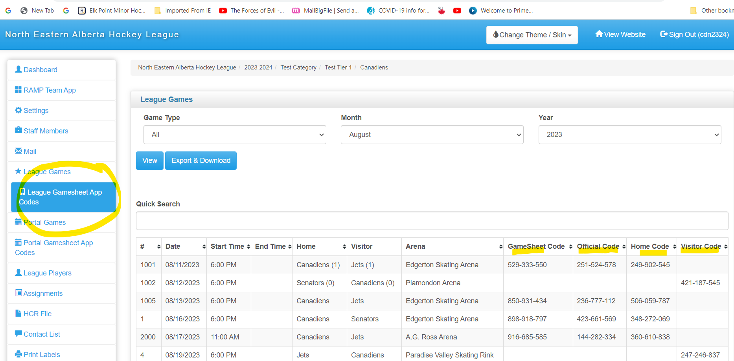
NOTE - NOT IN THE TUTORIAL - each team has a TEAM CODE (it’s on the dashboard page when you first login). If you enter the team code into the ramp app, it will add any games that have not yet been played along with the home or visitor codes for those games so that you don’t have to add the individual code for each of those games. Game Sheet Code and Official Code will still need to be added for each individual game. There may be a short delay between when the team code is entered and all the games are synced to your app.

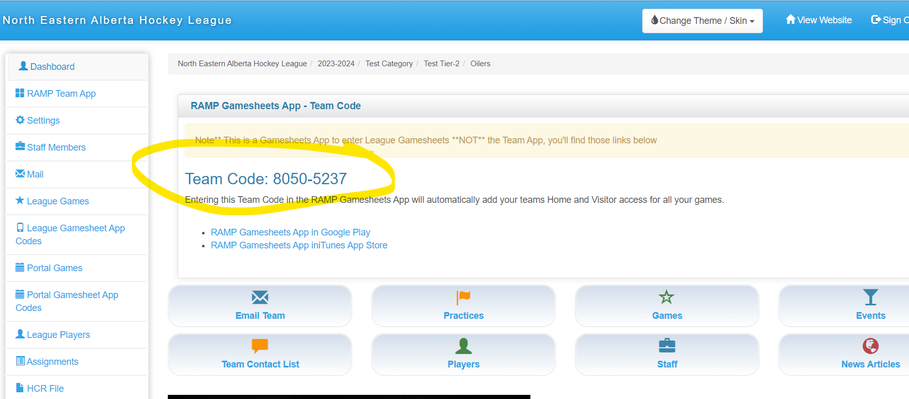

TUTORIAL

- Use your personal cellular device. No need for a tablet - designed to work on each individual’s own mobile phone - timekeeper, home staff, visitor staff, officials.

- To get the game sheet app, find it in IOS app store or in the google play store. Search “ramp gamesheet”

- you will be asked to create an account if you don’t already have one. You can use the same login if you have the ramp team app.
Create account - email, password, first name, last name, cell number
Password must contain a lowercase letter, an uppercase letter, a number and a symbol

- Sign in with your credentials.

- You will go to your home page where you will see any codes you have previously entered in as well as space to enter additional codes.
Enter code and hit add game button. If the code exists, it will be added to your account.

From home page you can review all the games that have been added to your account and can see what type of game they are by viewing the bottom row of game details.

HOME TEAM

- tap on the game in the home page list, and the app will pull up the game. If logged in as home or visiting team, you can view the details of the game, but will be unable to change them. - goals, penalties, goaltenders etc
What you can and should do as home or visiting team is enter in your roster information.

Roster will automatically populate. You can adjust player numbers and select which players are attending the game. This is important because whoever you select here will be available to the gamesheet admin to select for goals and penalties.
Can also tap the player and update player info such as whether they are a captain or assistant captain. Access to change player info depends on what is allowed by your association/league. You may be able to update player info, delete players, add players.
[Note - governors and deputy governors have the ability to lock additions or changes to rosters - please ensure that you have entered your roster in full prior to your games - your team roster on ramp should match your official HCR roster]

Do this for both players and staff - staff interface is entirely identical.

Finally, sign off on the game sheet - signatures will be saved in the app and listed under the staff.

You’ll be able to view the roster and staff of the visiting team as well and check their signatures.

That leaves the hamburger menu which allows you to jump to all the menu items, as well as the officials and the officials’ notes write up. Depending on the league, these buttons might not appear.

Once you have done your part entering roster and signing off, then you only need to review the game information after the game (goals, penalties etc).

VISITOR TEAM
Identical to the home team interface except for the visitor team. Visitor team can view the same information as the home team. Only difference is they have access to visitor players and visitor staff.

GAMESHEET ADMIN
The next person to work on the game.
The person who will be filling in the game sheet from the timekeeper box.
From their code, they are able to see all the other codes (home, visitor, official) to supply them to teams and officials if need be, as well as the controls for the game.

“Mark game as completed” will submit this game to the association website.

Live scores will share live updates to the website if you have an internet connection. If it’s turned off, nothing will turn up on the front end of the website until you mark the game as complete.
Can indicate if it went to overtime or a shoot out.
An overview of the game information on the page:
- goals
- Ability to set the period length in minutes, which will be entered by the admin.
- Shots on goal by period- if your organization would like you to track this
- Powerplay successes & chances
Details - date, location, game number

After the game details page, the gamesheet admin has access to goals and penalties which work in similar fashion.

GOALS
At the top, click new goal, enter the period, time (clock time), team, PP/EH/SH, who scored, who got the assist, who got the second assist, and whether it’s a game winning goal (not required) then submit. If there’s an error (eg same player as goal and assist) will give an error.

You can edit existing goals by tapping on them then clicking edit or delete.

PENALTIES
Penalties - similar - Enter time on the clock, optional time on for when player returns to ice, offenses (list from the league), which team, which player or staff, and if need be a served area for bench minor
Once saved, will show up in penalties area.
You can edit and delete penalties like you can with goals.

Goalie stats - usually entered at the end of the game.
Can edit and delete.
Choose goalie, team, time on ice, stats, win/loss/tie, whether it was a shoot out.

Roster area - should have been completed by home and visitor team, but you have the ability to do updates (e.g. adjust player number, add/remove players) - some options might be restricted by the league.

Finally, a hamburger menu with all the features for quick access.

Officials
As game sheet admin, at beginning of the game, you need to add officials to the game. Either they can enter on own device or you can add them.

You can also view the write ups, but only the officials can create and edit them.

OFFICIALS
Can enter their code and go to the game, usually when it’s done, for 2 things.
Can review the game.
Sign off on the game under officials.
Can also create official notes and write ups - notes or incident reports for penalties. - note there must be a penalty recorded in the game in order for the official to attach a note or incident report to it
[Note - the “officials” button on the bottom of the home screen of the app is only for officials who are assigned games through a ramp assigning website. NEAHL does not assign refs. Refs will enter the Official Code under “Games” to have the game added to their app]

There’s also some interface on home page to update your account settings or logout.

