 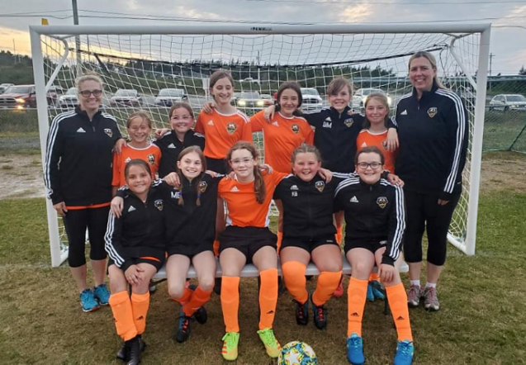

**The North East United Soccer Club is pleased to introduce the expansion of our Metro Soccer Program**

**The NEUSC is currently building a roster of Metro Teams for the 2022 Metro Soccer Season in the following age categories:**

***U7 Girls***

***U7 Boys***

***U9 Girls***

***U9 Boys***

***\*Each group will require 10 players in order to form a team***

**\*Other age groups can be considered, pending interest and available coaches.**

**The NEUSC is looking to recruit coaches and team managers for all age groups, please reach out for more information*.***

Cost: $300 for the Spring/Summer Program (can be paid in two separate installments of $150)

**What this includes:**

Registration for the Metro Soccer League and Associated Jamborees, Insurance with the NLSA, Team Uniform, Equipment and Rental fees

**Practice Locations:** Torbay Common (8 Kinsmen Place, Torbay) & Upper Three Corner Pond Field

Spring Pre-season training will be held from April 30th-May 28th at the Torbay Common. Groups will practice twice during the weekends leading into the outdoor season. Each team will have 8 indoor practices before moving to the field.

Summer Practices will start Mondays/Wednesday evenings in early June on the Field. Teams will compete in Metro league games and tournaments in the region throughout the summer.

For more information on the Metro Soccer Program please visit our website at: [**https://neusc.ca/content/metro-league**](https://neusc.ca/content/metro-league)

If you are interested in having your child added to the roster of a Metro Team for the 2022 Spring/Summer session, please send us an email[**neuscsoccer@outlook.com**](mailto:neuscsoccer@outlook.com)