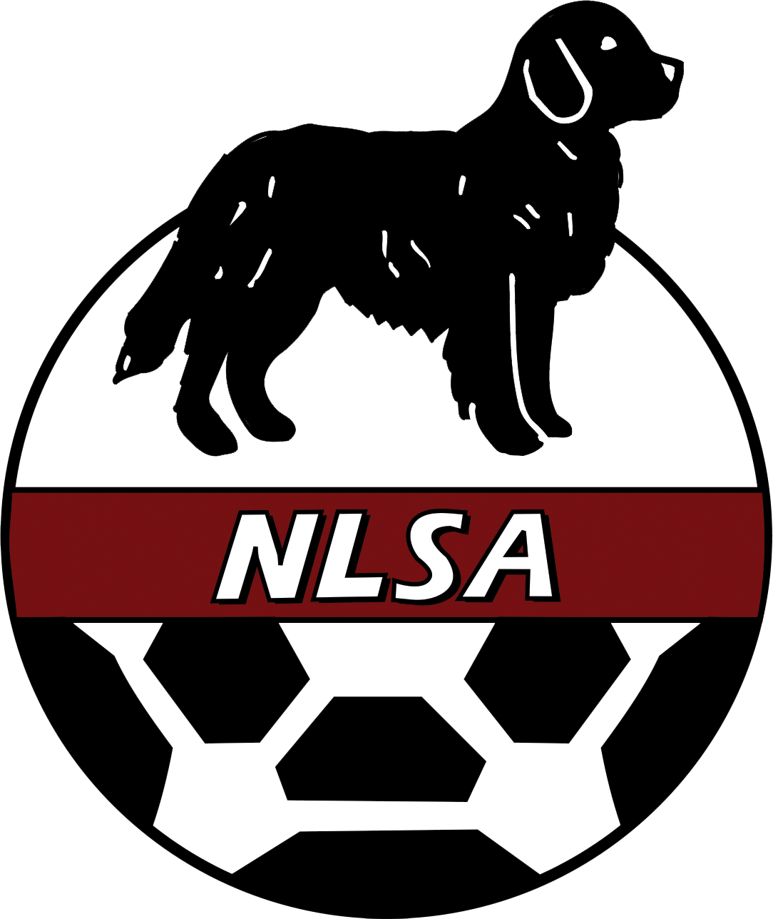

NEWFOUNDLAND & LABRADOR

SOCCER ASSOCIATION

REFEREE HANDBOOK

2026 edition

Last revision: November 8, 2025
Contents
PREAMBLE 4
1. NLSA REGISTRATION 4
2. BENEFITS OF REGISTERING WITH THE NLSA 4
3. REFEREEING WITHIN THE NLSA 5
3.1 GOVERNANCE 5
3.2 Assessment Responsibilities 6
3.3 Educational Responsibilities 7
3.4 NLSA Assigning 7
4. REFEREEING COURSES 8
SMALL-SIDED REFEREE COURSE 8
ENTRY LEVEL COURSE 8
REGIONAL UPGRADING COURSE 9
PROVINCIAL LEVEL COURSE 9
FUTSAL 9
5. REFEREE LEVELS 9
6. REFEREE PROMOTION 10
7. FITNESS TRAINING 11
8. FITNESS TESTING 11
9. ASSIGNING RECOMMENDATIONS 13
Referee levels 14
Recommended assignment guidelines 14
10. PROVINCIAL GAME FEES AND HONORARIA 15
Travel and subsistence for referees, assessors and instructors 16
11. MISCONDUCT REPORTING 16
12. CONDUCT OF REFEREES AND ACTION IN RELATION TO REGISTRATION 17
13. APPEALS AGAINST DECISIONS OF THE CANADA SOCCER REFEREES’ COMMITTEE 17
14. CONFLICTS OF INTEREST 17
15. NLSA POLICY REGARDING NON-SANCTIONED OFFICIALS/GAMES 18
16. REFEREE CODE OF ETHICS 18
17. THE NLSA ZERO TOLERANCE POLICY TOWARDS THE HARASSMENT OF OFFICIALS. 18
Officials’ Assessment 20
18. BLOOD POLICY 20
19. CAST POLICY 21
20. LIGHTNING/ SEVERE WEATHER POLICY 21
21. INSULIN PUMP POLICY 23
22. HEAD COVERINGS 23
23. CONCUSSION PROTOCOLS 24
24. CHANGE ROOM POLICY 24
25. CANCELLATION POLICY 26
26. RISK MANAGEMENT 26
Rule of two 26
27. CONTACT INFORMATION 27

PREAMBLE
The NLSA referee program falls under the jurisdiction of the NLSA Board of Directors. Various aspects of the refereeing program, particularly the conduct/misconduct of officials, are governed by the Rules and Regulations established by Canada Soccer.

1. NLSA REGISTRATION
The Newfoundland and Labrador Soccer Association is responsible for the administration of soccer programs across Newfoundland and Labrador. These responsibilities include referee registration, in conjunction with the NLSA office. Newly qualified referees will be automatically registered with the NLSA for the current year. All others must register on-line via the links on the NLSA web site.
The NLSA registration year runs from January 1st to December 31st. Officials must register directly via the on-line form available on the NLSA web site (https://www.rampregistrations.com/login?v3=9463a883) to be eligible to officiate in NLSA-sanctioned games. All officials must be registered prior to officiating in their first league game of the season.
Registration fees 2026
Classification | Fee
Senior Referee (District and above) | $55
Youth (under 14 years) and small-sided (over 14): | $25
Instructors: | $55
Assessors: | $55
Referees, instructors, and assessors will pay the highest of the fees appropriate to their classifications and will only pay one fee.

2. BENEFITS OF REGISTERING WITH THE NLSA
Local soccer associations will only assign games to NLSA-registered referees.
- As a referee, you are covered by NLSA insurance. This covers you against personal injury at a game when you are refereeing. Even more importantly, it covers you against liability if a player is injured at a game in which you are officiating. Note that referees who officiate at a level they are not qualified (i.e., those who have taken only the small-sided course but are officiating 11/side soccer) will not be covered by insurance.
- You will be eligible to be assessed on your performance. This is a requirement for upgrading. These assessments, along with your on-field performances, are used to determine suitability for higher-level competitions. Your assessments and on field performance are also used to determine appointments to university and other provincial and national competitions.
- Depending on your current classification, you may be eligible to be an official in NLSA competitions (indoor and outdoor provincials, University games, and Challenge Cup/Jubilee Trophy Competition). You may also be considered for out-of-province assignments as requested by Canada Soccer. Note that commitment to referee in your local district/region is mandatory before Provincial assignments may be expected.
- Refresher courses and professional development sessions are offered at no cost to registered referees.
- Fitness tests are scheduled and offered at no cost to the referee.
- As an NLSA registered official you qualify for upgrading clinics and have the opportunity to qualify as an instructor and / or assessor.
- If you move or visit anywhere else in the world, NLSA will forward your referee qualifications to Canada Soccer and they will forward to your new local soccer association.
If you choose not to re-register as an NLSA referee, then as per Canada Soccer regulations, after two years your referee qualification expires. For example, if you first qualified in 2022, but you were not registered in 2024 or 2025, you must follow the required procedures to register as a referee in 2026:
Any referee who wishes to re-certify must produce evidence of taking and passing referee courses:
- Referees who have previously been upgraded to regional or provincial level and have been registered since 2011 can re-register if they attend a professional development day, a Laws of the Game refresher, or otherwise demonstrate that they are familiar with changes in the Laws of the Game.
- District referees with at least two years officiating experience of 11/side soccer can re-register on successful completion of the Entry Level exam.
If they cannot provide such documentation, they must take a full entry level or small-sided course.

3. REFEREEING WITHIN THE NLSA

3.1 GOVERNANCE
Background
Refereeing in the province is under the governance of the NLSA as outlined in the Constitution, By-Laws, Rules and Regulations of the NLSA. The referee program is managed by a Referee Manager, supported by administrative staff at the NLSA office. The Referee Manager shall advise the NLSA Board with respect to the regulations of referees in Newfoundland and Labrador, and to administer referee activities in the province. The Referee Manager may recommend changes to the Board regarding NLSA rules and regulations and administrative regulations with respect to referees. The Referee Manager shall administer referees according to requirements of Canada Soccer.
Referee Manager Responsibilities
- Recommending policies, rules and regulations affecting referees to the NLSA Board, and implementing those policies upon approval by the board.
- Developing an annual budget for refereeing in the province for approval by the Board.
- Ensuring FIFA and Canada Soccer direction on refereeing is followed within the province.
- Communicating NLSA and Canada Soccer policies and directions on refereeing to referees throughout the province.
- Providing technical advice of the Laws of the Game to the NLSA.
- Providing advice on refereeing issues to regions and leagues.
- Promoting officiating in coordination with regions, clubs and leagues
- Coordinating referee assessments and maintaining records.
- Coordinating assignments of referees to games under NLSA direct jurisdiction (Challenge Cup, Jubilee Trophy, and Provincial Youth Leagues; other provincial tournaments).
- Recommending pay rates for matches under NLSA jurisdiction.
- Coordinating and providing referee instruction, education and development.
- Recommending honoraria for instruction, assessing, and mentoring.
- Coordinating referee fitness training and fitness testing and maintaining records of fitness performance.
- Consideration and approval for requests for support for developmental refereeing opportunities out of province.
- Consideration of promotion requests from referees, instructors and assessors (apart from those under Canada Soccer jurisdiction).
- Nominating referees, assessors and instructors for promotion to national level.
- Liaison with Canada Soccer refereeing department on refereeing issues.
- Implementing the Canada Soccer policy on classification of referees.
- Dealing with disciplinary complaints against referees and providing support to referees at any disciplinary hearing.
- Preparation and updating of the NLSA referee handbook.
- Soliciting nominations and assisting in their review for annual awards relating to officials; ensuring the terms of reference for awards are appropriate and current.
- Representing the NLSA to Sport NL on officiating issues

3.2 Assessment Responsibilities
The assessment process is designed to evaluate how well a referee can manage a soccer game. An assessment is not an attempt to catch the official doing things wrong. It is a process by which a more experienced referee can help a less experienced referee, by developing the skills necessary to reach a higher level. Assessments are a key part of the referee upgrading process.
The Referee Manager (or designate) is responsible for recruiting assessors, assigning them to games, ensuring a copy of the assessment is delivered to the individual referee, and maintaining records of assessments. Assessments should normally be completed and forwarded to the Referee Manager (or designate) within 72 hours of the assessed game.
Referees are responsible for maintaining their own portfolio of assessments.
The NLSA priorities for allocating assessors to games are:
- Officials who are eligible for upgrading, or those officials identified as being on the development path to national nomination
- Nominated National referees and above (assessment requirements are set by Canada Soccer)
- Officials where there have been concerns raised about performance
- Officials who request an assessment, as part of their personal development
- Requests for assessments by clubs/ leagues/ regions.
All referees wishing to upgrade should note that, while every effort is made to get copies of local district schedules, and get assessors out to assessable games, it is the responsibility of the referee to notify the Referee Manager (or designate) of his/her refereeing schedule. These referees must notify the Referee Manager (or designate) of any changes to their schedules.
Clubs, leagues and regions are encouraged to include assessments and mentoring as part of their referee development programme, and they should contact the Referee Manager (or designate) to develop a plan for doing so.
The NLSA recognizes that assessments are a critical component of referee development and cover the cost of assessments, within the confines of the Referee Program budget.

3.3 Educational Responsibilities
The responsibility for referee training belongs to the NLSA, in cooperation with Canada Soccer. This includes training programs for referees, for referee assessors, and for referee instructors. It is the responsibility of the Canada Soccer Referee’s Committee to provide the provincial associations with material for referee courses. The NLSA and Canada Soccer arrange introductory referee training courses, and courses for upgrading referees from District class to Regional class. The NLSA recommends candidates for upgrading from Regional to Provincial class; these courses generally are held annually by Canada Soccer.
The Referee Manager (or designate) is responsible for recruiting referee instructors, who will then be assigned to courses that have been requested.

3.4 NLSA Assigning
The NLSA hosts or oversees competitions throughout the year. These include Provincial tournaments at Senior level, the Challenge Cup/Jubilee Trophy Competitions, University leagues, Provincial Youth Leagues etc. It is expected that the host club(s) will appoint an assigner for NLSA matches in their area.
The NLSA Assigner, in cooperation with the Referee Manager, has various responsibilities. These include:
- Ensuring local districts use suitably qualified and registered referees
- Assigning officials for University games
- Verifying the classification of local and newly arrived officials
The NLSA assigner is compensated at a rate determined annually.
Officials are ideally assigned to NLSA events according to the following priorities:
1. Officials assigned to referee in the senior club championships and A level provincials, and University games will all be Regional class or above, wherever possible and should have successfully completed the annual fitness test, as outlined for their classification.
2. Referees currently in process of upgrading.
3. Referees who have successfully completed fitness testing in the current year.
4. Other active referees.

4. REFEREEING COURSES
The NLSA, in cooperation with Canada Soccer, offers the basic Entry Level certification course, which qualifies participants to officiate in 11/side soccer, and an entry level Futsal course. The NLSA also offers a Small-Sided Referee Course for those interested in only refereeing small-sided matches.

SMALL-SIDED REFEREE COURSE
This is a basic refereeing course, designed for those interested in refereeing games in the Under 11 division or below designed for less than 11/ side soccer.
This is a 7-hour course provided by the NLSA. It is important to note that completion of the small-sided referee course does not qualify an official to referee 11/side soccer at any level, or to act as an assistant referee at any level, or to officiate in provincial tournaments (other than small-sided games). The small-sided course is open to everyone, but you must be at least 12 years of age to register as a small-sided (Youth) referee. The course is practically oriented, and should ideally be offered on a soccer field, with a classroom available.
The intent of this clinic is an introduction to refereeing. The clinic is interactive and introduces young referees to the basic concepts of refereeing. They then need to apply this knowledge to officiating recreational micro- and mini-soccer players in the ages of U4 to U11. To referee matches where direct free kicks, penalty kicks or the offside law is being applied, officials must have completed the Entry Level course.
Candidates aged 14 and over are strongly encouraged to take the full Entry-Level course that qualifies them for 11/ side games as well as small-sided soccer.

ENTRY LEVEL COURSE
The Entry Level course is an introduction to officiating. It is a 16-hour Canada Soccer-certified course designed to teach the Laws of the Game. The course is practically oriented and there is an examination. The Entry Level course is open to everyone, but the successful candidate must be at least 14 years of age to register as an Entry Level (District) referee.
The Entry Level course is split into 2 components:
- On-line program. This is a 4-to-6-hour course (see below) managed by Canada Soccer.
- Practical session. This is a one-day session focused on practical aspects of game management. It starts with 2 hours in the classroom then 3 hours on the field and finally 2 more hours in the classroom. The final exam for the course occurs at the end of this session.
To register for the Online Entry Level Course
First, the potential referee will need to go to the Canada Soccer Shopify page, https://canada-soccer.myshopify.com/ and click on the link at the top of the page labelled “Referee Education”. You will then select either the French or English course and proceed with the payment of this course. Once you pay for the course you will receive a SmarterU access key which will allow you to register with SmarterU and take the course. You can either go back to the Shopify page and click on the “Training Login” button which is beside the Referee Education button, or you can go to https://canadasoccer.smarteru.com/remote-login/login.cfm. Under the space for the login details there is text that says, “If you have an access key, register for an account.”. You will need to complete the registration process and then you will have access to take the course.
Following successful completion of the Entry Level course, officials will be expected to be assessed before further upgrading is considered. Promotion from District level to Regional level is performance based but requires completion of the Regional Upgrading course.

REGIONAL UPGRADING COURSE
This course is designed for the District referee who has completed the requirements for Regional promotion level. This course will cover more advanced aspects of officiating and will normally be instructed by a Provincial Instructor. The course is normally taken following successful completion of the Regional Exam, which is administered by Canda Soccer.

PROVINCIAL LEVEL COURSE
This course is designed for the senior official who has completed the requirements for upgrading to Provincial level. Candidates must pass a fitness test and on-line exam and be recommended by the NLSA to Canada Soccer to participate in the annual course.

FUTSAL
The NLSA is promoting Futsal for off-season play, and referees officiating in NLSA Futsal tournaments must complete the Canada Soccer Futsal course.

5. REFEREE LEVELS
Levels | Notes
FIFA | International level. Appointed by FIFA. Recommended by Canada Soccer.
National | Appointed by Canada Soccer
Provincial | 11/side soccer. Candidates are recommended by NLSA
Regional | 11/side soccer
District | 11/side soccer; small-sided soccer where offside or penalty kick laws are used.
Small sided | Qualified for small-sided soccer only, cannot officiate as an assistant referee.
Futsal | Qualified to referee Futsal

6. REFEREE PROMOTION
Referees must apply for promotion in writing. Promotion takes effect on approval by the Manager of Referees (or designate). It is the individual referee’s responsibility to ensure all appropriate information for upgrade is submitted.
Every year, the NLSA attempts to hold one or more upgrading courses (to upgrade from small-sided to district referee, the full entry level course must be taken). These courses are run depending on numbers being available to conduct such courses. To be eligible to participate in an upgrading course, you must meet certain requirements.
Upgrading from District to Regional level
To be eligible to request promotion, you must have been a referee for at least one full outdoor season with the majority of the matches officiated at the competitive U16 level or above, but preferably at the senior level.
To be considered for promotion, you must have completed all of the following:
- Passed the Regional Exam, administered by Canada Soccer (the exam is usually held in February/ March)
- Attended, participated in, and passed the annual fitness test at regional level.
- Completed four successful assessments within the last 24 months, two as a referee, and two as an assistant referee.
- Provided a portfolio of all games officiated (copies of assessments, record of appointments).
- Refereed at least 20 competitive matches (11-a-side competitions for players U16 or above) within the province in senior provincial play.
- Completed a minimum of five games as an Assistant Referee in the promotion season.
- Attended, participated and passed the Regional Course.
If you are not successful in upgrading because of assessments, or failing to attend a fitness test, you may complete these requirements in the following season.

Upgrading from Regional to Provincial level
To be considered for promotion, you must have:
- Been a Regional-level referee for at least one full outdoor season.
- Successfully completed the Provincial-level upgrading clinic. This is hosted annually by Canada Soccer. Candidates are recommended by the NLSA.
- Successfully met the standards of the fitness test.
- Completed three successful assessments in the same outdoor season (2 as a referee and 1 as an assistant). If required, assessments may be carried forward to second year.
- Provided a portfolio of all games officiated per outdoor season (copies of assessments, record of appointments).
- Refereed at least 20 competitive matches (11-a-side competitions for players U16 or above) within the province in senior provincial play.
- Completed a minimum of five games as an Assistant Referee in the promotion season.

Upgrading to National List Referee
Each year, the NLSA may nominate referees to Canada Soccer for promotion to National referee. He/she must have consistently performed at a high level, received appropriate assessments at a senior level in the past 24 months, and must also be active in other areas of soccer (such as referee instruction, referee assessment, or serving as a mentor to the younger referee).

Upgrading to FIFA-List Referee
Canada Soccer nominates officials to FIFA for inclusion on the International Referees list and the Assistant Referees list. These nominees are commonly, but not necessarily, taken from the National referees list.

7. FITNESS TRAINING
It is obviously important that referees maintain a high level of fitness. Canada Soccer has resources to assist in strength and conditioning training. Here is a link to these resources:
https://canadasoccer.com/referee/fitness-training/

8. FITNESS TESTING
NLSA officials are expected to maintain a level of fitness appropriate to the games they are officiating. At the start of every outdoor season, the NLSA arranges the opportunity for referees to attend fitness tests. This test is a very useful gauge for officials to check whether their conditioning will meet the physical demands of outdoor soccer.
The Canada Soccer guide to fitness testing is found here:
https://canadasoccer.com/wp-content/themes/betheme-child/assets/Referee%20Fitness%20Test%20Guide%20ENG.pdf
Tests will be offered as needed. Tests must be completed for priority for assignment to high-level games (Challenge Cup, Jubilee and University), for upgrading, and to maintain Regional- and Provincial-level referee status. Referees are encouraged to take the fitness test at the beginning of the outdoor season, and test results will be taken into account in all assignments. Fitness tests from the past season remain valid until July 1st.
Fitness testing is designed to have participants reach their physical limits. As such they can put significant stress on the body, and referees are strongly advised to obtain clearance from their family doctor if they have any concerns about their physical capability. In particular, Canada Soccer will not permit any candidate with high blood pressure (160/95 or higher) to attempt fitness tests. Participants are encouraged to check their blood pressure prior to attempting testing.
The Fitness Standards:
There are two main types of fitness tests that will be run this season, the “Beep” Test and the Canada Soccer/ FIFA High Intensity Test (HI Test). The High Intensity Test is required for officials who wish to officiate at the top level (Regional and above) and are interested in being considered for national-level competition. Canada Soccer has stipulated that it is a requirement for maintaining classification as a Provincial referee and for candidates for provincial promotion.
District-level referees are expected to pass the Beep test.

High Intensity Test
What you need to know:
- The test starts with six repeated sprints over 40 metres (you have 60 seconds between each sprint).
- After the sprints is the interval run. One interval is a 75 m run followed by a 25 m walk (rest period). Forty intervals must be completed. 40 intervals are 10 laps of a 400-metre track.
- The test is “all or nothing”. With the HI test there is no graduated score. The referee either meets a particular standard or not. If that referee fails, he/she will need to re-run the test at a later date.
- The best suggestion for training for this test is to get used to interval running (repeated runs then walks). Do this over varying distances and times and gradually raise your level to meet the standard you require.
The Canada Soccer test standards are as follows:
Category | Sprints | Interval Run (150 m run/ 50 m walk)
Provincial male | 6.4 sec | 15/20 sec
Provincial female | 6.6 sec | 17/22 sec
Regional male | 6.6 sec | 17/22 sec
Regional female | 6.8 sec | 17/24 sec

Beep test
The Beep test consists of continuous running between two lines 20 m apart. The runner must complete each 20 m run in a set time denoted by a beep (provided over a speaker from an audio recording). The time allowed for the 20 m run decreases progressively and the runner continues until they are unable to complete two successive 20 m intervals in the time allowed. The test consists of up to 20 levels with each level consisting of a series of runs that last about a minute. For instance, at level 6, 10 20 m runs are required, each in under 6.55 seconds. The next 20 m is at level 7, where only 6.26 seconds are allowed, and so on. The runner’s test score is the highest level attained before failing to keep up.
Level | Number of 20m runs | Time per run
1 | 7 | 9 seconds
2 | 8 | 8 seconds
3 | 8 | 7.58 seconds
4 | 9 | 7.2 seconds
5 | 9 | 6.86 seconds
6 | 10 | 6.55 seconds
7 | 10 | 6.26 seconds
8 | 11 | 6 seconds
9 | 11 | 5.76 seconds
10 | 11 | 5.54 seconds
11 | 12 | 5.33 seconds
12 | 12 | 5.14 seconds

The NLSA standards are:
Level | MALE | FEMALE
Provincial | Stage 9 | Stage 8
Regional | Stage 8 | Stage 7
District/Youth | Stage 6 | Stage 6

- Regional and provincial referees are required to attempt the high intensity test rather than the Beep test.
- Regional and provincial referees over the age of 40 are encouraged to take the beep test

9. ASSIGNING RECOMMENDATIONS
The following is designed as a guide to the appropriate level of referee to officiate in different levels of competition in the province. It is suggested that, if possible, these guidelines be followed in all games under the jurisdiction of the NLSA. These should however be treated as guidelines and are not meant to replace the knowledge and experience of an assignor who best understands the abilities of the referees available for matches, and the challenges that each match might bring. In interpreting these, the following should be kept in mind:
- A referee can always officiate games below their recommended level, but should only be assigned to games above the recommended level in exceptional circumstances
- In determining which level a referee should be considered, there may be other factors that can be taken into consideration. For instance, a very experienced senior player to takes up refereeing may well be considered a “senior” district level after their first few games if they perform well.
- In no circumstances can a referee who has not completed the full entry level course officiate in 11/side games, or act as an assistant referee
- Youth referees (Under 18) should not officiate their peers- same age group. For example, a 16-year-old referee should not officiate Under 17 games as a centre referee. It is recommended that they do not act as assistants either, but it is recognized that this may be needed if there is a shortage of officials.
- In terms of number of games, a referee doing their job properly will run as far or further than most players in a game. Thus, it is recommended that referees are assigned only one centre referee assignment in a day, with a maximum of three games a day (one centre referee and two AR assignments). Referees refereeing Senior Provincial play (as defined below) should not be assigned as a centre referee in the preceding 24 hours.

Referee levels
Referee class | Minimum age | Qualifications | Fitness
Small sided | 12 | Small sided course | -
District | 14 | Entry level | Male beep 6 Female beep 6
Regional | 18 | Regional | Male beep 8, Female beep 7
Provincial (includes national, provincial with beep test fitness levels) | 18 | Provincial upgrade complete | Male beep 9, Female beep 8

Recommended assignment guidelines
Matches | Description | Recommended | Minimum | AR (recommended/ minimum)
Small sided U6/8/10 | House league, NLSA Jamboree | Small sided at least one age class older | Small sided | N/A
Small sided- using offside; small sided U12 | Tournaments using the offside law; small sided under 12 with penalty kicks, cards etc. | District | District | District
Youth recreational | 11/side house league, Under 17 11/side outside of PYL | District | District | District
Youth competitive | High School regional games, PYL U13. | District | District | District and one age class older than level refereed
Youth provincial/ regional | PYL games leading to national tournaments (PYL U15/17) | Regional | District | District and one age class older than level refereed
Senior recreational | Local league masters, women’s matches | District | District
Senior competitive | Local league senior men’s play, master’s and women’s play-offs | Regional | District | District
Senior Provincial | Senior provincial tournaments, regional senior men’s play-offs, University, CC and Jubilee | Regional or Provincial | Regional | Regional/ District

10. PROVINCIAL GAME FEES AND HONORARIA
The following are the NLSA referee fees for 2026:
Division | Referee | AR
Premier League Senior (Challenge Cup/ Jubilee Trophy) | 105 | 68
Intermediate Senior | 63 | 42
Masters | 63 | 42
U17 - PYL/ MEGA | 75 | 50
U15 - PYL/ MEGA | 63 | 42
U13 - PYL/ MEGA | 58 | 37
U12 - PYL/ MEGA | 47 | n/a

The following are other fees/ honoraria for 2026
Description | Fee
Entry Level Practical (per instructor) | $350
Futsal course (2 day) | $570
Small-sided Course (per instructor) | $250
Assessor Course | $500
Instructor Course | $500
Laws of the Game refresher | $75
Assessment (by qualified assessor) | $70
Mentor fee | $25
Where assessors or supervisor of officials are appointed to assess at NLSA- or NLSA-sanctioned tournaments they shall receive an honorarium not exceeding $300, in addition to the allowances outlined below. This honorarium is based on the completion of at least 5 assessments or completing the responsibilities of a supervisor of officials.

Travel and subsistence for referees, assessors and instructors
Entitlements and rates are determined by the NLSA and may be amended on an annual basis. The following shall apply to NLSA referees, assessors and instructors.
- Referee program staff, referees, assessors and instructors required to travel on NLSA business are entitled to receive a meal allowance as per NLSA rates.
- Where an overnight stay is required, the cost of accommodation will be covered by the NLSA.
- Where travel is required, the driver of a vehicle will be reimbursed as per NLSA rates. Wherever possible, referee program members should travel together to reduce costs.

11. MISCONDUCT REPORTING
If a player or team official is dismissed (sent off) during a game that you are refereeing, you must complete a misconduct report (all cautions – yellow cards- must be reported on the game sheet in RAMP but usually do not require a detailed report). This report needs to be completed promptly and provided to the appropriate authority. Misconduct normally will be reported to the administration of the league in which the match is being played in.
For matches under the direct authority of the NLSA (provincial tournaments, provincial youth league, Jubilee Trophy and Challenge Cup) the following applies:
- NLSA tournaments: the misconduct report must be provided to the NLSA tournament representative within 2 hours of the completion of the game. This will ensure that any necessary action can be taken before the player’s next game.
- Provincial Youth League, Jubilee Trophy and Challenge Cup: misconduct reports should be sent to the NLSA Vice-President responsible (youth, senior men, senior women) and the Referee Manager within 48 hours of the incident.
Serious misconduct
Irrespective of the competition or league (i.e., for any NLSA-sanctioned game in any league or level), a misconduct report must be sent directly to the NLSA if it describes:
- Any incident of misconduct against a referee involving physical assault, attempted physical assault or threatening behaviour in any game.
- Any incident that involves racist or sexist comments.
In such cases, the report must be sent to the Newfoundland and Labrador Soccer Association (info@nlsa.ca), with a copy to the respective league/regional association within 48 hours.
Failure to submit misconduct reports within the appropriate timelines may result in sanctions being imposed on the referee by the NLSA. Failure to submit subsequent misconduct reports will result in suspension.
The Misconduct Form (if not using RAMP) can be found on the NLSA web site in PDF and Word format at: https://www.nlsa.ca/content/referee-documents-and-forms
Copies of the form should be printed and made available at the field, particularly at tournaments where there may not be time to prepare an electronic report.

12. CONDUCT OF REFEREES AND ACTION IN RELATION TO REGISTRATION
These are governed by Canada Soccer Rules and Regulations, found on the Canada Soccer web site.

13. APPEALS AGAINST DECISIONS OF THE CANADA SOCCER REFEREES’ COMMITTEE
These are governed by the Canada Soccer Rules and Regulations, found on the Canada Soccer web site

14. CONFLICTS OF INTEREST
The following is taken from the Canada Soccer Regulations:
“A referee shall at all times act impartially. Where a referee believes that there is a material interest conflicting with the duties and obligations of a Match Official and any appointment, then the referee shall decline to act or officiate and declare it to Canada Soccer (in respect of National List Officials) or the Provincial Association, whose decision in relation to any dispute or difference in such matters shall be final and binding.”

NLSA-POLICIES REGARDING REFEREEING

15. NLSA POLICY REGARDING NON-SANCTIONED OFFICIALS/GAMES
a) No person shall officiate as a referee in any competition under the jurisdiction of the Association unless he/she is on the Official List of Referees. Organizations who assign or use unregistered or unqualified referees are liable to fines.
b) No NLSA-registered referees may officiate in any unsanctioned game, competition or tournament, whether in or out of Newfoundland and Labrador. Failure to comply will result in disciplinary action being applied to the individual concerned.

16. REFEREE CODE OF ETHICS
All officials should be aware of the Newfoundland and Labrador Soccer Association Code of Conduct and Ethics. These are found at https://www.nlsa.ca/content/rules-regulations-policies-and-documents The section that specifically applies to officials is reproduced here:
Match Officials must:
- Conduct themselves with dignity both on and off the field of play, and by example seek to inspire the principles of fair play in others
- Adhere to all standards and directives established by the NLSA, Canada Soccer, International Football Association Board and FIFA
- Be neat in appearance and maintain a high level of physical and mental fitness
- Study and enforce the current Laws of the Game and any event‐specific rules and regulations
- Perform his/her designated duties, including attending organized clinics and lectures, etc. and shall assist their colleagues in upgrading and improving their standards of officiating, instructing and assessing
- Adhere to the NLSA’s Anti‐Doping Policy
- Honour any appointments accepted, unless unable to do so by virtue of illness or personal emergency
- Not publicly criticize other referees or the NLSA (note that this includes use of social media)
- Not make any statement to the media (newspaper, television, radio, etc.) related to a game in which the referee has officiated, or to the performance of the players or other officials (this also includes social media)
- Not accept any appointment to officiate in unsanctioned events
- Be fair, equitable, considerate, independent, honest, and impartial in all dealings with others
- When writing reports, set out the true facts and not attempt to justify any decisions; and
- Report any approach to fix the result of a match.

17. THE NLSA ZERO TOLERANCE POLICY TOWARDS THE HARASSMENT OF OFFICIALS.
The development of young referees, as well as players, takes time. Referees in Newfoundland and Labrador have received classroom training and are required to pass an examination before they can referee within our system. When they referee, they are gaining the experience required to become a good official. At the club level and in the minor soccer system many of the officials that parents will see are mostly at the entry-level, not the experienced officials you may see refereeing higher-level games. At Provincial tournaments, many regions or clubs, use young officials who, although they have completed their Entry Level courses, are inexperienced.
Harassment is defined as offensive, abusive, belittling or threatening behaviour directed at an individual. The NLSA Code of Conduct contains a more exhaustive description of harassment. Although evidence is largely anecdotal, harassment of officials by spectators and coaches is recognized as a major factor contributing to lack of retention in sports. Soccer is certainly not alone in this regard, and although officials leave the sport for many reasons, having been harassed by spectators or coaches should not be one of them. In soccer, as in many sports, most harassment (~95%) is verbal, and commonly difficult to deal with. However, the NLSA has implemented measures to help eliminate harassment from our game.
The NLSA administers soccer at all age and skill levels, and the following is sub-divided into Youth and Senior. These measures apply to all NLSA league and tournament play (provincial youth and senior tournaments, Challenge Cup and Jubilee Trophy), although clubs and regions are encouraged to adopt this policy for their leagues. Some regions already have their own policies towards referee harassment, and the following is adopted from theirs and from other associations in North America and internationally.

Youth Leagues, including Provincial tournaments
This policy has a simple premise: All persons responsible for a team and all the spectators should support the referee. This policy has a simple guideline: Don’t talk to the referee during the game!
Naturally, there are exceptions to this guideline, and they are as follows:
A. Person Responsible for a team (i.e., Coach)
During the Game:
- Responding to a referee initiating a communication.
- Making substitutions.
- Indicating kickers at kicks from the mark to decide a game.
- Pointing out emergencies or safety issues.
At half-time or at the end of the game:
- A coach can ask a referee to explain law(s) in a polite and constructive way.
- Polite feedback can be given to a referee.
- Absolutely NO sarcasm, harassment or intimidation is permitted.
Penalties:
As with all policies there must be penalties for those not wishing to abide by them. These are covered by the Laws of the Game, and they give the referee the power to abandon games and/or to caution or dismiss team officials (coach, assistants, managers etc.) if they indulge in abusive behaviour. Referees have been instructed to enforce the Laws.
B. Spectators
During the game:
- Referee initiating a communication.
- Pointing out emergencies or safety issues.
Penalties:
Although the Laws of the Game provide referees with the authority to suspend or terminate a match due to outside interference, there is limited recourse for a young official in what is commonly an intimidating situation. The NLSA therefore requires the use of Field Marshals at all Provincial Tournament and Youth League games to act as monitors. This is based on the premise that communication should be between participants in the game, rather than between the referee and spectators, which may be less than beneficial. As such, referees have been instructed to direct their concerns about spectators to the field marshal.
1st Infraction | Referee should stop the game and ask the field marshal to quiet the offending spectator.
2nd Infraction | The referee shall instruct the field marshal to direct the spectator to leave the field. The referee should abandon the game if the spectator does not leave the field.

If the referee abandons the game, the referee shall file a report and the NLSA may impose further sanctions.
NLSA Senior Leagues (Challenge Cup and Jubilee Trophy; and Senior Provincial tournaments)
Referees at this level are considerably more experienced than their counterparts at the minor level. The pace, skill level and intensity of games is also considerably higher and the ability of officials to deal with incidences of harassment from players and coaching staff is greater.
However, officials are still limited in their control of spectators. Although a certain amount of ‘comment’ from spectators is generally accepted, there will be no tolerance for comments of a racist or sexual nature directed at match officials, and incidents of threatened or actual assault on match officials will be dealt with firmly. To effectively deal with spectators, host clubs/teams will be expected to provide clearly identified security/field marshals at all CC/JT games and Senior Provincial tournaments. The security/field marshals shall act on the direction of the match officials, and/or club staff.
Reported incidences by the referee of harassment from spectators may result in sanctions from the NLSA to offending teams, which could include points deductions, moving of future games, banning of spectators etc.

Officials’ Assessment
The power given to officials obviously does not come without a price. Officials are expected to behave in an appropriate manner and referee games to the best of their abilities. To ensure this occurs, officials are assessed on a regular basis by qualified assessors. This process is another important step in referee development.
Coaches can comment on the referee’s performance, through completion of an evaluation form. It is on this evaluation form that comments about the officiating are to be made, and not verbally at the game.

18. PLAYER EQUIPMENT
The NLSA Policy regarding player equipment is consistent with FIFA (Law 4). In particular, referees are reminded to ensure that the tape on cut socks is the same colour as the sock, and that undershorts are the same colour as the main part, or the lowest part, of the short or that undershirts are the same colour as the main colour of the shirt sleeve. All players on a team must wear the same colour undershorts or undershirts.

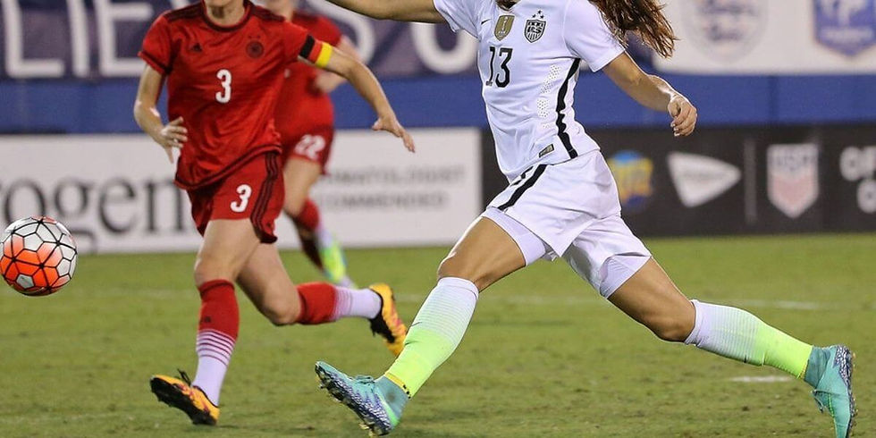
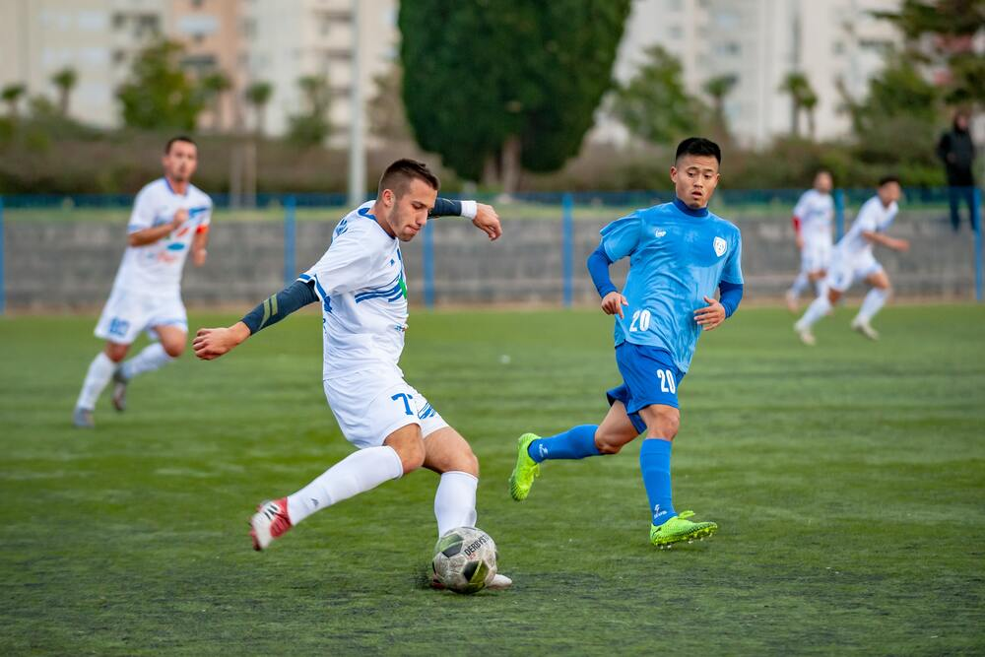




Referees are reminded of the expectation that Player Equipment conforms with the law.

19. JEWELRY POLICY
The NLSA Jewelry policy is consistent with FIFA (Law 4). Players are not permitted to wear anything that is dangerous to themselves or other players. No jewelery: that includes rings, bracelets (except medical alert bracelets that must be either made of Velcro or similar soft material or covered with a sweatband), earrings, necklaces, other visible body piercing, etc. The practice of taping jewellery is not acceptable. If it can be seen it must be removed.

Referees are reminded of the expectation that the Jewelery Policy be enforced.
The Jewellery Policy is applicable to referees, with the exception of watches.

20. BLOOD POLICY
Dealing with a bloody wound;
a) If bleeding occurs where other participants may be exposed to blood, the individual's participation must be interrupted until the bleeding has been stopped. The wound must be securely covered and blood removed.
b) All clothing soiled with blood should be replaced prior to the athlete resuming training or competition.
c) If an athlete leaves the field, has his/her injury treated and covered and wishes to re-enter the game in another, differently numbered jersey, that replaces a blood-stained jersey, he/she may re-enter only after the referee has been advised of the change of number.
d) All equipment and surfaces contaminated with blood and other body fluids should be cleaned prior to re-entering the field with the referees’ permission.
e) While cleaning blood or other body fluid spills, the following must be done:
- wear waterproof gloves.
- wipe up fluids with paper towels or disposable cloths.
- disinfect the area as described in (d).
- place all soiled waste in a plastic bag for disposal.
- remove gloves and wash hands with soap and water.
Referees are responsible for a) to c) only. However, referees can advise individuals involved in wound treatment and clean-up of points d) and e).

21. CAST POLICY
At all NLSA youth tournaments, casts are not permitted. For provincial senior tournaments and all Canada Soccer sponsored tournaments, the Canada Soccer policy will be upheld.
Canada Soccer policy
This Canada Soccer policy document issued by the Referees Committee is designed to reduce inconsistencies in rulings over players wearing casts. All referees are expected to follow these policies in all matches sanctioned by Canada Soccer
Law 4 states that a player may not use equipment that is dangerous to himself or another player. This is further expanded upon in the Interpretations of the Laws of the Game whereby it is advised that players may use equipment that has the sole purpose of protecting the individual physically providing that it poses no danger to the individual or any other player. Modern protective equipment made of soft, lightweight, padded materials are not considered dangerous and are therefore permitted. Hard plaster casts are considered to pose a danger to both the wearer and other players and are not permitted to be worn. The practice of padding a hard plaster cast does not reduce the element of danger.
Players wearing a soft, lightweight, cast will be permitted to play if the cast does not present a danger to the individual or any other player.
The referee or Supervisor of Officials (if one has been appointed to the match/tournament) will make the final decision as to the acceptability of any cast.
Any player who uses a cast to intimidate or injure an opponent shall be cautioned or sent off depending on the nature of the player's action.

22. LIGHTNING/ SEVERE WEATHER POLICY
When thunder roars, go indoors!
The safety of players, coaches, management and spectators is the primary concern in any weather event that occurs during all matches sanctioned by Canada Soccer. By understanding and following the below information, the safety of everyone shall be greatly increased. Ultimately, the referee has the final say over delaying or restarting a match due to weather. Waiting to stop play or not waiting to start play may result in a serious injury or loss of life. Referees are expected to act responsibly when dealing with such events during matches they are controlling.
If you can hear thunder, you can get hit by lightning. As soon as you hear thunder, quickly get to a safe location. More people are struck before and after a thunderstorm than during one. Stay inside for 30 minutes after the last rumble of thunder.
Additional Information
Please note the following recommendations from Environment Canada:
- To plan for a safe day, check the weather forecast first. If thunderstorms are forecast, avoid being outdoors at that time or make an alternate plan. Identify safe places and determine how long it will take you to reach them.
- Watch the skies for developing thunderstorms and listen for thunder. As soon as you hear thunder, quickly get to a safe location. If you can hear thunder, you are in danger of being hit by lightning. More people are struck before and after a thunderstorm than during one.
- Get to a safe place. A safe location is a fully enclosed building with wiring and plumbing. Sheds, picnic shelters, tents or covered porches do NOT protect you from lightning. If no sturdy building is close by, get into a metal-roofed vehicle and close all the windows.
- Do not handle electrical equipment, telephones or plumbing. These are all electrical conductors. Using a computer or wired video game system, taking a bath or touching a metal window frame all put you at risk of being struck by lightning. Use battery-operated appliances only.
- If caught outdoors far from shelter, stay away from tall objects. This includes trees, poles, wires and fences. Take shelter in a low-lying area but be on the alert for possible flooding.
Be aware of how close lightning is occurring. Thunder always accompanies lightning, even though its audible range can be diminished due to background noise in the immediate environment and its distance from the observer.
When larger groups are involved, the time needed to properly evacuate an area increases. As time requirements change, the distance at which lightning is noted and considered a threat to move into the area must be increased.
Know where the closest “safe structure or location” is to the field or playing area and know how long it takes to get to that safe structure or location. Safe structure or location is defined as any building normally occupied or frequently used by people, i.e., a building with plumbing and / or electrical wiring that acts to electrically ground the structure.
Avoid using shower facilities for safe shelter and do not use the showers or plumbing facilities during a thunderstorm. In the absence of a sturdy, frequently inhabited building, any vehicle with a hard metal roof (not a convertible or golf cart) and rolled-up windows can provide a measure of safety. A vehicle is certainly better than remaining outdoors. It is not the rubber tires that make a vehicle a safe shelter, but the hard metal roof which dissipates the lightning strike around the vehicle. Do not touch the sides of any vehicle!
If no safe structure or location is within a reasonable distance, find a thick grove of small trees surrounded by taller trees or a dry ditch. Assume a crouched position on the ground with only the balls of the feet touching the ground, wrap your arms around your knees and lower your head. Minimize contact with the ground because lightning current often enters a victim through the ground rather than by a direct overhead strike. Minimize your body’s surface area and the ground! Do not lie flat! If unable to reach safe shelter, stay away from the tallest trees or objects such as light poles or flag poles), metal objects (such as fences or bleachers), individual trees, standing pools of water, and open fields. Avoid being the highest object in a field. Do not take shelter under a single, tall tree.
Avoid using the telephone, except in emergency situations. People have been struck by lightning while using a land-line telephone. A cellular phone or a portable remote phone is a safe alternative to land-line phones, if the person and the antenna are located within a safe structure or location, and if all other precautions are followed.
When considering resumption of any athletics activity, wait at least thirty (30) minutes after the last flash of lightning or sound of thunder before returning to the field.
First aid for lightning victims
Prompt, aggressive CPR has been highly effective for the survival of victims of lightning strikes.
- Lightning victims do not carry an electrical charge and can be safely handled.
- Call for help. Victims may be suffering from burns or shock and should receive medical attention immediately. Call 9-1-1 or your local ambulance service.
- Give first aid. If breathing has stopped, administer cardio-pulmonary resuscitation (CPR). Use an automatic external defibrillator if one is available.
For additional information the following websites are helpful:
http://www.ec.gc.ca/foudre-lightning/default.asp?lang=En&n=57412D67-1
http://www.weatheroffice.gc.ca/lightning

23. INSULIN PUMP POLICY
This Canadian Soccer Association (“Canada Soccer”) policy is designed to reduce inconsistencies in rulings over players with diabetes who wear an insulin pump. All referees are expected to follow these policies in all matches sanctioned by Canada Soccer.
An insulin pump is designed to ensure that the player maintains a proper blood glucose level during the game. An extended period without infusion of insulin may result in hyperglycaemia (excess sugar in the blood).
Law 4 states that a player may not use equipment that is dangerous to him/herself or another player. This is further expanded upon in the interpretations of the Laws of the Game whereby it is advised that player may use equipment that has the sole purpose of protecting the individual physically providing that it poses no danger to the individual or any other player.
A player wearing an insulin pump because of a medical condition is permitted to play providing he/she has received written medical clearance and is able to provide the referee with a note indicating such. The pump itself must not present a danger to the individual or any other player.

24. HEAD COVERINGS
Players are permitted to wear head coverings for religious reasons (hijab, turbans, patkas, keski). The Laws of the Game stipulate that:
Where head covers are worn, they must
- be black or of the same main colour as the jersey (provided that the players of the same team wear the same colour)
- be in keeping with the professional appearance of the player's equipment
- not be attached to the jersey
- not pose any danger to the player wearing it or any other player (e.g., opening/closing mechanism around neck)
- not have any parts) extending out from the surface (protruding elements)

25. CONCUSSION PROTOCOLS
With the increasing concern about head injuries and concussions, referees are reminded they have a responsibility in this regard and can, under the Laws of the Game, take action (Law 5 states that the referee “stops play if a player is seriously injured and ensures that the player is removed from the field of play”).
Concussion should be treated as a serious injury, and the referee may well be in a better position to recognize signs of concussion than the coach or players. The following pocket concussion recognition tool provides a basic reference, but referees are encouraged to fully educate themselves on the signs of this serious injury.
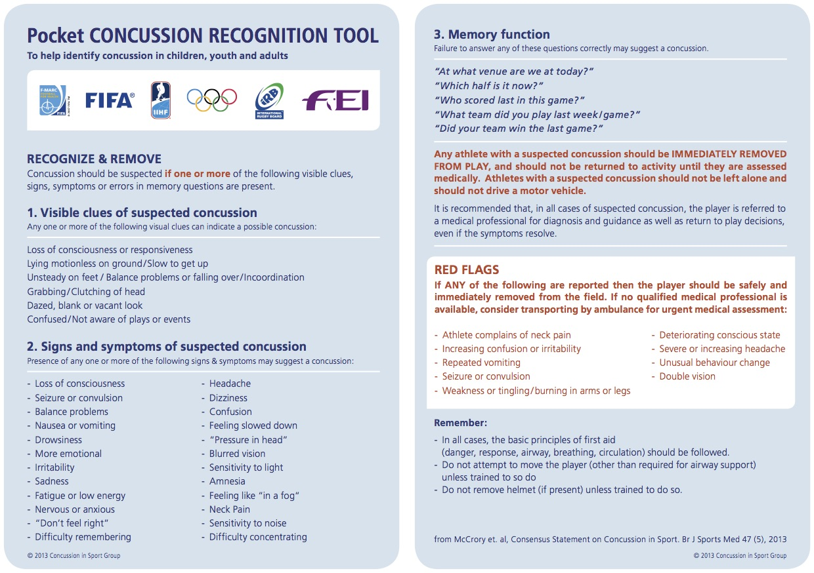

26. CHANGE ROOM POLICY
The NLSA adopted this Change Room Protocol for match officials in 2018.
When teams of officials are assigned to matches, there usually is only a single changing room available for their use, meaning that both male and female officials; and adult and youth officials may be assigned to the same room. It is important that in such circumstances arrangements are made so that individual privacy is respected, and that risky situations are avoided.
1. Only assigned match officials and assessors are permitted in the change room.
- Unauthorized visitors are not allowed in the Change Room prior to, during, or after any sanctioned game.
- It is the responsibility of all officials working a sanctioned game to ensure that a “professional” appearance and perception is maintained with regards to activities in the change room.
2. If male and female officials must share the same dressing room (and no separate lockable space exists in the dressing room), whoever arrives at the venue first has the opportunity to change first. The other officials will remain outside the room at this time.
- Changing rooms should be fitted with a means of locking the door from inside, to avoid inadvertent intrusion; or have private washroom space with locking doors.
- It is never appropriate to change or dress in the same space at the same time. Officials will take turns changing before and after games based on gender.
- The key should be held by the person within the change room
- If male and female officials are in the same dressing room at any time, the door must not be completely closed.
3. Cameras and any other electronic devices capable of capturing images are prohibited in the change room. Cell phones that have camera capability are permitted for the purposes of telephone communications only and imaging is strictly prohibited.
4. Any inappropriate behaviour in the change room must immediately be reported to a supervisor or someone in a position of trust and may need to be followed up in writing to the Referee Manager, or an NLSA staff or board member.
5. Regardless of gender, if any officials under 16 years of age are working with another official(s) who is 16 years or older, the same policy must be observed. The other officials will remain outside the room at this time.
- If <16 and >16 officials must share the same change room, whoever arrives at the venue first has the opportunity to change first.
- It is never appropriate to change or dress in the same space at the same time. Officials will take turns changing before and after games based on age and gender.
- The key should be held by the person within the change room.
- If <16 and >16 officials are in the same dressing room at any time, the door must not be completely closed.
It is essential to respect each other’s privacy. These guidelines are for the safety and protection of all officials.
Opposite genders must never use the change rooms at the same time without following the Change Room Protocol, regardless of age.
Officials found guilty of violating the dressing room protocol will be subject to disciplinary action.
It is recommended that this policy be posted publicly in changing rooms reserved for the use of match officials.
It is recommended that if possible private changing facilities be made available for each gender and for youth and adults.
Officials’ changing/ meeting rooms should be designed so that if needed, they are open to observation from outside, to ensure one on one interactions can be observed.

27. CANCELLATION POLICY
Officials will receive payment for Jubilee or Challenge Cup games cancelled or re-scheduled in the following circumstances:
1. The official was assigned to the game.
2. The match was re-scheduled or cancelled within 48 hours of the scheduled start time
3. The referee could not be re-assigned to another match in the same time slot
4. The re-scheduling or cancellation was not due to weather or field conditions.
5. If a referee is re-assigned to a match where the compensation will be less (e.g.., St. John’s Senior League versus Jubilee, centre referee versus AR) they will be paid the difference

28. RISK MANAGEMENT
The NLSA has approved a risk management/ safe sport policy available at
https://www.nlsa.ca/content/Safe-Sport
The policy does not expressly address officials so the purpose of this document is to provide guidance as to how it should apply to the refereeing programme. This document is a supplement to the NLSA policy document and will not repeat definitions and material covered there. All officials should be fully aware of the NLSA policy.
The main area of concern deals with interactions between adults and minors, or relationships between individuals one of which might be viewed as having a position of power over the other in vulnerable situations.

Rule of two
The “rule of two” concept is designed to apply to a coach-athlete relationship but has wider application. It is critical in ensuring a safe environment for all. Its application to officiating is mainly in the areas of:
- Instruction: instructors often have students defined as youth or minors.
- Assessment: assessors act essentially as coaches to referees and need to be aware of the rule of two.
- Mentoring: a mentor is essentially a coach and should follow the same procedures.
In all cases instructors, assessors and mentors should ensure that they are never one on one with a student or official under the age of 18 in a closed-door situation. Situations with a mix of gender, irrespective of age, should also follow the same principles.
The rule of two suggests that two coaches or qualified adults should be present in any such situation. It may be that a second individual will not be present in many instructional or mentoring/ assessing situations. In such cases it is critical to ensure that no one-on-one situations occur in areas that cannot be publicly observed. Thus, if for instance an assessor needs to hold a debrief with a youth referee, this should be done in the stands or field side, not one-on-one in the dressing room.
In an instructional setting, wherever possible, courses should be designed to accommodate two instructors, to allow the rule of two to be followed if required. There should be no need for a one-on-one situation to occur in standard referee courses; the most likely situation where this might occur would be at the end of the day where a single instructor remains with a single student who is waiting for pick up. Instructors in this situation should ensure that the student waits in a public space, not in the classroom behind closed doors.
Referees should be aware of, and abide by, the dressing room policy, included in the NLSA Risk management policy. If a referee team includes a mix of adults and minors, then one on one situations behind closed doors must be avoided. At minimum dressing room doors should be open, but it is the responsibility of the adult referee in such situations to move to a public place until a third member of the team is present.
It is recognized that a situation of one adult and a small group of youths may be perceived as a vulnerable situation, and if possible, the rule of two should be followed in these situations as well.

29. CONTACT INFORMATION
NLSA Office
Tel: (709) 576- 0601; Fax: (709) 576- 0588
Website: www.nlsa.ca
E mail: info@nlsa.ca

Referee Development Officer
Martin Batterson
Email: martin.batterson@nlsa.ca

