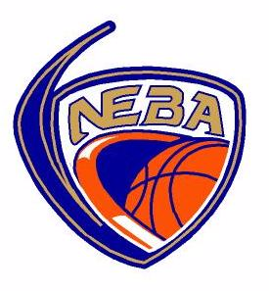

AS A COACH I WILL:
- Ensure that all athletes get fair playing time, instruction and support.
- Be reasonable when scheduling games and practices, remembering that young athletes have other interests and obligations.
- Teach my athletes to play fairly and to respect the rules, officials, teammates, and opponents.
- Not ridicule or yell at my athletes for making mistakes or for performing poorly.
- I will remember that children play to have fun and must be encouraged to have confidence in themselves.
- Make sure that equipment and facilities are safe and match the athletes’ age and abilities.
- Remember that children need a coach they can respect. I will be generous with praise and set a good example.
- Obtain proper training and continue to upgrade my coaching skills.
- Work in partnership and communicate well with parents and players and the NEBA executive.
- I will treat other coaches, players and referees with respect and yelling at participants will not be condoned.
- I will not wear my street shoes in the gymnasium, nor bring food, coffee or other drinks (except for water) into the gymnasium.
- I will maintain and look after the equipment provided to me by the NEBA equipment director, I will return it at the completion of my season when asked to do so by the equipment director. I will ensure that all jerseys and pinnies are returned washed and ready for the next season.

As a NEBA coach I have read and understood my commitment to the NEBA program.
My understanding if I violate this code of conduct that I may be disciplined by the NEBA executive.

Coaches signature: ________________________________________Dated : ___________________

