RCMP – Manitoba

Re: Criminal Record Check/Vulnerable Sector Check

_____________________________________________________
(name – please print)
Will be an (unpaid) volunteer with North East Softball Association.
He/She will require a Criminal Record Check including the Vulnerable Sector Check prior to volunteering for our association.
If you require further information, please do not hesitate to call me at (204) 297-7831.

Thank you,
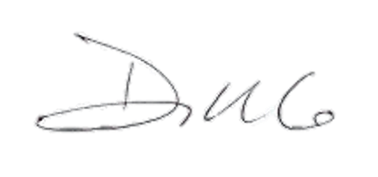
Daphne Wiebe
President, North East Softball Association

