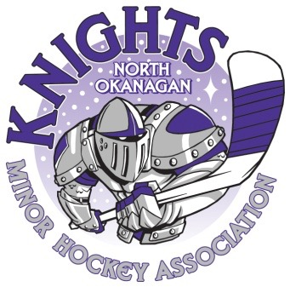
Welcome to the North Okanagan Knight’s
Initiation Fun Day 2020

Dear Managers and Coaches,
On behalf of NOMHA, we would like to welcome you to our tournament. We are happy to have you here with us and hope that you enjoy yourselves at our tournament. If at any time, you should need anything or have any questions please come to the raffle table at the arena and one of our volunteers will be pleased to help you.
We are looking forward to a great weekend of hockey. You will find a master schedule in the arena. Please be respectful of the game times, as we are running on a tight schedule. We ask that your team is dressed and ready to go on the ice fifteen minutes prior to the game, so there are no delays. Please be respectful of our facility by leaving the dressing room on time and tidy. Fair play codes are in effect for coaches, players, spectators and officials.
Please remember that this tournament is run by volunteers, if you have any issues or concerns, please contact Alida Lucas at tournaments@nomha.com. Have a great time and let’s remember the most important thing for our players is to have fun!
Sincerely,
North Okanagan Minor Hockey Association

