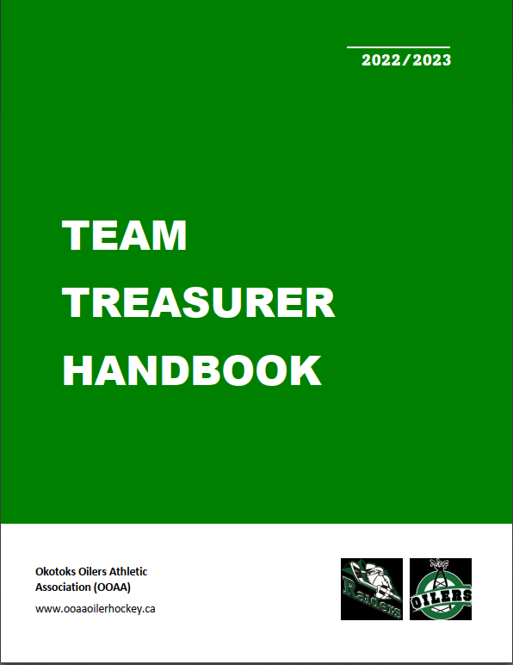

Welcome 2
Overview 3
Banking 3
Signatories 3
Payments 4
Deposits 4
Risk Management 4
Additional Team Bank Accounts 4
Returning Your Team Bank Account 5
Budgets 5
Cash Call 6
Fundraising 6
Fundraising with Raffles 6
Sponsorships and Donations 7
Unbudgeted Expenses 7
Reporting 7
Initial Budget Reporting 7
Financial Reporting to Parents 8
Financial Reporting to OOAA 8
Other Financial Reporting 8
Retention of Financial Information 9
Compliance 9

Welcome

Thank you for volunteering for the role of Team Treasurer for the upcoming minor hockey season.

Each OOAA team is responsible for its own financial operations. Teams must anticipate, budget and fundraise for any team costs, and must be accountable to both the association and parents through careful and sensitive budgeting.

The purpose of this document is to guide you through the Team Financial Guidelines & Policy. All association policies and procedures are available on our webpage.

As a registered Canadian amateur athletic association, OOAA is required to meet specific accounting standards. Failure to do so jeopardizes our status with our governing bodies, and can put our Team Treasurers, signatories and membership at risk. Teams must regulate their financial activities in a way that meets the association policy, ensures the proper use of funds and reduces risk to all parties.

We appreciate your assistance in this regard.

Have a wonderful season!

Overview

Fees paid to Okotoks Oilers Athletic Association (OOAA) for registration entitles each player to participate on a hockey team. OOAA provides each team in the association with jerseys, practice ice times, and registration and participation in the applicable hockey league.

Each team will incur additional costs during the hockey season that are not part of the fees paid to OOAA, and therefore must anticipate and budget for these costs. These additional costs are the responsibility of the team and parent group. The funds to cover these costs will have to be raised through a payment from each family or by fundraising to cover these costs.

The Team Manager must appoint a Team Treasurer who is responsible for collecting, banking, and disbursement of team funds. The Team Treasurer cannot be the spouse, direct relation, or a person residing in same residence of the team’s Head Coach or team’s Manager.

The Team Treasurer shall account for fundraising and spending of the hockey team, and report to OOAA and to the parents of the respective hockey team. The Team Manager is required to ensure that the Team Treasurer provides to the team parents and to OOAA the financial information as outlined in this document and as required by OOAA Policies & Procedures.

At any time, the OOAA Board of Directors can request team financial statements or authorize the OOAA treasurer to intervene on behalf of the society.

Banking

OOAA has set up team bank accounts for all teams. At your banking appointment you will have the option to choose a bank plan that fits your team needs. Currently the team account is set up as a NPO account. Bank location:
ATB Financial
31 Southridge Dr, 131
Okotoks, AB T1S 2N3

Signatories

Each team requires two signatories — the Team Treasurer and a second signatory (commonly the Team Manager but can be another parent). The two signatories should not have a personal relationship or connection outside of the team. The segregation of duties means that no single person is responsible for a transaction from start to finish.

Once your two signatories selected, you are required to email these details to kdengler@okotokshockey.com. We will then notify the OOAA banker at the Branch.

Payments

Cheques written from the team bank account require two signatures. When writing a cheque, please fill out the description line and, if one is available, write the invoice number on the cheque.

E transfers are available to be made from the NPO account assuming that there are two approvals required (this is set up as a requirement).

Ensure receipts are obtained or a copy provided for all transactions. In general, receipts should be numbered for easy tracking and should contain the following information:
- Date of transaction
- Service rendered/purpose of payment
- Company owing payment
- Company receiving payment
- Signature of individual accepting payment
- Amount
- Form of payment

Deposits

Deposits can be made using the ATM card, in-person through a bank teller or electronically deposited. E transfer deposits must use the OOAA email provided from the association. All funds received must be deposited as soon as practicable.

Risk Management

The OOAA Team Financial Guidelines & Policy found in the OOAA Policy Manual are intended to meet the accounting standards of our governing bodies, to reduce the risk of fraud and susceptibility to phishing scams, to ensure that all transactions cannot be re-directed into an account at another bank, and to ensure that all transactions are tracible in the event of an audit. Therefore:

- Use of personal bank accounts is NOT permitted.
- Interac e-Transfer payments can be sent where both signors must approve the transfer prior to it being sent. There must be a control in place to ensure there are two approvals.
- Do not make cheques out to cash.

Additional Team Bank Accounts

Should your team host a tournament, you have two options for managing tournament finances:

- Use your Team Bank Account
- Contact OOAA kdengler@okotokshockey.com to set up a separate tournament account. If you anticipate hosting a tournament and would like to set up a tournament account through OOAA banking, please contact us as soon as possible.

Returning Your Team Bank Account

Each team is required to leave a minimum balance of $30 at the end of the year. Any remaining monies should be:

- Distributed equally to parents up to the amount of the cash calls they have respectively contributed.
- Donated to the OOAA.
- Donated to another charity organization(s).

Each parent must have the option to receive back their pro-rata share of any remaining team funds (based on cash call contributions) and/or to donate their share in the manners outlined above.

Any funds remaining in the bank account as of June 1, 2023 will be transferred to the OOAA Financial Assistance Fund.

Bank cards and unused cheques are to be delivered to the OOAA Treasurer’s office at the end of the season. The address is:

1020, 11012 Southport Road
Calgary, Alberta
T2W 4X9

Budgets

Each team must prepare a budget for the upcoming hockey season. An optional template is provided on the OOAA website. Examples of costs may include, but are not limited to:

- Ice time
- Referee costs
- Meals
- Trainers
- OMHA fees
- Coach Honourarium
- Hotels
- Tournament Fees
- Team Equipment
- Team apparel (including hockey socks)
- Team social events
- Bussing, driver tip
- Player Development (i.e. Dryland Training, etc.)
- Practice Jerseys
- Year End Party/Gifts
- Bank Fees

Cash Call

The intention of a cash call is to provide immediate cash flow for a team’s operations and activities. The amount of a cash call should be appropriate for the budget. Cash calls should not be made in the absence of an approved team budget.

Returning cash calls to parents should be a priority if any balance from fundraising is remaining in the team account at the end of the season. It is important to note that parents can only be reimbursed for the amount that they have contributed as a cash call. Any funds remaining in the bank account as of June 1, 2023 will be transferred to the OOAA.

Fundraising

OOAA does not restrict the type of costs that a team may incur. Parent oversight and good judgment will be the overall deciding factors when it comes to determining what spending is appropriate. These costs are to be shared equally by the parents of the hockey players and can be minimized by fundraising activity.

Fundraising activity also needs to be planned & budgeted for and can include, but are not limited to:
- Silent Auction
- Bottle Drives
- Fundraising Sales
- Raffles

The amount and type of fundraising activities is determined by the parents of each hockey team. There is not a requirement to do any fundraising, however fundraising will reduce costs to the parents to cover team expenses.

Fundraising with Raffles

If a raffle (i.e. 50/50 draw, raffle for prizes, etc.) is planned as a team fundraising activity, the team is required to operate as a properly licensed raffle as per The Alberta Gaming, Liquor and Cannabis Commission (AGLC) regulations and requirements. In order to obtain a raffle license, a team must complete the form Eligibility for Raffle License which can be obtained at http://www.aglc.ca .

Application must include “Okotoks Oilers Athletic Association - TEAM NAME.” The address on the application is the member applying for the license.
Approval is normally received from the AGLC in 3 to 5 business days. A team only needs to apply for eligibility one time. Once the team receives its AGLC identification number, the team can apply to obtain raffle licenses for any raffle activity planned (done online via AGLC or at any Alberta registry agent). TEAMS WILL NOT BE ABLE TO USE THE OOAA’s AGLC ID # TO OPERATE TEAM LEVEL RAFFLES.

It is important to ensure that the Team Manager and/or Treasurer are familiar with the AGLC requirements for operating a raffle, and that all licensing and record keeping and reporting requirements are met. A summary of your raffle fundraising must be sent to AGLC using a prescribed reporting form within 60 days of your raffle event. Failure to do so will jeopardize the OOAA’s own status with the AGLC and may affect our ability to fundraise as an association in the future, including our own raffle license and casino fundraising.

If your team plans to operate a raffle and is applying to the AGLC for eligibility – please notify OOAA by sending an email to kdengler@okotokshockey.com outlining your plans.

For further information: https://aglc.ca/gaming/charitablegaming

Sponsorships and Donations

A team may be offered a sponsorship or donation from an individual or company in support of the team’s expenses. The sponsorship or donation may be designated for a specific expenditure or may be used at the team’s discretion.

Sponsorships and donations may also take the form of a good or service (rather than money). It is recommended that all sponsorships and donations to a team be acknowledged by some form of thank you note or letter of appreciation to the donor.

All apparel sponsorship should follow the OOAA Hockey Equipment and Clothing policy in the Policy Manual (Section 19).

Unbudgeted Expenses

Any unforeseen (unbudgeted) expenditures/payments that arise during the year should be discussed with the parents before any transaction takes place.

Reporting

Initial Budget Reporting

Team Budgets should be completed by the Team Treasurer as soon as possible and emailed to the team for approval. 75% approval is required from the parent group. Once reviewed and approved, each team must report the following to the OOAA Treasurer (kdengler@okotokshockey.com) by November 15, 2022.

- An email that identifies your team and provides confirmation that the attached budget has been approved by 75% of parents.
- Approved Team Budget

Financial Reporting to Parents

It is recommended that the Team Treasurer provide regular updates to the team with respect to the financial position of the team in order to prevent “surprises” and/or misunderstandings. A simple financial update could include a summary of money spent and on what, and how much more would be required to pay for budgeted expenditures as outlined in the initial budget.

A final Budget vs. Actuals Report must be prepared and provided to parents and OOAA. This can be included in the optional template is provided on the OOAA website. The report should account all money raised through fundraising, parent contributions, sponsorships, donations, etc., and all money spent compared to the approved budget. This must be done by the end of the month following the end of the team’s hockey season (end of season is defined as final game played).

Financial Reporting to OOAA

At a minimum, OOAA requires the following financial reporting:

1) Initial Budget Reporting to OOAA Treasurer by November 15, 2022 as detailed above.

2) An email that includes the following sent to the OOAA Treasurer (kdengler@okotokshockey.com) within 60 days of the end of the team’s hockey season (end of season is defined as final game played):
- A copy of the Budget vs. Actuals Report sent to parents.
- Confirmation that excess funds were distributed to the parents or donated as applicable.

Other Financial Reporting

A team parent or a member of the OOAA Board of Directors is entitled to request financial information at any time from any OOAA team. If requested, the team must provide the following within seven (7) days of the request, as applicable:

- A copy of the most recent bank statement.
- A list of outstanding items that are to be paid.
- A current financial statement indicating the funds raised and money spent up to a date that is within 30 days of the date of the request.

Any parent request for any of the above financial information is required to be in writing (i.e. email) with a copy of the request sent to the OOAA Treasurer at kdengler@okotokshockey.com.

Retention of Financial Information

Receipts (or copies of receipts) should be obtained where applicable for expenditures and retained with the team financial records. The financial records of the team must be kept for three years following the end of the hockey season.

Compliance

Compliance with the above financial guidelines and policies is mandatory. Please contact the OOAA Treasurer with any questions or if assistance is required.

Non-compliance can result in sanctions against the head coach, team manager, or team treasurer as deemed appropriate by the OOAA Board of Directors.

