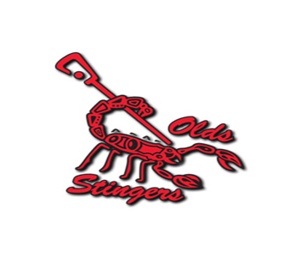
Olds Lacrosse Association
Player Code of Conduct
It is the intention of this contract to promote fair play and respect for all participants within the Olds Lacrosse Association (“OLA”). Accordingly, all players MUST sign this contract before being allowed to participate in any OLA lacrosse sanctioned activity and must continue to observe the principles of fair play and the rules, regulations, policies and procedures of OLA. Failure to observe the terms of this contract may result in disciplinary action being taken against the member in violation. Said disciplinary action may include but is not limited to: suspension or expulsion from OLA. Any disciplinary action would be governed by the OLA discipline chair and any OLA policies that may be relevant to the matter at hand.

- I will play lacrosse because I want to
- I will play fairly and respect the rules, the officials, my opponents, my teammates and my coaches according to the fair play principles of the Government of Canada (Fitness and Amateur Sport)
- I will do my best to be a team player
- I will observe and abide by the policies of OLA, the Alberta Lacrosse Association and the Canadian Lacrosse Association
- I will do not miss practices unless there is a specific reason and my parent has notified the Coach or Manager of my absence
- I will respect the arena facilities and staff wherever I am privileged to play. I will act accordingly in all public places such as hotels, restaurants etc. during all OLA lacrosse sanctioned events
- I will refrain from using foul language or becoming physical towards coaches, teammates, officials and opponents
- I will respect the judgments and rulings of officials and coaches

Player Name: ___________________________ Player Signature: _________________________________

Date: _________________________
This document is to be reviewed and signed by both parents, the absence of a signature does not excuse the party from the standards or consequences set out by the OLA.

