U9 - LTAD Rules
Long Term Athletic Development Program
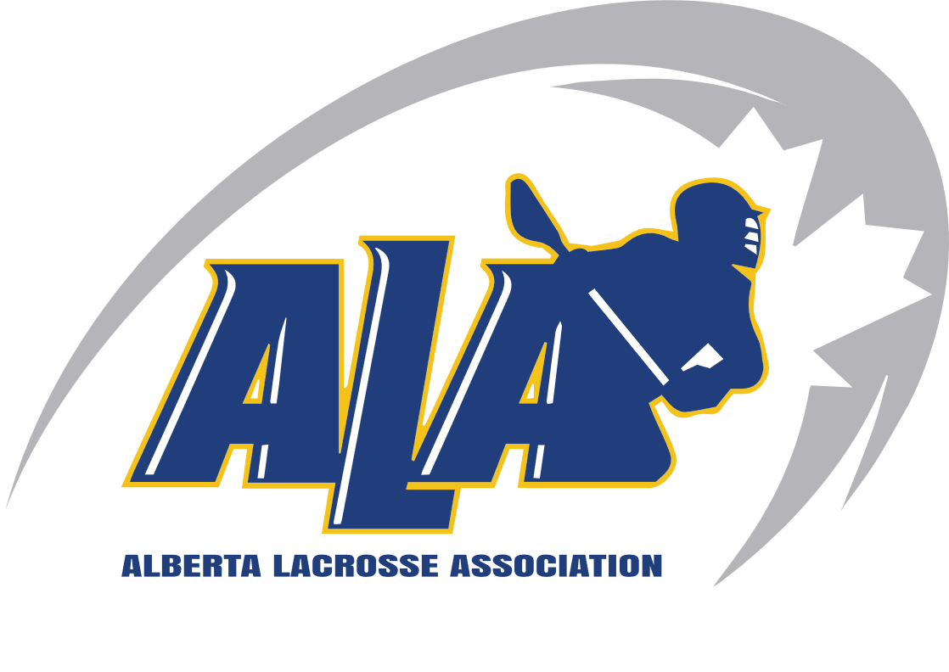

U9-
• No Shot Clock (ALA Rule)
• The stick shall measure no longer than 40” (101.6cm) and no shorter than 26" (66.04cm). • The ball used shall be a standard lacrosse ball that conforms to CLA standards and is approved by the CLA.
• Each goal shall consist of two upright poles 3’ (91.44cm) apart, joined by a rigid crossbar 3’ (91.44cm) from the playing surface
• All players must wear the following equipment: helmet, mask, elbow pads, mouth guard, gloves, jock/jill strap, shoulder and arm pads, back/kidney pads.
• Soft knee pads are optional.
• The duration of the game shall be three 15-minute straight time periods, with 3-minute intermissions.
• Each period starts with a face-off, as well as after each goal scored.
• Shift changes are done on the fly
• NO coaches on the floor
• A score sheet (provided by the home team) must be completed prior to each game.
• All goals, assists, and penalties are recorded on the game sheet and displayed on the scoreboard.
• A differential of more than 5 goals shall not be displayed but still needs to be recorded on the score sheet.
• Defensive players may place their stick on their opponent and push them away (“place and push”).
• Any offensive player (including the ball-carrier) who deliberately charges toward an opponent may be assessed a charging penalty.
• There is to be NO BODY-CHECKING.
• A defensive player may check an opponent by placing their stick head on the opposing player’s stick head.
• Fall Back Rule applies. The Fall-Back Rule Explained:
• Applies whenever possession is gained by the goalkeeper (by a save or awarded possession).
• All opposing players must clear out to the neutral zone (over the nearest restraint line) before they can re-enter the offensive zone.
• If the opposing team fails to clear all players to the neutral zone before re-entering, the play will be stopped, and possession will be awarded to the goalkeeper.
• The referee shall ensure that all opposing players are in the neutral zone before restarting play.
• All of the goalkeeper’s teammates must clear out of their dotted line/24’ arc.
• Goalkeeper must PASS the ball to a teammate OUTSIDE the 24’ arc, in an overhand passing motion.
• Rolling the ball to a teammate from the crease is not allowed
• If the pass to a teammate is unsuccessful (i.e., does not leave the 24’ before being retrieved), the referee shall blow the whistle to stop play and allow the goalkeeper to try again

