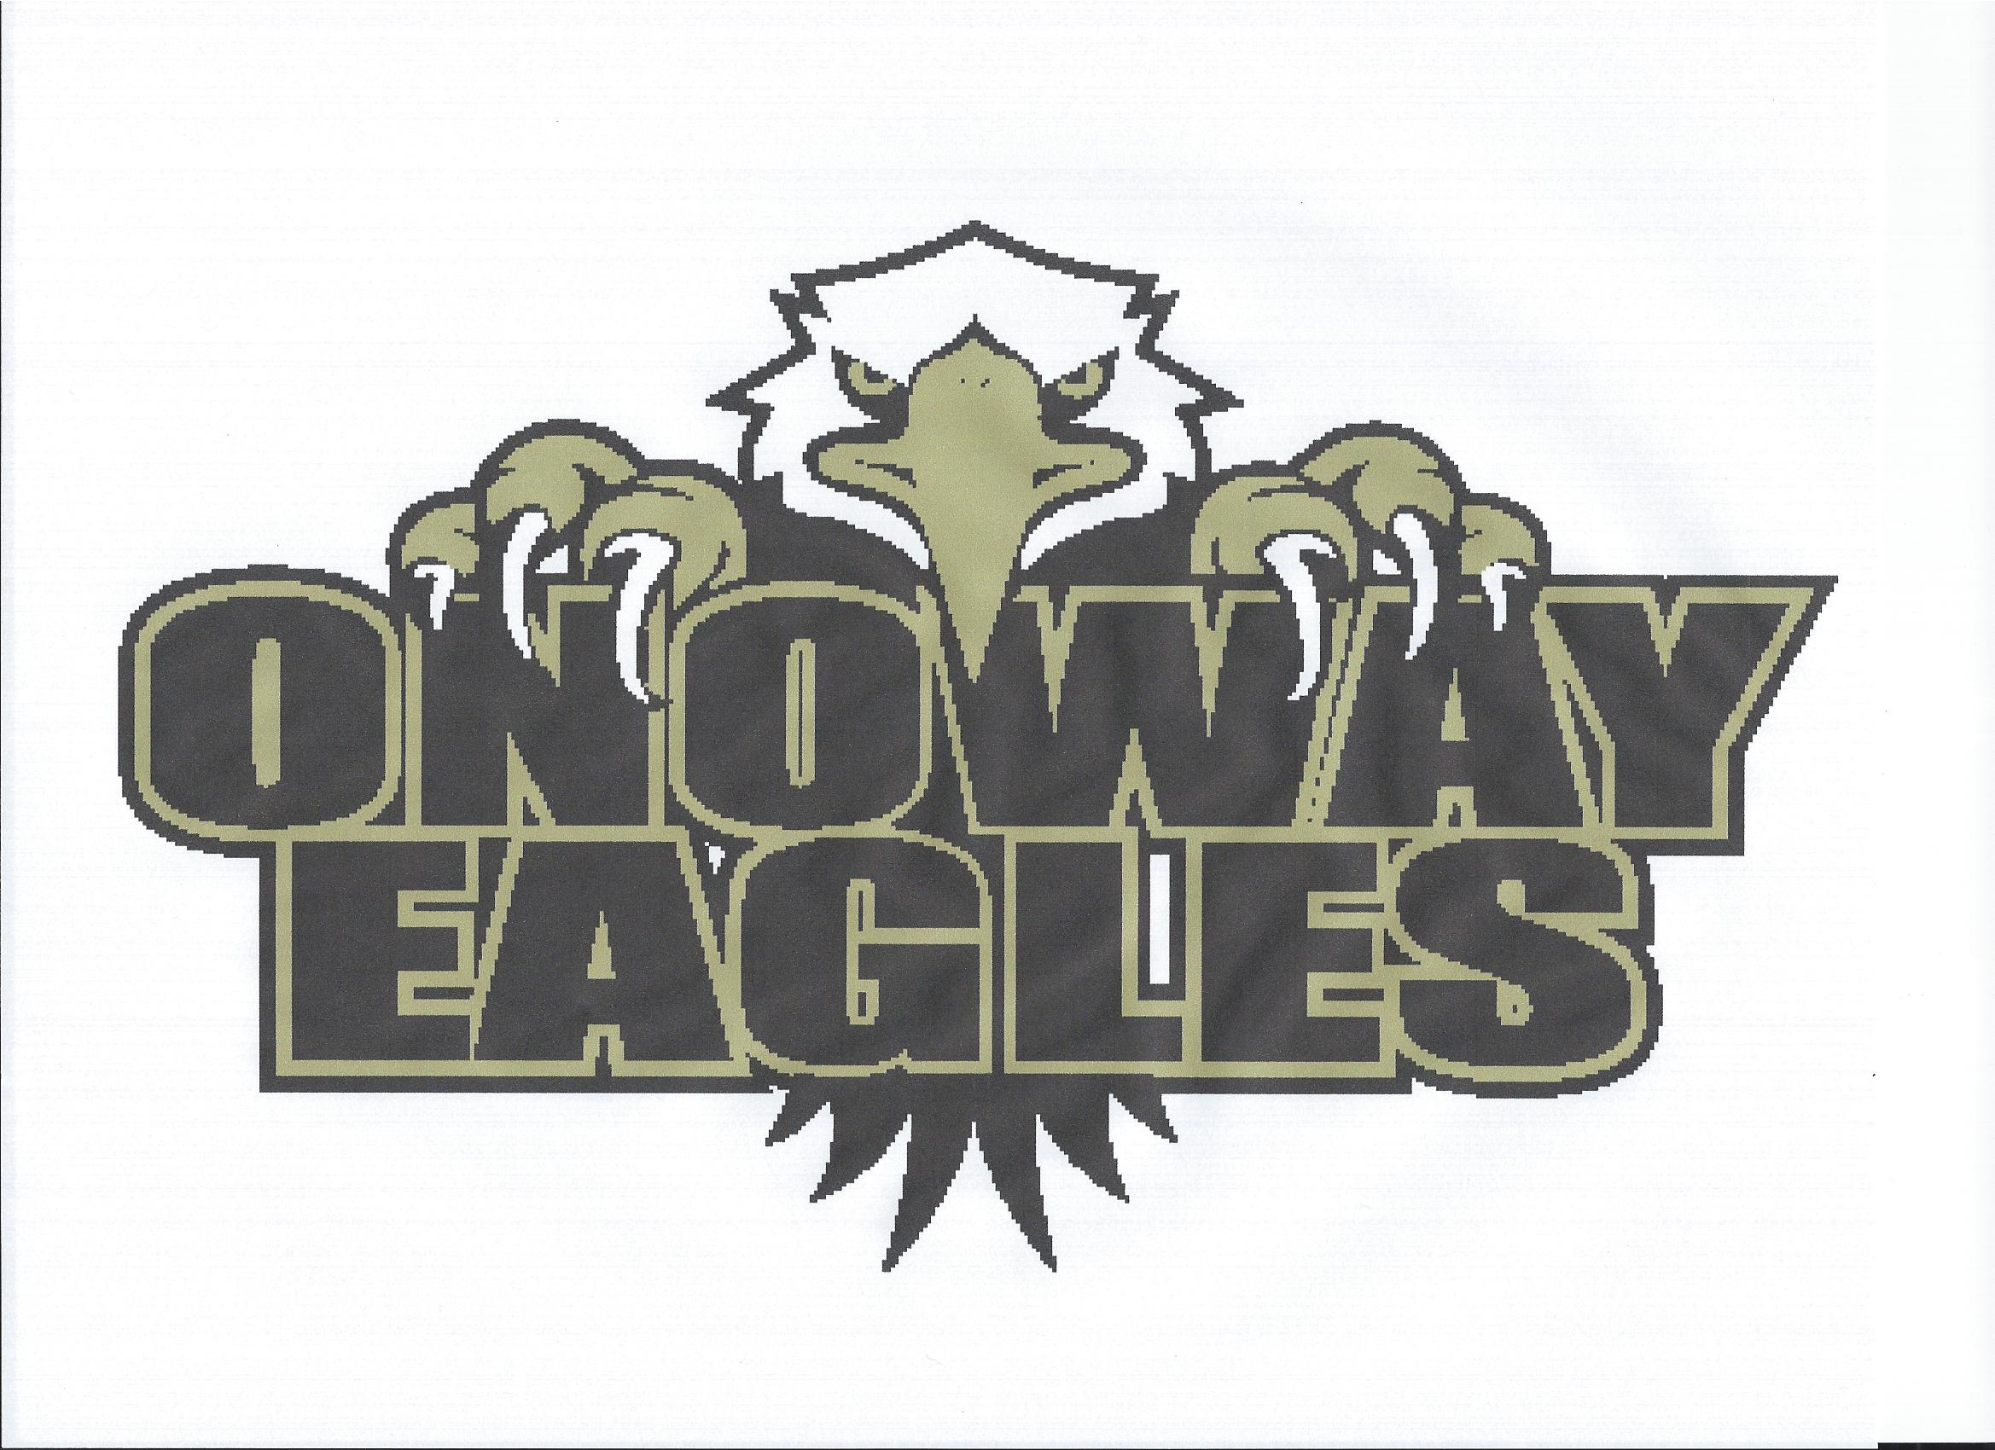
Coach Application
2021/2022 Season

Name:
Address:
City: Postal Code:
Home Phone: Cell Phone:
Email Address:
Date of Birth (D/M/Y):

Division you would like to coach:
Please indicate by prioritizing the level in which you would like to coach. Indicate your desire to be a head coach or assistant.
Level | Head Coach | Assistant Coach
U7 (Initiation)
U8 (Novice)
U11 (Atom)
U13 (Peewee)
U15 (Bantam)
U18 (Midget)

Coaching Certification:
Course | Year Completed | Location Completed
Intro to Coaching/Initiation
Coach Level/Coaching stream
Development1
Development2
Speak Out
Checking Skills
Safety
OldNCCPLevel1
OldNCCPLevel2
Other(please specify)

Hockey Coaching Experience:
Year | Age Group | Association | Role (Head Coach, Asst. Coach)

Other Coaching Experience (Other Sports):

Year | Sport | Age Group | Community | Role (Head Coach, Asst. Coach)

Hockey Playing Experience:
Year | Level | Association/ Team | Coached under

Briefly describe your coaching philosophy:

Highlight your team initiatives, objectives and goals:

Questions | YES | NO
1. Do you have a child registered with Onoway Minor Hockey(OMH)?
2. Have you ever received disciplinary action from a minor sports association?
3. Have you ever had a positive hit in obtaining a criminal record check?
4. Are you certified for the level for which you are applying?
5. If you are not certified at the required level, are you willing to take acourse to attain the required level?
6. Would you be willing to work with a Coach mentor?
7. Would you be willing to be a Coach Mentor too the other coaches in the association?

Coaching References:
Name | Contact Number | Position

******Please submit a current Criminal Record Check with your Application for the 2021-2022 Season*******

Declaration:
I, the undersigned certify the above information to be true and inconsideration of the granting of this certificate to me with the privileges incident there to, and by signing this certificate I have become subject to the rules, regulations and decisions of Onoway Minor Hockey, which may be restricted in some areas such as movement from team to team, conduct etc., and I agree to abide by such rules, regulations and decisions of Onoway Minor Hockey. Further, the information requested above is required by Onoway Minor Hockey to facilitate hockey programs on behalf of the registrant, volunteers and Onoway Minor Hockey. Onoway Minor Hockey will treat this personal information with the utmost respect and in accordance with Onoway Minor Hockey Privacy Policy at all times.

Onoway Minor Hockey does not sell, trade or otherwise share information we collect outside of the association, leagues associated with, Hockey Alberta or Hockey Canada, however, we may from time to time use this information for the purpose of offering additional services and/or hockey specific research. By signing this registration form you are acknowledging that you have read and understand this statement.

Signature: Date:

All applications should be submitted to the OMHA Vice President for the upcoming
2021-2022 Hockey Season via the VP mail slot or at VPOMHA@GMAIL.COM

