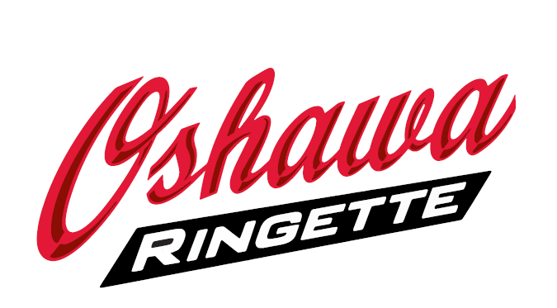

2022 - 2023 Refund Policy

Refunds will only be given with written requests. Please submit your request by email to the oshawastormpresident@gmail.com

Please allow approximately 3 weeks for processing from the time of notification.

Refund Schedule

On or before September 14, 2022 | 100 % of OSRA registration fee
After September 15, 2022 | 80 % of OSRA registration fee
After November 1, 2022 | 50% of OSRA registration fee
After December 31, 2022 | No refund of OSRA registration fee

Team fee refunds are handled at the team level.

