
OVDGHA AGM Minutes

Wednesday, May 21, 2025

6:30 P.M

In Person Meeting/Virtual Meeting

Meeting called to order 6:43 P.M

Attendance of voting members:
In Person: Colin Etmanski, Jan Sunstrum, Megan Kelly, Thea Nicolai, Amber Costello, Ed Tierney, Brandy Sandrelli, Kyle Sandrelli Virtually: Erika Leu & Jon Malcolm

Attendance of Non Voting Members:
Kenny Peplinskie, Jon Murray, Jessica Fleury, Monica McGinnis, Yvonne Goulet, Meghan Pattinson, Jessica Ullrich, Mike McMahon, Michelle Buckle, Jon Buckle, Amber Regier
Virtually: Lindsay McCleese, Dan Fleury

Approval of Agenda: Motioned by Jan, seconded by Ed. Motion carried.

Adoption of 2024 AGM Minutes: Motioned by Megan, seconded by Kyle. Motion carried.

President Report: Couple of new teams this year. Many successful tournament wins throughout all the age groups. U13B and U18C went to Provincials. U18C won 3rd for Provincials which was amazing. U9 House went well and had great registration. The League is growing.

Vice President Report: We had some suspensions this year and a social media incident which has been dealt with.

Registrar Report: Had a successful tryout registration and all went well. Will open registration for house soon.

Treasurer Report: We have a balance in the account of $57,000. Some money still owing for last’s year registrations but not much.

Secretary Report: I. See Appendix A.

Media Officer Report: Our social media presence has grown through the season. We can see that our engagement has increased and we have more followers.

Ice Allocator Report: II. See Appendix B

Risk and Safety/Equipment Report: All jerseys have been returned from the teams. They are with either the new coaches for the upcoming season or in the storage room. Tryout jerseys were difficult as we did not have enough. We will know better for next season. U13 needs new goalie equipment.

Members-at-large reports: Kyle and Ed reported that they have been working on the golf tournament and just finished helping with the banquet. Ed has been in discussions with the Silverstick Committee about bringing Thunder back into the fold.

Amendments and Notices of Motion:
III. Proposed Amendments to the OVDGHA Rules and Regulations
A Suggest to add Fundraising Policy

B. Moved by Megan to add Fundraising Policy into the Rules and Regulations. Seconded by Yvonne Goulet. All in favour. Motion Carried.
IV: Proposed to add Exec Position of Fundraising Officer
B. Motioned by Adam. Seconded by Yvonne Goulet. All in favour. Motion carried.

New Business:
Election of Executive
- Election of President
- Megan nominated Colin Etmanski. Adam seconded. Colin graciously accepted to continue his role as President.

- Election of Vice-President
- Megan nominated Jan Sunstrum. Colin seconded. Jan graciously accepted to continue her role of Vice-President.

- Election of Treasurer
- Jan nominated Adam Law. Colin seconded. Adam graciously accepted to continue his role as Treasurer.

- Election of Registrar
- Jon Murrary nominated Erika Leu. Mike McMahon seconded. Erika graciously accepted to continue her role as Registrar.

- Election of Secretary
- Jan nominated Megan Kelly. Adam Seconded. Megan graciously accepted to continue the role of Secretary.

- Election of Social Media Officer
- Jan nominated Brandy. Megan seconded. Brandy graciously accepted to continue in her role as Social Media Officer.

- Election of Ice Allocator
- Colin nominated Thea. Megan seconded. Thea graciously accepted to continue in her role as Ice Allocator.

- Election of Equipment Manager/ Risk and Safety Officer
- Jan nominated Kyle. Seconded by Ed. Kyle graciously accepted the role of Equipment Manager/Risk and Safety Officer.

- Election of Members at Large
- Ed Tierney re-appointed as Member at Large
- Jessica Ullrich appointed as Member at Large
- Lindsay McCleese appointed as Member at Large
- Meghan Pattinson appointed as Member at Large

- Election of Fundraising Officer (New position 2025)
- Ed Tierney nominated Yvonne Goulet. Brandy seconded. Yvonne graciously accepted the role of Fundraising Officer.

U9 Recap: Jon Murray discussed the success of U9 last season. He plans for a competitive U9 team this season. Notes that requirements for U9 is a roster of 16 skaters, 2 goalies. He asked about borrowing rink bumbers for half ice. Thea will confirm with the rinks. He mentioned for U9, green arm refs are encouraged.
Suggested to run a fundamentals type program this season with U15/U18 volunteers.

House League Concerns: Jessica Fleury and Mike McMahon are concerned for the future of house league. Mentioned girls have left due to no numbers for a team. Exec will continue to promote house league enrollment but cannot run teams without coaches.

Motion to adjourn: Moved by Megan, seconded by Ed. Motion carried.

Meeting Adjourned at 9:13 P.M

Appendix A

OVDGHA SECRETARY REPORT 2024/2025 SEASON

Prepared by Megan Kelly

The OVDGHA had a great season of development and growth. I joined the Executive this season so there were some growing pains as I learned to navigate the website and set up the managers in RAMP and linking it all at the beginning of the season.
Brandy and I worked well together with ensuring a cohesive partnership with posting our messages and posters to both the website and our Facebook page.

Appendix B

OVDGHA Ice Allocator Report 2024-25 Season

Prepared by Thea Nicolai

Conditioning Ice ran in August for total of 10.5 hours

Tryouts were completed using Pembroke ice to form the U11B, U13B, U15BB, U18C and U18BB competitive teams

New this year - each rink required individual proof of insurance (some required us to use a specific portal to submit for approval) along with our seasonal contracts - all of this will need to be reviewed and completed annually

5 main arenas for ice PMC, Cobden, Renfrew, Beachburg Westmeath - Pembroke and SIlver Dart provided extra ice at the beginning of the season to help offset till the ice was in everywhere - all ice was available including Westmeath following Thanksgiving weekend

Our seasonal ice ended Mar 30 - this left time without predictable practices before provincials - For next season will ask areas to include the first week of April in our seasonal ice
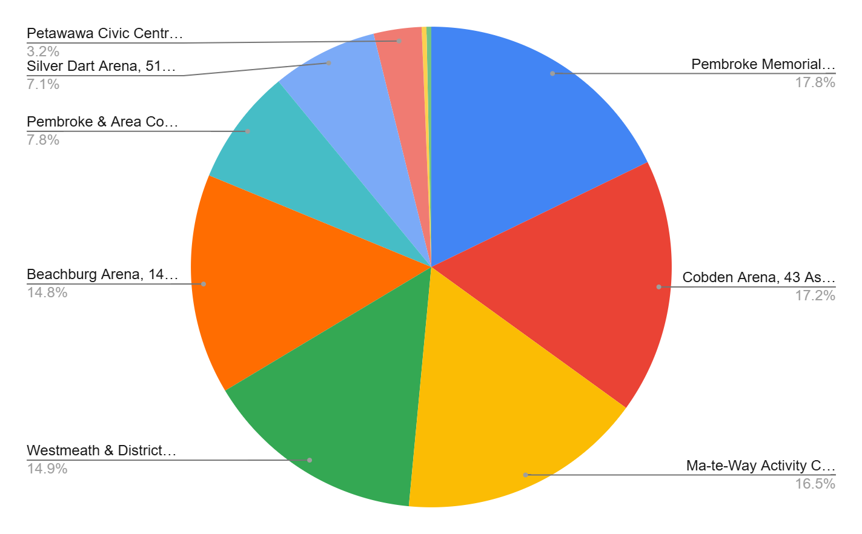

We had an abundance of ice this season - we gave back hours of ice weekly throughout the season and we transferred 12 hours of ice to Titans (Renfrew, Westmeath, Beachburg and Silver Dart)

Ice allocated per Team

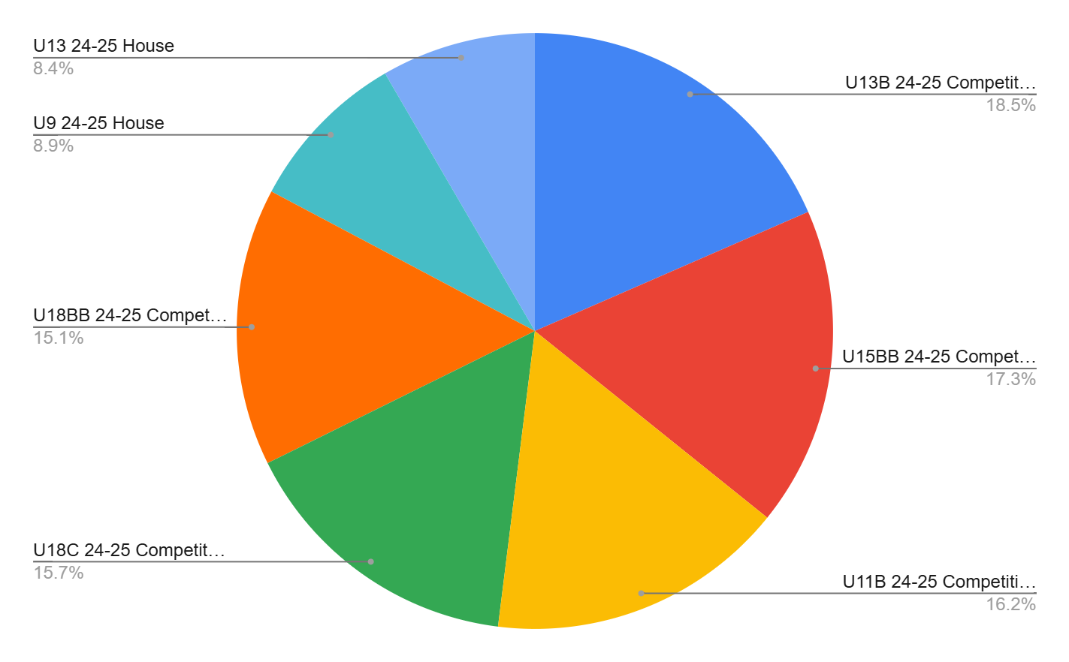

Total hours of ice 620:30
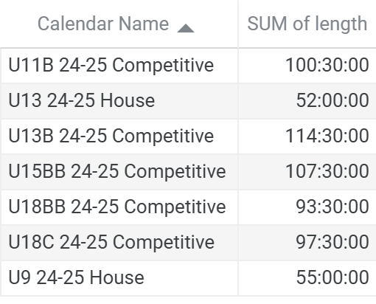

Each of the Thunder teams had at least 1 PMC game this season

U9 - Petawawa Civic center and Cobden 5pm start
U11B - Games -mostly Cobden and Practices mostly Beachburg and Westmeath
U13 house - Games and practices mostly in Beachburg
U13B - Games -mostly Cobden and Practices mostly Westmeath (1 practice in Barrys Bay at request of the team)
U15BB - Games -mostly Renfrew and Practices Renfrew and Pembroke
U18C - Games -mostly Cobden and Practices mostly Renfrew
U18BB - Games mostly Pembroke (1 game in Deep RIver) and Practices mostly in Pembroke and Renfrew
Spring Tryouts were held at Silver Dart for U13-U18 and U9-U11 had some development ice
U9 and U11 will have tryouts in September

Pembroke will not have any ice till Sept 5th next season

Working on securing ice for next season so far Renfrew, Silver Dart and Westmeath agree to provide the same ice as this past season.

Thunder day for 2025-26 season - Ice booked Dec 14th both pads all day at Silver Dart - also able to use the Canteen - Plan to book home games for every Thunder team that day with events like raffles, 50/50, chuck a puck etc

Thank you to all the team managers and coaches this season.

