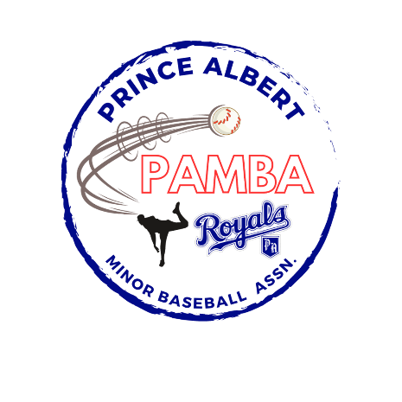

11U AA Provincial Team Roster

Ellis Anderson

Sawyer Bonthoux

Dawson Boulet

Grady Bradbury

Beckham Byers

Rhett Collins

Brandt Fazio

Meyer Gane

Luke Kulczycki

Billy Ouellet

Brody Parenteau

Cruz Worth

Head Coach: Dane Byers

Assistant Coach: Dave Ouellet, Curtis Bradbury, Brad Parenteau, and Quinn Worth

Manager: TBD