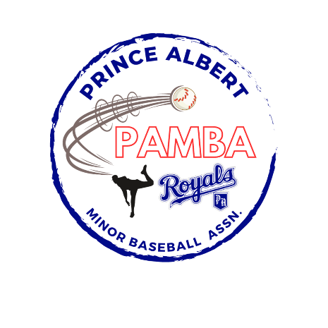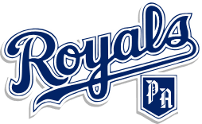

11U AA Provincial Team Roster

Ryker Ambrose

Declan Callaghan

Lawson Delorme

Logan Duret

Noah Dunn

Emerson Halkett-Fiddler

Camden Holcomb

Parker Krasilowez

Easton Ostoforoff

Emmerson Rumpel

Wyatt Toews

Blake Wawro

Head Coach: Dan Toews

Assistant Coach: Jordan Ambrose, Shane Callaghan, Chris Delorme, and Andrew Ostoforoff

Manager: TBD