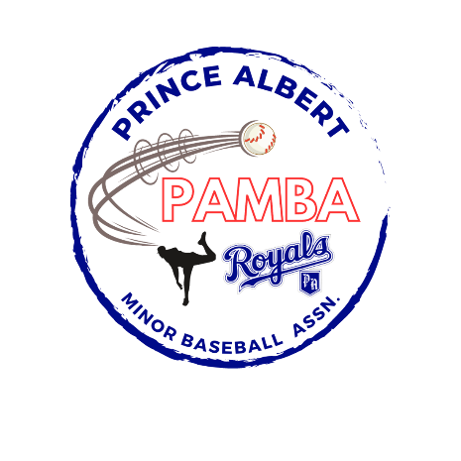
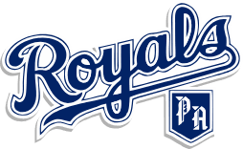

11U AA Second Team Roster
Cooper Bourdon
Riggins Braaten
Ben Charles
Noah Dunn
Jack Hoey-Seto
Percy McBeath
Crew Mushka
Austin Noble
Ben Pilon
Emerson Rumpel
Thomas Swaby

Head Coach: Nathan Noble

Assistant Coach: Jason Bourdon, Cliff McBeath, Trevor Rumpel, and Dave Seto

Manager: TBD
Treasurer: TBD

