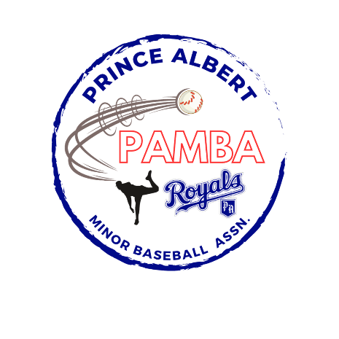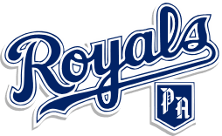

13U AA Royals Provincial Team Roster

Boston Byers

Maclain Dallyn

Beckett Grimard

Trysten Groerick

Brody Hanson

Tobin Hurd

Nolan Kihn

Connor Kovitch

Bohden Kuzma

Tyson Noble

Weston Nygaard

Head Coach: Tom Hurd

Assistant Coach: Shane Nygaard, Chris Dallyn, and Nathan Noble

Manager: TBD