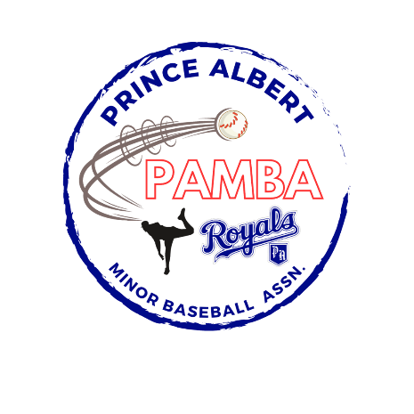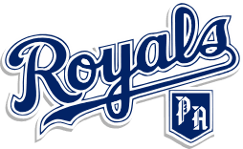

13U AA Royals Provincial Team Roster

Nyjah Ancheta

Hudson Ball

William Boden

Jamie Cournoyer

Jaxx Duerksen

Joaquin Elliot

Sam Gray

Charlie Harvey

Kody Kulczycki

Owen Lypchuk

Nixon See

Nathaniel Stasiw

Head Coach: Matt Gray

Assistant Coach: Curtis Stasiw and Greg Harvey

Manager: TBD