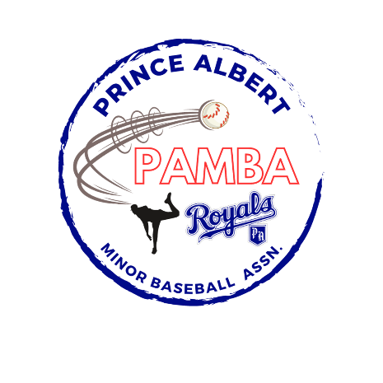

15U Tier 1 AA Provincial Team Roster
Daniel Acorn
Josh Bonthoux
Declan Borthwick
Criseyde Borthwick
Marcus Exner
Emmett Kihn
Seamus McFarlane
Jett Miller
Nash Noble
Aiden Strachan
Nash Stacey
Noah Van Otterloo

Head Coach: Jason Van Otterloo
Assistant Coach: Corey Borthwick

