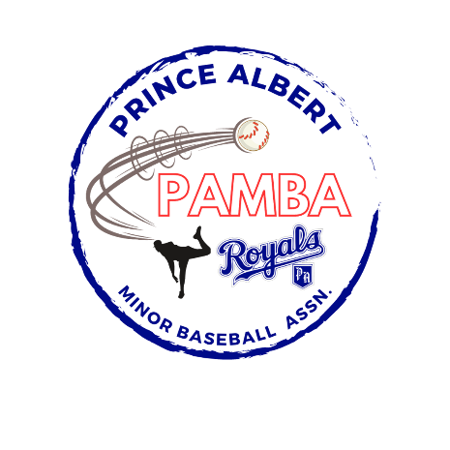

15U Tier 1 AA Provincial Team Roster

Josh Bonthoux

Beckett Dallyn

Marcus Exner

Emmett Kihn

Declan Lavallee

Seamus McFarlane

Jett Miller

Nash Noble

James Shultz

Nash Stacey

Tommy Sutherland

Noah Van Otterloo

Head Coach: Jason Van Otterloo

Assistant Coach: Chris Dallyn, Mike Bonthoux, and Nathan Noble