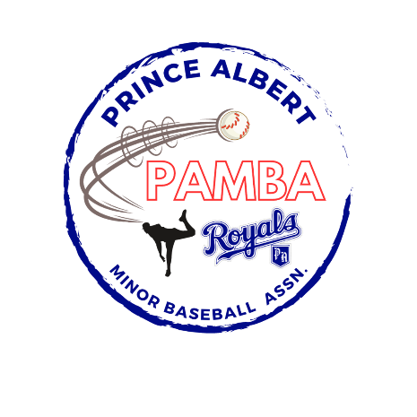

15U Tier 2-6 AA Provincial Team Roster
Jaxson Boyer
Beckett Dallyn
Rowan Fox
Declan Lavallee
Luca Lavoie
Ashdyn Lysak
Brooklyn Leibel
Ronan Marion
Alex Moose
Jace Poulin
Grayson Ross
Drew Schultz

Alternate Players:
Derek Bear
Tommy Sutherland
Kale Worobec

Head Coach: Trevor Leibel

Assistant Coaches: Terry Lysak, Chris Dallyn, Landon Lavallee, and Marc Poulin

