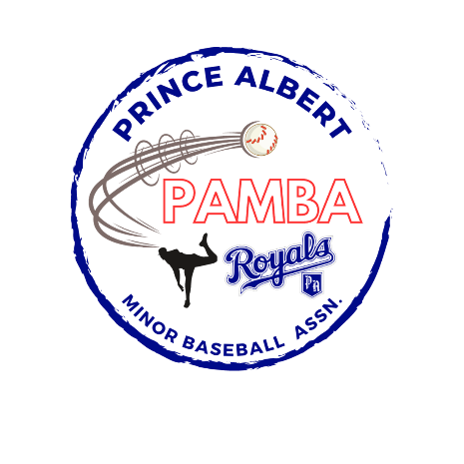


18U SPBL AA First Team Roster
Daniel Acorn
Jackson Anderson
Declan Borthwick
Criseyde Borthwick
Carter Krip
Declan Lavallee
Carter Martin
Kole McGregor
Alex Moose
Jaxson Robertson
Tye Semenchuk
Owen Tolley-Procyk

Head Coach: Troy Semenchuk
Assistant Coaches: Corey Borthwick, Carson McGregor, Graham McGregor, Jim Robertson
Manager: Duane Krip
Treasurer: Karla Brassard

