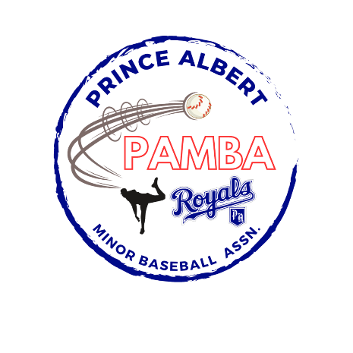


18U SPBL AA Second Team Roster
Josh Bonthoux
Beckett Dallyn
Markus Exner
Ashdyn Lysak
Morgan McEwen
Seamus McFarlane
Jett Miller
Nash Noble
Drew Schultz
Tommy Sutherland
Nash Stacey
Noah Van Otterloo
Head Coach: Jason Van Otterloo
Assistant Coaches: Mike Bonthoux, Chris Dallyn, Nathan Noble
Manager: TBD
Treasurer: TBD

