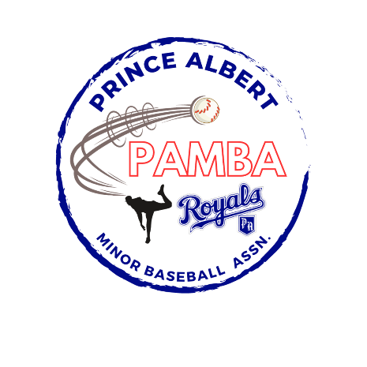
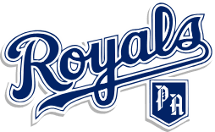

18U Tier 1 AA Provincial Team Roster
Jackson Anderson
Cole Bolotniuk
Kolby Brown
Kayden Burns
Carter Gladstone
Carter Martin
Carson McGregor
Kole McGregor
Brandon Moose
Isaiah Parent
Jaxson Robertson
Lukas Robin
Tye Semenchuk
Owen Tolley-Procyk
Landyn Vandale

Head Coach: Scott Gladstone

Assistant Coaches: Graham McGregor, Troy Semenchuk

