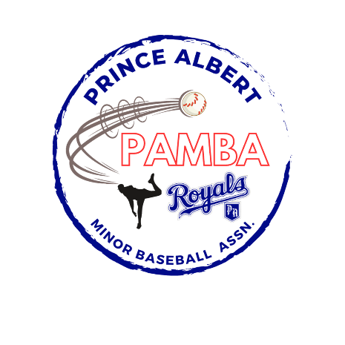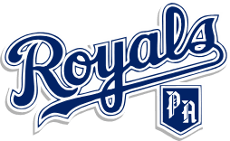

18U Tier 1 AA Provincial Team Roster

Daniel Acorn

Jackson Anderson

Declan Borthwick

Carter Krip

Carter Martin

Kole McGregor

Alex Moose

Brandon Moose

Isaiah Parent

Jaxson Robertson

Tye Semenchuk

Owen Tolley-Procyk

Head Coach: Troy Semenchuk

Assistant Coaches: Graham McGregor, Josh Martin, Jim Robertson, Carson McGregor, and Corey Borthwick

Manager: Duane Krip