Polar Kings Athletic Club
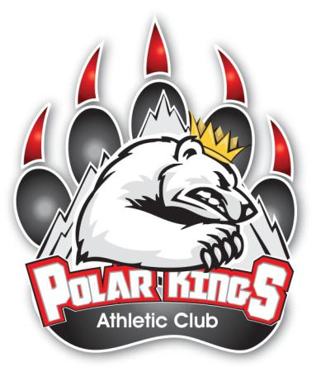

Sponsorship Program

The Polar Kings Athletic Club requires each player to sell one advertisement – raising a minimum of $175.00/player (or more if they wish) for the Polar Kings Athletic Club. Each player will be credited 30% to his player account for each ad sold. The profits will be used by the Polar Kings Athletic Club to cover club management costs, team socials,

promotional event costs, year-end banquet, etc.

The deadline for the sponsorship ads will be October 22th, and this form must be submitted to the Coordinator. Please Email your logo to PKACWainwright@gmail.com

Platinum Sponsor - $500.00

- Large logo inside game day program for all home games.

- Large logo on sponsorship banner which travels with the team, and is set up in the lobby for home and away games, as well as any team functions.

- Recognised for your sponsorship on all Social Media Platforms (Twitter, Facebook, and polarkings.com)

Gold Sponsorship - $275.00

- Medium logo inside game day program for all home games.

- Medium logo on sponsorship banner which travels with the team, and is set up in the lobby for home and away games, as well as any team functions.

- Recognised for your sponsorship on all Social Media Platforms (Twitter, Facebook, and polarkings.com)

Silver Sponsorship - $175.00

- Company listed inside game day program for all home games.

- Company listed on sponsorship banner which travels with the team, and is set up in the lobby for home and away games, as well as any team functions.

- Recognised for your sponsorship on all Social Media Platforms (Twitter, Facebook, and polarkings.com)

Sponsor Name as listed for advertising:_____________________________________

Mailing Address of Sponsor:______________________________________________

Phone:_________________________Email:_________________________________

Players Name:________________________

Team (Circle One): U11 - U13 - U15 - U18

Notes:_______________________________________________________________

Please make cheques payable to Polar Kings Athletic Club

