POLAR KINGS ATHLETIC CLUB
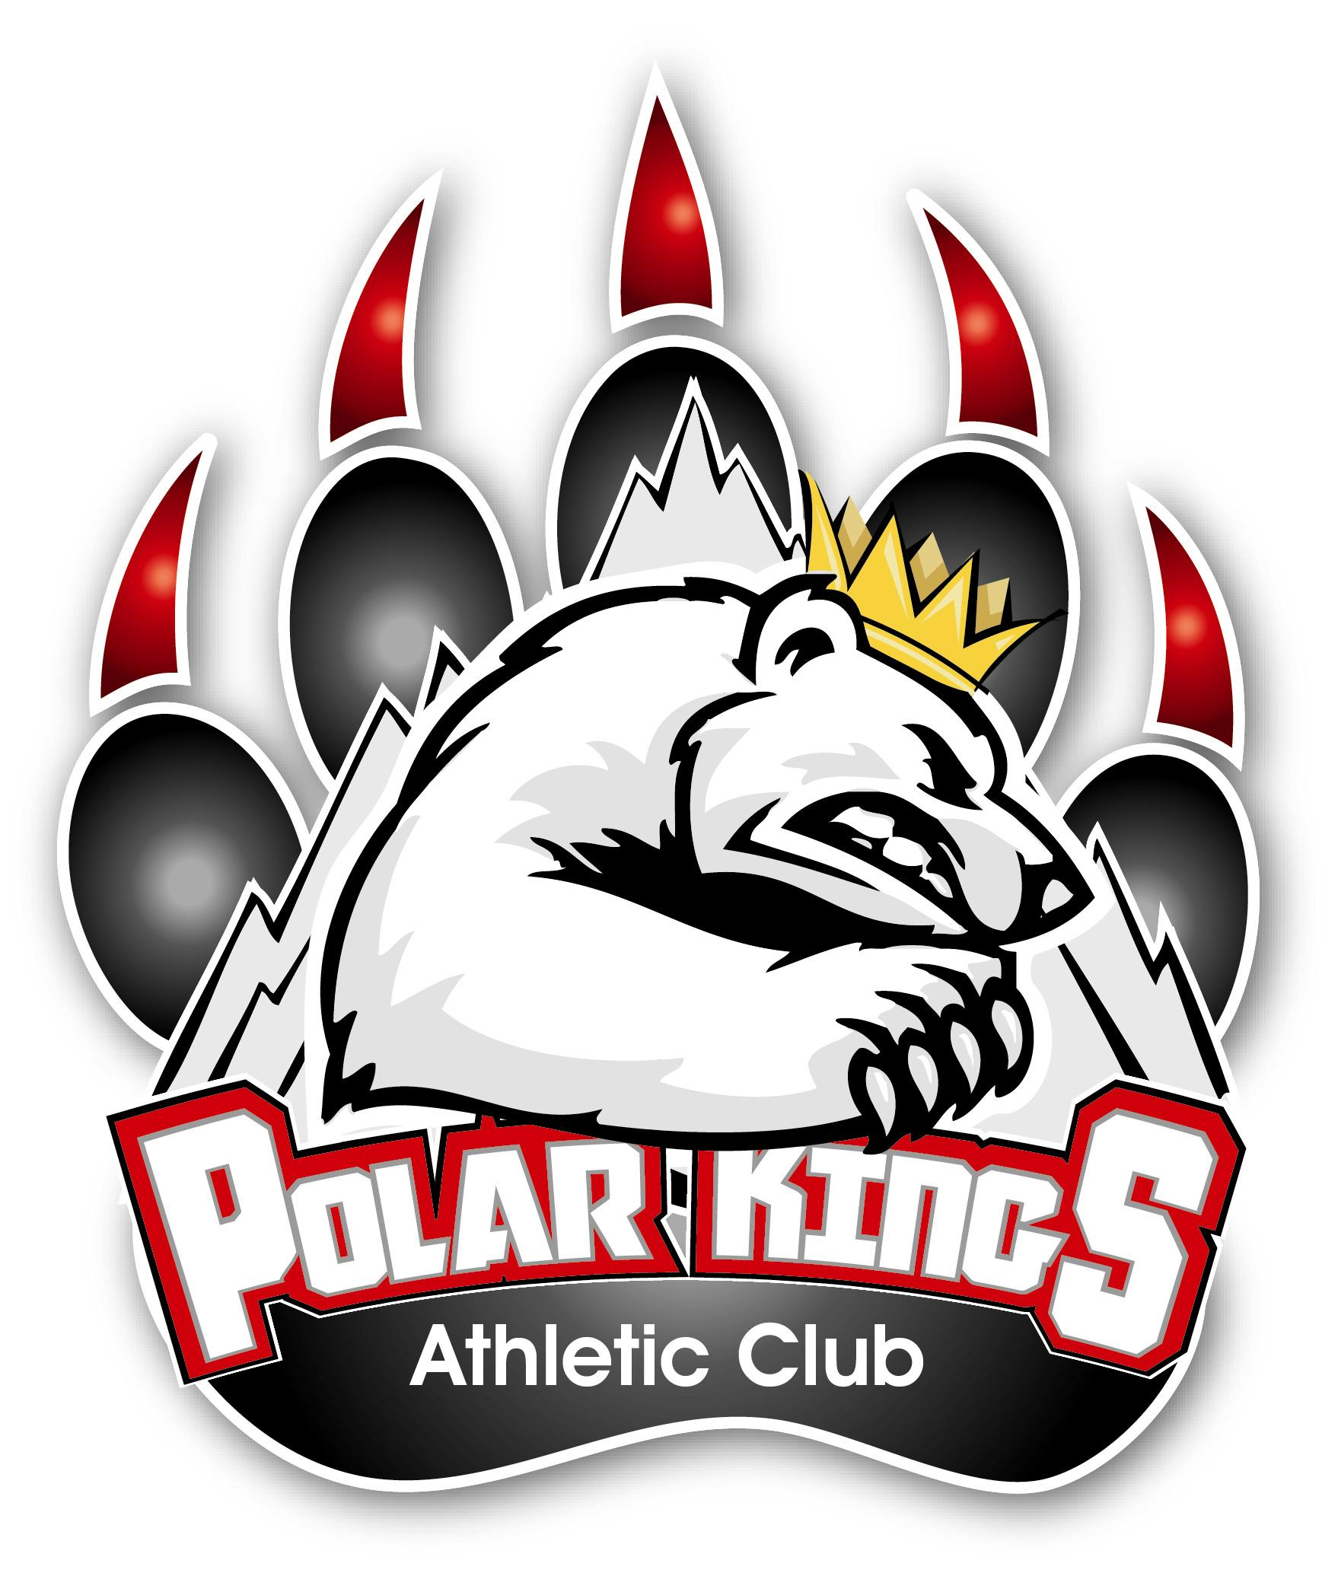

Information Handout

2023-2024

POLICY, RULES & RESPONSIBILITIES

AA U11
AA U13
AA U15
AA U18

Polar Kings Athletic Club
Box 3002
Wainwright, AB. T9W 1T1
www.polarkings.com

Mission Statement

The Polar Kings Athletic Club is committed to player development and providing young, talented and dedicated hockey players in rural Alberta the opportunity to play a higher caliber of hockey.

Slogan
The Heart of Hockey – Rural Alberta

Polar Kings Athletic Club Objectives
The objectives of the Polar Kings Athletic Club are: to promote, govern and improve organized Minor Hockey as a division of Hockey Alberta by authority of the Canadian Hockey Association.
- To promote, supervise and administer the operation of regional AA hockey teams.
- To foster a sense of general community spirit among its members, supporters and teams.
- To maintain and increase interest in the game of hockey.
- To exercise a general care, supervision and direction over the playing interests of its teams and players.
- To raise funds as deemed necessary for the operation of the Polar Kings Athletic Club.
- To establish, maintain and interpret rules and regulations and to decide all matters in dispute in relation thereto.

POLAR KINGS ATHLETIC CLUB BOARD OF DIRECTORS 2022-2023

PRESIDENT Kent Erickson 780-842-8490
VICE PRESIDENT Nolan Goodwin 780-806-9519
SECRETARY Stacey Leggett 780-842-1961
TREASURER Stacey Leggett 780-842-1961
U11 DIRECTOR Adam Doyle 780-842-9684
U13 DIRECTOR Sheldon Currier 780-806-1799
U15 DIRECTOR Clayton Swanson 780-753-8708
U18 DIRECTOR Kent Erickson 780-842-8490

PLAYER CODE OF CONDUCT AND RESPONSIBILITIES
The Polar Kings Athletic Club board of directors is committed to providing hockey players in rural Alberta with a higher level of hockey and to player development. In order to have a successful hockey season it requires full commitment from players to the Players Code of Conduct, to the coach, fellow team members and to the Polar Kings Athletic Club. The following is the Player Code of Conduct that is to be followed and maintained by all players throughout the season.

DRESS CODE
- MANDATORY - The Polar Kings Athletic Club dress attire consists of: designated Polar Kings Athletic Club jacket, dress pants (no jeans or khakis), dress shirt (shirt must be tucked in) & tie, and dress shoes. NO HATS OR TOQUES. All team players are required to be in dress attire for all games (home & away). Non-compliance will result in player not participating in game. The Polar King organization will order dress jackets, track suits, and dry-land apparel for all players and work cost into the budget.
- Players may dress casual while traveling to games on the bus only if approved by the coaching staff.

CURFEW
- Curfew will be established by the team coach.

BEHAVIOUR
- While representing the Polar Kings Athletic Club players shall be self-motivated in the area of conduct. Supervision should not be necessary to ensure conduct is acceptable.
- Zero tolerance for the use of ILLEGAL DRUGS, ALCOHOL and TOBACCO PRODUCTS while REPRESENTING THE POLAR KINGS ATHLETIC CLUB.
- No profane language while representing the Polar Kings Athletic Club and the team.
- Players are expected to know what's going on at all times regarding games/practices.
- Show respect to the coaching staff, on ice officials, team mates, manager and parents.
- Work equally hard for yourself and for your team... your team's performance will benefit and so will you. You are part of a team.

BUSSING
- Players are required to ride the bus for all road games unless permission from team officials is obtained for special circumstances well in advance of game day.
- Transportation costs will be divided equally among team members whether or not a player rides the bus. This fee covers a player, one parent or parents if room permits.
- Girlfriends will not be allowed to ride the bus.
- It is recommended that players pack a lunch to be eaten on the bus to and from games. The bus does not stop for meals unless prearranged by team officials.

ACCOMMODATIONS
- Players must stay in the same hotel as team officials.

ATTENDANCE
- Players are required to participate in all practices, games, off ice sessions and special events of the team and the Polar King Athletic Club.
- Injured players are required to attend unless one of the following exemptions are met.

EXEMPTIONS
- ILLNESS / INJURY- Coach or manager must be notified if player is unable to attend.
- SPECIAL CIRCUMSTANCES - Special circumstances must indeed be "special" to override team commitment. Permission must be requested well in advance if a player is not able to attend a practice or a game.
- SCHOOL WORK / STUDYING - Required school attendance for special events, (award nights, science fair, etc.) is an acceptable excuse for missing practice. Advance notice must be given to the Coach or Manager.

SCHOOLING
- The Polar Kings Athletic Club believes that education is priority.
- Occasionally some games overlap with school attendance. Players are encouraged to maintain quality performance and attendance in school so that an occasional missed day due to hockey will not be a cause for concern.
- Studying and homework may be done on the bus if needed.
- Attempts are made to keep school time missed to a minimum.

ELECTRONICS
No cellphones or cameras permitted in the dressing rooms at any time. Coaching staff will collect all devices at every practice and game; the devices will then be placed on the bench with the coaches. The discipline for an infraction of this policy is as follows: 1st infraction – player will be benched the first period of the next game. 2nd infraction – player will be benched the entire next game. 3rd infraction – player and parents will meet with the executive and the suspension will be determined. Offending player will be required to attend and dress for the game in which the suspension occurs. In all cases, the parents will be informed of the infractions.

SOCIAL MEDIA
The PKAC has adopted and will enforce WMHA Social Media Policy, see pages 12-13. Discipline will be handled by PKAC as directed WMHA guideline.

NON COMPLIANCE OF THE ABOVE WILL NOT BE TOLERATED.
THE BOARD OF DIRECTORS OF THE POLAR KINGS ATHLETIC CLUB, WILL HAVE THE FINAL SAY ON MATTERS OF DISCIPLINE.
COACH AND COACHING STAFF CODE OF CONDUCT AND RESPONSIBILITIES
The responsibilities of the coach and the coaching staff are vital to the game of hockey. It is their responsibility to develop players to the best of their ability by providing them with the tools needed to improve their hockey skills and life skills.
GENERAL CONDUCT
- Become familiar with the Polar Kings Athletic Club Rules and Regulations and ensure that they are followed.
- Understand that you have an obligation to abide by and enforce the Rules and Regulations set out by the Polar Kings Athletic Club Board of Directors. Failure to do so could result in a loss of coaching privileges.
- The Polar Kings Athletic Club endorses the National Coaching Certification Program as required by Hockey Alberta.
- Model and develop respect towards the team, opponents, officials, parents and all parties related to the game of hockey.
- Be generous with your praise when deserved and teach your players when they do things incorrectly.
- Be reasonable in your demands on the player's time, energy and enthusiasm.
- Follow the advice of a physician when determining when an injured player is ready to play and comply with Hockey Canada’s return to play policy.
*** Follow PKAC bench dress code: shirt and tie, dark dress pants and PKAC dress coat
(preferred option) or dress coat of choice –preferably dark with no affiliations.

DISICPLINE
- Zero tolerance for the use of any ILLEGAL DRUGS, ALCOHOL or TOBACCO PRODUCTS WHILE REPRESENTING THE POLAR KINGS ATHLETIC CLUB.
- Maintain a good working relationship between yourself and the Manager.
- Document discipline issues and the resultant actions taken.
- Should problems arise notify the team Manager and Division Director. At the discretion of the Division Director – if further assistance is required they can consult the PKAC Board.
- While representing the Polar Kings Athletic Club players and coaching staff must respect both home and away dressing rooms by keeping them clean and free of damage.

PRACTICES & GAMES
- Attend all practices and games. If unable to attend arrange for a replacement.
- In the absence of a Team Manager, the coach will assume the Manager's responsibilities.
- Ensure that all players are in full equipment that is CSA approved.
- Players are not permitted to enter the ice surface until a member of the coaching staff is present.
- Ensure that all gates onto the ice surface are closed.
- SUPERVISE and be responsible for the conduct of players - at no time shall the players be unsupervised. Two adults (at least one being a coach/staff member) shall be present at all times during games, practices, off-ice training and events. Players shall not be left unattended in the dressing room.

COMPLAINTS & CONFLICTS
- Parent Grievances must be taken to the Team Manager. At no time shall a parent approach members of the coaching staff.
- It is recommended that all complaints be in writing and signed by the writer(s) then submitted to the Team Manager as well as the Polar Kings Athletic Club

TEAM MANAGER CODE OF CONDUCT AND RESPONSIBILTIES

The Manager is responsible for the operation and conduct of the team and coaching staff under the Rules and Regulations established by the Polar Kings Athletic Club.
- The manager should maintain a good working relationship with team officials, players and parents.
- The Team Manager is accountable to the Polar Kings Athletic Club Board, Division Director and the Coaching Staff.
- Work with the coaching staff to insure team continuity by following the Rules and Regulation set out by the Polar Kings Athletic Club Board of Directors
- Understand that you have an obligation to abide by the policies of the Polar Kings Athletic Club, failure to do so could result in a loss of management privileges.
- Treat coaching staff, players and parents with respect.
- Follow team dress code – when required to be part of the coaching staff.
- Help support all parent volunteer positions to carry out roles and responsibilities

PARENTS / MEETINGS
- The Team Manager shall act as liaison between the Polar Kings Athletic Club, coaches, parents and players.
- Conduct all parent meetings.
- Call parental information meetings as required.

DISCIPLINARY
- Zero tolerance of the use of ILLEGAL DRUGS, ALCOHOL, and TOBACCO PRODUCTS while representing the Polar Kings Athletic Club.
- Ensure that your players' parents understand and abide by the PARENT CODE OF CONDUCT.
- No profane language will be tolerated.
- The team manager will handle any complaints by parents or other parties in a respectful and fair manner.
- Complaints will be reported to the Division Director - who will advise the Polar Kings Athletic Board.
- Report disciplinary problems to the Division Director who will advise Polar Kings Athletic Club Board of Directors if a serious matter presents itself.

TEAM FINANCES
- Assume responsibility of all team finances in conjunction with the team Treasurer.

GAME / PRACTICES
- Arrange all transportation for away games.
- Responsible for the game sheets before and after each game.
- Input all game sheets to the website
- Notify players and parents of practice and games times, time changes and special events and locations, with as much notice as possible.
- Notify WMHA Referee and Chief, WMHA Ice Convenor of game changes in a timely manner.
- Ensure that Referees are in place for all home games.
WAINWRIGHT MINOR HOCKEY ASSOCIATION
- Ensure that a good working relationship is maintained at all times.
- Supply a list of affiliated players/team to the Wainwright Minor Hockey and to the Polar King Athletic Club.
- Should a player be added to the roster it is the manager’s responsibility to ensure that the player is properly carded and all paper work is completed before said player participates in a game and or practice.
- Report to WMHA ice convenor when ice times change or an ice slot is not being used.

- Participate in the Wainwright Minor Hockey Minor Hockey Week functions if possible.

PARENT CODE OF CONDUCT AND RESPONSIBILITIES
The Polar Kings Athletic Club requires a full commitment from parents in adhering to the Polar Kings Athletic Club Rules and Regulations. All parties must work towards the common goal of the growth and development of each Polar Kings hockey player. The continuity of teams, parents, coaches and managers is a vital element to the success of a hockey team.

GENERAL
- Zero tolerance of any ILLEGAL DRUGS, ALCOHOL or TOBACCO PRODUCTS, WHILE REPRESENTING THE POLAR KINGS ATHLETIC CLUB.
- Respect and support players, coaches, managers, officials, volunteers and other parents.
- Enforce the "Player Code of Conduct" regarding your hockey player.
- Attend all parent meetings called by the manager and keep informed regarding games, practices and other team functions.
- Turn defeat to victory by helping your child work towards good sportsmanship. Never ridicule your child or yell at any player for making a mistake or losing a competition.
- Congratulate your child on honest effort and skill improvement, not just goals and assists.
Applaud all players.

COACHES
- The Polar Kings Athletic Club recruits high calibre coaches with quality coaching expertise, excellent coaching skills and experience. They have the experience and knowledge of the game that enables them to teach and develop young hockey players individually and as a team. It is important that the parents support and encourage the coaches and the players. LET THE COACHES DO THE COACHING.

COMPLAINTS
- Parent Grievances must be taken to the team manager. At no time, shall a parent approach members of the coaching staff.
- It is recommended that all complaints be in writing and signed by the writer(s) then submitted to the team manager as well as the Polar Kings Athletic Club by mail or email.
- Any concerns with the operation of the league and /or officiating must be directed to the Team Manager. Any concerns with the Team Manager will be directed to in writing to the Division Director by mail or email.

GAMES & PRACTICES
- Parents are to have players at the arenas at the specified time established by the coach, for all practices, games and team functions.
- Responsible to inform the manager when players will not be attending practices or games.
- Responsible to maintain respectable behaviour while representing the Polar King Athletic Club.
- Parents are required to work as score/time keepers, run music, and attend doors in the penalty box at home games. If you are unable to work it is your responsibility to find a replacement.

FUNDRAISERS
- All players/parents must participate in all fund-raisers.
- Ensure that all fund-raising projects are completed in the allotted time period.

.
FEES
Player fees must be paid at the team organizational meeting. Fees must be paid as follows: Paid in full at the meeting or paid by post-dated cheques at the meeting. (half of the fees are due by October 31st and the balance must be paid in full by December 31st.

A $25.00 fee will be charged for all NSF cheques. This applies to all payments owed to the Wainwright Polar
Kings Athletic Club.

***By permitting your child to be carded with a Polar King team, you are consenting and agreeing to adhere to the policies, rules and regulations set forth in this handbook. No player will be carded until a parental/guardian signature is in place.

TEAM POSITIONS and RESPONSIBILITIES
TEAM MANAGER
Refer to page (7)

TRAINER
- Must be a certified Trainer with Hockey Alberta.
- Trainers MUST be on the bench for all games and present for all practices.
- Consult with team coaches regarding injured players.
- Ensure all equipment and first aid supplies are at all games and practices.

SOCIAL MEDIA REPORTER
- Post the Game Day Updates to Twitter and Facebook. (refer to Social Media Guidelines)
- Upcoming events, news, etc

JERSEY MANAGERS (2)
- Ensure that team jerseys are at all games and practices.
- Clean and repair jerseys on a regular basis.
- Ensure name bars are removed at season end.

VOLUNTEER SCHEDULE COORDINATOR
- Provide work schedules to parents for Scorekeeper, Timekeeper, Penalty Box Officials and Music for all home games.

MEAL COORDINATORS (2)
- Responsible to arrange for all team meals. (bus, overnight trips, etc)
- To collect all funds required to facilitate meals for the team. (NOT included in team fees; therefore NOT payable from team budget)
- To be accountable for all funds received and to dispense funds to caters or meal service providers.
- If a surplus occurs the Meal Coordinator is also responsible to dispense funds back to the parents.

TEAM SOCIAL COORDINATOR(S)
- Responsible for organizing team social events. (ei: Christmas party, team building, tournament socials)
- Responsible for co-organizing Club social events as designated by the PKAC.
- Participate in the Wainwright Minor Hockey ~ Minor Hockey Week functions if possible

GAME-DAY PROGRAM PERSON
- Print and distribute game-day programs for all home games in compliance with League requirements.
- “The home team must provide a program and a line up sheet for each home game and includes ALL League Sponsors.”

BANNER SPONSOR COORDINATOR
- Collect all Banner Sponsor payments and forms for each player (including online)
- E-transfers: note players name in memo
- Submit information/advertisement forms and payment to Secretary of PKAC.
- Set up & take down of banner at all home/away games

PICTURE COORDINATOR
- Responsible to meet with other PK Team Division Picture Coordinators to organize picture times and dates.
- Responsible to get order information to parents/player and coaching staff.
- Responsible for distributing jersey sponsor pictures.
- Note: team photo per player is included in fees

ACCOMMODATIONS COORDINATOR
- Responsible for making booking arrangements for hotel rooms for players, bench staff and bus driver. (tournaments, overnight trips)

POWERPOINT COORDINATOR
- Responsible for PowerPoint presentation at Year-end banquet.

FACEBOOK LIVE COORDINATOR
- Responsible for Facebook Live games.

APPAREL COORDINATOR
- Responsible for team apparel – assist with sizing and distribution of apparel. (PKAC will arrange the apparel samples)

**NOTE: All Positions – it is your responsibility to relay information to team members directly as required, with a cc to the manager. The manager will have an email list available after the team organizational meeting.

WAINWRIGHT MINOR HOCKEY ASSOCIATION SOCIAL MEDIA GUIDELINE

THINK BEFORE YOU POST
Social Media and Networking Policy

- INTRODUCTION
For the purpose of this Social Media and Networking Policy, the policy will encompass public communications through such internet mediums and websites as Twitter, Facebook, Instagram, Snapchat and any other social media network that allows users to communicate online as well as other forms of electronic communication, but not limited to, methods such as instant messaging, emailing or texting. Email corresponding, texting and social media posts should be encouraged as tools to share information only.
The policy will be applicable to all members of the WMHA Community, including Directors, Teams, WMHA members and staff, on-ice and off-ice officials, billets, players, players’ family members and supporters. The WMHA recognizes and appreciates the value of social media and the importance of social networking to all of its stakeholders. The WMHA also respects the right of all Teams and Association personnel to express their views publicly. At the same time we must be aware of the dangers social media and networking can present.
The purpose of this policy is to educate the WMHA Community on the risks of social media and to ensure all Teams and Association personnel are aware that conduct deemed to be inappropriate may be subject to disciplinary action by the WMHA.

- SOCIAL MEDIA GUIDELINES
  - The WMHA holds the entire WMHA Community who participates in social media and networking to the same standards as it does for all other forms of media including radio, television and print. It should be recognized that social media and comments are on the record and can be instantly published and available to the public and media.
  - Comments or remarks of an inappropriate nature that are detrimental to a Team, the Association or an individual will not be tolerated and will be subject to disciplinary action.
  - Use your best judgment at all times – pause before posting or sending. Once your comments are posted or sent they cannot be retracted. Ultimately, you are solely responsible for your comments.

- SOCIAL MEDIA VIOLATIONS
The following are examples of conduct through social media and networking mediums that are considered violations of the WMHA Social Media and Networking Policy and may be subject to disciplinary action by the WMHA.
  - Any statement deemed to be publicly critical of Association officials or detrimental to the welfare of a member Team, the Association or an individual.
  - Negative or derogatory comments about any of the WMHA staff, programs, stakeholders, players or any member of a WMHA Team.
  - Any form of bullying, harassment, intimidation or threats against players or officials.
  - Photographs, video or comments promoting negative influences or criminal behavior, including but not limited to:
o drug use, o alcohol abuse, o public intoxication, o hazing o sexual exploitation, etc.
  - Online activity that contradicts the current policies of the WMHA
  - Inappropriate, derogatory, racist, or sexist comments of any kind, in keeping with the WMHA policies and regulations on these matters.
  - Online activity that is meant to alarm other individuals or to misrepresent fact or truth.

Because social media violations may vary in terms of their seriousness and effect, care must be taken to consider sanctions that are appropriate in each situation that presents itself.
Factors that can be considered when dealing with social media violations include:
  - The intent of the violator
  - Whether harm, physical or otherwise, resulted from the violation
  - The circumstances of the violation
  - The effect the violation had upon its recipient, the recipient’s family, the team, the Association, or the community
  - Any previous social media violation history

- DISCIPLINE
WMHA will investigate reported violation(s) of this policy in the manner set out in the Communication Protocol in WMHA policies for other types of violations. If the investigation determines that a violation has occurred, the WMHA Executive involved will impose an appropriate suspension. Any appeal of the suspension will be dealt with as set out in WMHA policies for other types of suspensions.

Possible disciplinary measures therefore depend on a number of factors. Please consider the following suggested responses for various conducts:
  - Implicit or implied threats of death or serious bodily harm: indefinite suspension, referral to WMHA Executive for investigation and punishment (also refer to police) - Encouraging someone to do themselves serious harm: indefinite suspension, referral to WMHA Executive for investigation
  - Posting of pictures of a threatening nature: indefinite suspension, referral to WMHA Executive for investigation and punishment (also refer to police) - Slurs against someone’s race, religion, sex, or sexual orientation: lengthy suspension - Slurs against another or their family: warning or short suspension - Posting comments and/or pictures of self of an implied sexual nature: short suspension - Posting comments and/or pictures of someone else of an implied sexual nature: indefinite suspension, referral to WMHA Executive for investigation and punishment (also may refer to police)
  - Gossip - Posting or sending cruel gossip to damage a person’s reputation and relationships with friends, family, and acquaintances: warning or short suspension
  - Breaking into someone’s e-mail or other online account and sending messages that will cause embarrassment or damage to the person’s reputation and affect his or her relationship with others: indefinite suspension, referral to WMHA Executive for investigation and punishment (also refer to police)
  - Posting or sending unwanted or intimidating messages: suspension
  - Tricking someone into revealing secrets or embarrassing information, which is then shared online: short suspension
  - Negative or derogatory comments about Team, etc.: warning or short suspension

- SUMMARY
When using social media and networking mediums, the WMHA community should assume at all times they are representing the WMHA and/or its Teams. All members of the WMHA community should remember to use the same discretion with posting or commenting on social media and networking as they do with other traditional forms of media. THINK BEFORE YOU POST.

